SUPPLEMENTARY DATA
Supplementary Table S1. Test result specific likelihood ratios
 | Interval | Total |  | BB |  | C |  | L |  | M
QuantaFlash | 0.0 - 12.5 | 0.10 | 0.07 to 0.15 | 0.17 | 0.09 to 0.29 | 0.02 | 0.01 to 0.16 | 0.08 | 0.03 to 0.19 | 0.11 | 0.06 to 0.21
 | 12.5 - 23.8 | 1.23 | 0.56 to 2.70 | 0.82 | 0.17 to 3.84 | 4.29 | 1.37 to 13.48 | 0.00 | 0.000 to 7.96 | 0.50 | 0.06 to 4.09
 | 23.8 - 74.3 | 10.22 | 5.64 to 18.53 | 6.14 | 2.62 to 14.39 | 15.46 | 4.35 to 54.92 | 22.05 | 4.96 to 97.88 | 7.50 | 1.48 to 37.94
 | 74.3 - 1049.8 | 64.84 | 33.61 to 125.09 | 35.32 | 11.26 to 110.73 | 41.22 | 12.95 to 131.21 | 54.40 | 17.39 to 170.14 | ∞ | 22.86 to ∞
 | 1049.8 - 3500.0 | ∞ | 9.82 to ∞ | ∞ | 0.52 to ∞ | ∞ | 4.16 to ∞ | ∞ | 2.44 to ∞ | ∞ | 2.79 to ∞
EliA | 0.0 - 2.1 | 0.10 | 0.07 to 0.15 | 0.15 | 0.08 to 0.27 | 0.05 | 0.01 to 0.18 | 0.10 | 0.04 to 0.22 | 0.11 | 0.06 to 0.20
 | 2.1 - 5.0 | 3.35 | 1.89 to 5.96 | 4.01 | 1.32 to 12.20 | 4.12 | 1.15 to 14.77 | 2.45 | 0.85 to 7.03 | 3.75 | 1.03 to 13.64
 | 5.0 - 16.0 | 11.79 | 6.58 to 21.14 | 6.54 | 2.82 to 15.21 | 33.45 | 7.82 to 143.46 | 6.6 | 1.93 to 22.67 | 30.00 | 3.90 to 230.90
 | 16.0 - 142.0 | 58.73 | 30.39 to 113.50 | 29.59 | 9.36 to 93.60 | 41.28 | 12.95 to 131.21 | 51.46 | 16.4 to 161.36 | ∞ | 20.23 to ∞
 | 142.0 - 180.0 | ∞ | 7.52 to ∞ | ∞ | 0.87 to ∞ | ∞ | 1.57 to ∞ | ∞ | 2.45 to ∞ | ∞ | 2.03 to ∞
Threshold values that corresponded to a specificity of 95%, 97.5%, 99% and 100% (if applicable) (see Table 1 and Table 2) were used to define test result intervals. For each test result interval, the interval-specific likelihood ratio (and 95% confidence intervals) for the total population as well as for the subpopulations recruited at four different centers (BB: Bad Bramstedt, C: Copenhagen, L: Leuven, M: Maastricht) is shown.
Supplementary Table S2. Immuno-assay versus IIF
Orgentec |  | Euroimmun |  |  |  |  | IIF
 |  | 0 | 1 | 2 | 3 | 4 | 0 | 0.5 | 1 | 2 | 3
0 | AAV | 19 | 8 | 3 |  |  | 25 | 2 | 1 | 1 | 1
 | control | 854 | 18 | 5 |  |  | 844 | 8 | 10 | 10 | 5
1 | AAV |  | 0 | 4 |  |  |  | 1 | 2 | 1
 | control | 13 | 5 | 4 |  |  | 16 |  | 3 | 2 | 1
2 | AAV | 2 | 3 | 16 | 4 |  | 2 | 4 | 9 | 5 | 5
 | control | 10 | 1 | 4 |  |  | 7 | 1 | 3 | 1 | 3
3 | AAV |  | 2 | 33 | 58 | 95 | 1 | 4 | 18 | 45 | 120
 | control |  |  | 1 | 4 | 5 |  |  |  | 2 | 8
4 | AAV |  |  |  | 1 | 3 |  |  |  |  | 4
 | control
Threshold values that corresponded to a specificity of 95%, 97.5%, 99% and 100% (if applicable) (see Table 1) were used to define test result intervals for immuno-assays (Orgentec and Euroimmun). For IIF, fluorescence intensity was scored (0, 0.5, 1, 2, 3). The table shows the distribution of patients (AAV) (n=251) and controls (n=924) across the combination of different intervals.

Supplementary Figure S1. Area under the curve for the Euro-Diagnostica immuno-assay and of various combinations
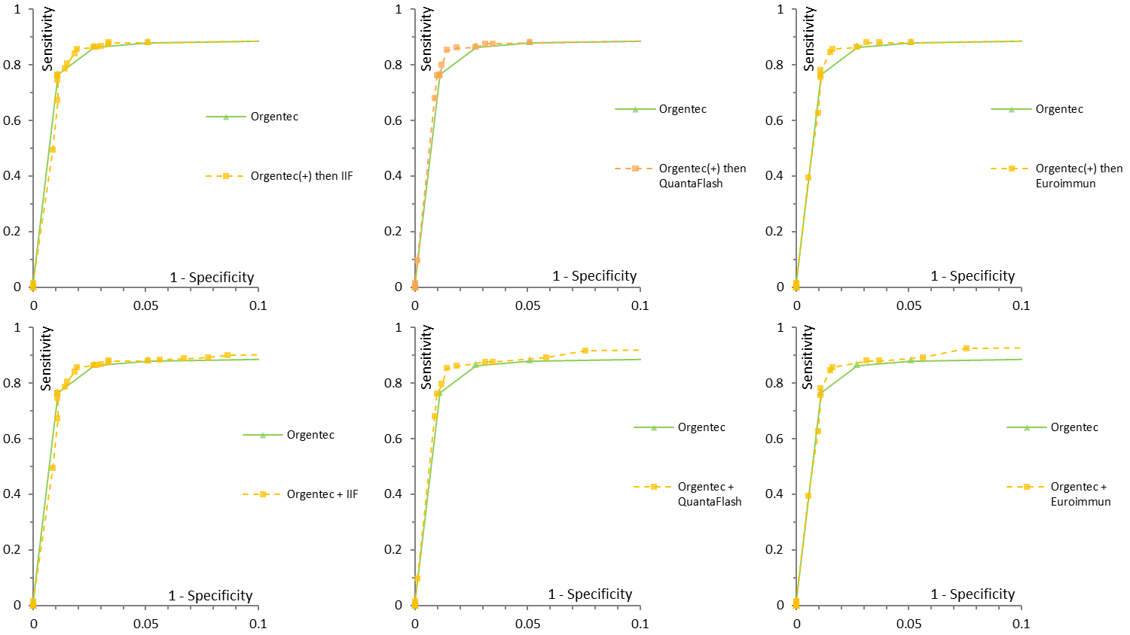
The combinations included: screening with Orgentec immuno-assay and if immuno-assay is positive (+) then IIF or another immuno-assay (QuantaFlash) was performed; or (Orgentec immuno-assay was performed together with IIF or another immuno-assay (Euro-Diagnostica or QuantaFlash) on all samples.

Supplementary Figure S2. Area under the curve for the Orgentec immuno-assay and of various combinations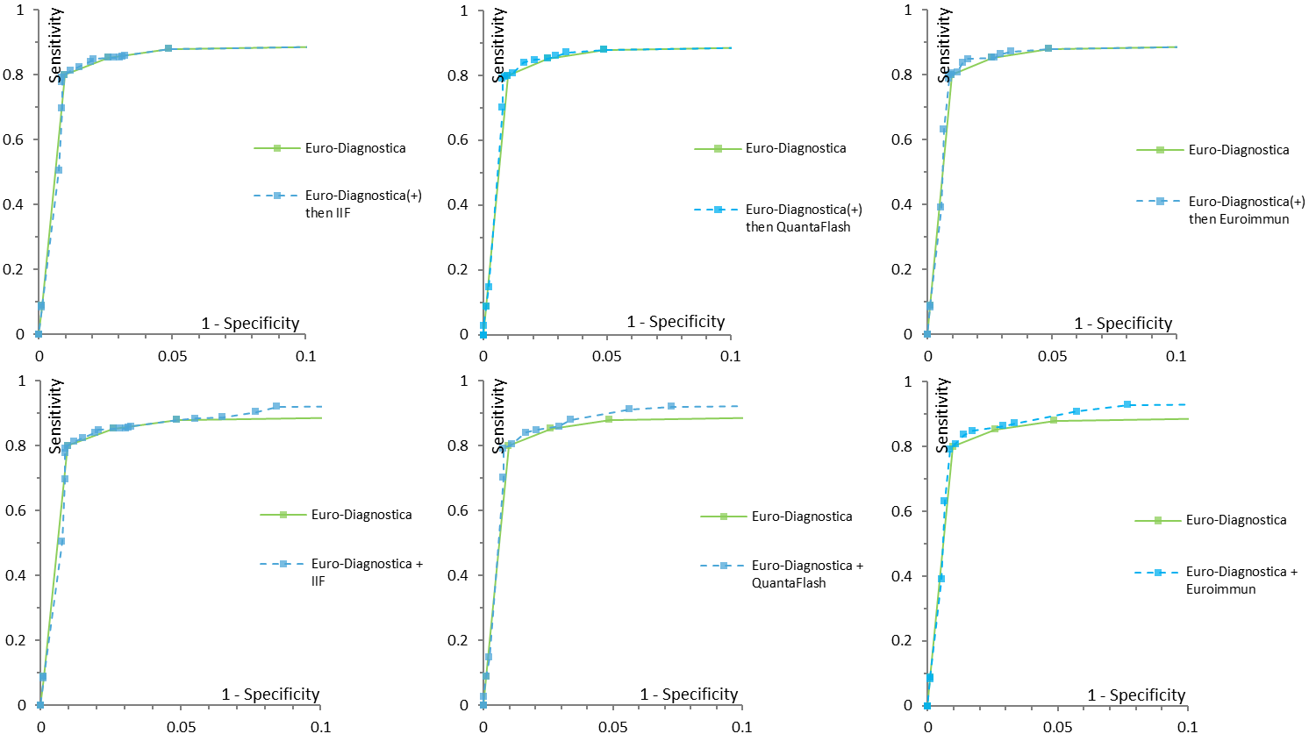
The combinations included: screening with Orgentec immuno-assay and if immuno-assay is positive (+) then IIF or another immuno-assay (Euroimmun) was performed; or Orgentec immuno-assay was performed together with IIF or another immuno-assay (Euroimmun or QuantaFlash) on all samples.

