SUPPLEMENTARY DATA
Supplementary Figure S1. Linear mixed models

Supplementary figure S2: Nine individual clinical courses showing disease activity versus time (in days) and IFN biomarker levels
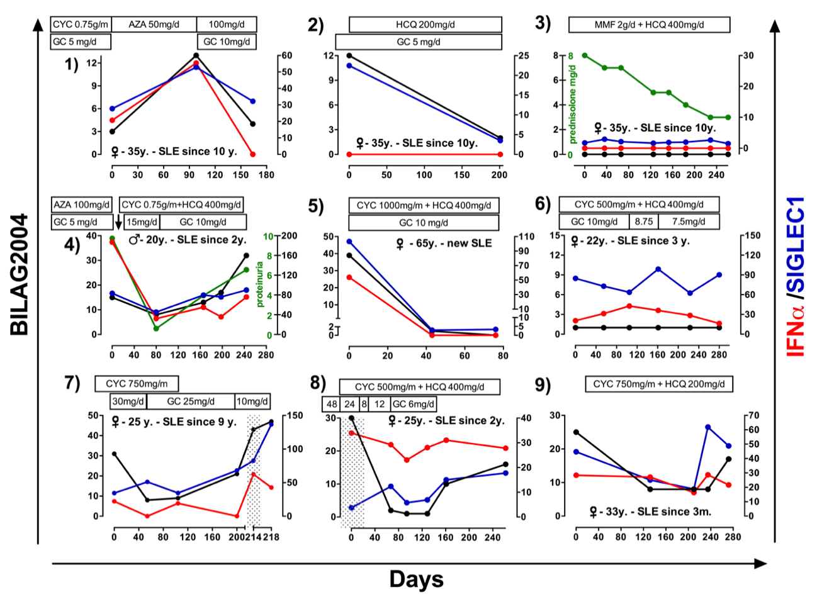
Changes in medication are shown above each course. Dotted areas show visits excluded from further analysis (e.g., due to less then 30 days time span or high prednisolone dose).
An increase or decrease in disease activity was mainly paralleled by IFN biomarkers. Patient no. 1 and no. 5 had a disease flare and were treated with glucocorticoids and dose adjustment of azathioprine or cyclophosphamide, respectively. This resulted in a decreasing disease activity accompanied by decreased values of the investigated IFN biomarkers. While patient no. 5 showed a complete suppression of IFN activation, patient no. 1 remained slightly activated, reflected by elevated levels of IFNα and an enhanced SIGLEC1 expression.
In patient no. 2, the introduction of the IFN-inhibitory hydroxychloroquine resulted in a parallel decrease of SIGLEC1 with BILAG-2004 while the less sensitive IFNα-test could not detect a change in IFNα. Patient no. 3 was clinically and serologically inactive when entering the study, and prednisolone tapering did not result in an increase of IFNα or SIGLEC1. In patient no. 4, a disease flare with nephritis and high proteinuria was treated with cyclophosphamide and the introduction of hydroxychloroquine therapy leading to slightly improvement of disease activity and reduced proteinuria. While IFNα could be suppressed remarkably, SIGLEC1 expression showed only a mild suppression. Both IFN biomarkers showed an ongoing and progressively activated type I IFN system that ended up in another flare. Patient no. 6 is stable but with ongoing IFN activity. In patient no. 7, a dramatic rise in IFNα levels and SIGLEC1 could be observed within four days, indicating that IFN biomarkers can change significantly within days. In patient no. 8, tapering of glucocorticoids led to an increase of IFNα and SIGLEC1 expression. In patient no. 9, the flare at fifth visit was anteceded by a significant rise in SIGLEC1 and IFNα.

Supplementary Figure S3: Disease activity was plotted against all tested biomarkers
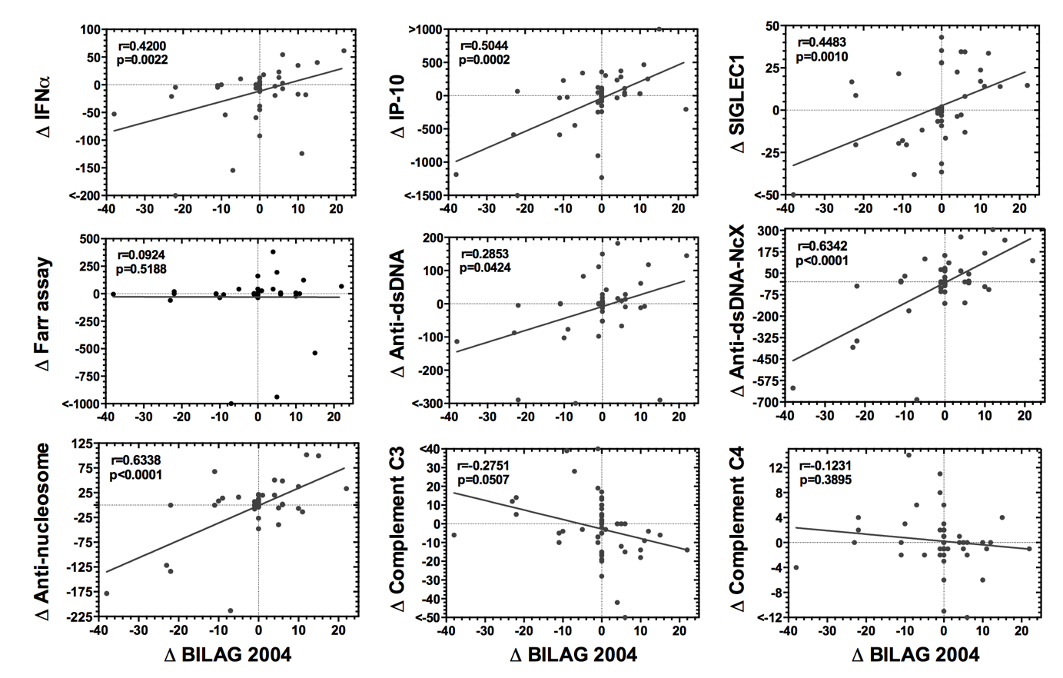
Weighted correlation coefficients were calculated to take into account the different numbers of serial visits per patient. This was done by an analytically weighted linear regression model. (p, p-value;; r, coefficient).

Supplementary Table S1. Patient characteristics
 | General |  |  |  | SLE- Medication
ID | Sex | Age | Visit number | Days after first visit | Prednisolone mg/d | HCQ mg/d | Azathioprine in mg/d | Cyclophosphamide mg/month | MMF in g/d
1 | female | 45 | 1 | 0 | 8 | 200 | 0 | 0 | 2
1 | female | 45 | 2 | 35 | 7 | 200 | 0 | 0 | 2
1 | female | 45 | 3 | 65 | 7 | 200 | 0 | 0 | 2
1 | female | 46 | 4 | 126 | 5 | 200 | 0 | 0 | 2
1 | female | 46 | 5 | 153 | 5 | 200 | 0 | 0 | 2
1 | female | 46 | 6 | 184 | 4 | 200 | 0 | 0 | 2
1 | female | 46 | 7 | 229 | 3 | 200 | 0 | 0 | 2
1 | female | 46 | 8 | 261 | 3 | 200 | 0 | 0 | 2
2 | male | 24 | 1 | 0 | 20 | 200 | 0 | 0 | 0
2 | male | 24 | 2 | 91 | 12.5 | 200 | 0 | 0 | 0
2 | male | 25 | 3 | 173 | 10 | 200 | 0 | 0 | 0
14 | female | 25 | 1 | 0 | 0 | 200 | 0 | 800 | 0
14 | female | 25 | 2 | 67 | 0 | 300 | 0 | 800 | 0
14 | female | 25 | 3 | 94 | 0 | 300 | 0 | 800 | 0
14 | female | 25 | 4 | 129 | 0 | 300 | 0 | 800 | 0
14 | female | 25 | 5 | 161 | 0 | 300 | 0 | 800 | 0
15 | female | 33 | 1 | 0 | 0 | 0 | 0 | 0 | 0
15 | female | 33 | 2 | 132 | 0 | 200 | 0 | 800 | 0
15 | female | 33 | 3 | 210 | 10 | 200 | 0 | 800 | 0
15 | female | 33 | 4 | 236 | 0 | 200 | 0 | 800 | 0
15 | female | 34 | 5 | 272 | 0 | 200 | 0 | 800 | 0
20 | female | 25 | 1 | 0 | 30 | 0 | 0 | 500 | 0
20 | female | 25 | 2 | 53 | 25 | 0 | 0 | 750 | 0
20 | female | 25 | 3 | 103 | 2.5 | 0 | 0 | 750 | 0
20 | female | 25 | 4 | 199 | 10 | 0 | 0 | 0 | 0
20 | female | 25 | 5 | 223 | 10 | 0 | 0 | 0 | 0
22 | female | 27 | 1 | 0 | 7.5 | 0 | 100 | 0 | 0
22 | female | 27 | 2 | 160 | 7.5 | 0 | 100 | 0 | 0
23 | female | 69 | 1 | 0 | 9 | 0 | 0 | 1000 | 0
23 | female | 69 | 2 | 24 | 8 | 0 | 0 | 1000 | 0
25 | female | 36 | 1 | 0 | 15 | 200 | 0 | 0 | 2.25
25 | female | 36 | 2 | 105 | 10 | 400 | 0 | 0 | 2.25
28 | female | 22 | 1 | 0 | 10 | 400 | 0 | 500 | 0
28 | female | 22 | 2 | 55 | 10 | 400 | 0 | 250 | 0
28 | female | 22 | 3 | 105 | 8.75 | 400 | 0 | 250 | 0
28 | male | 23 | 4 | 161 | 7.5 | 400 | 0 | 250 | 0
28 | male | 23 | 5 | 223 | 7.5 | 400 | 0 | 250 | 0
28 | male | 23 | 6 | 282 | 7.5 | 400 | 0 | 250 | 0
30 | female | 62 | 1 | 0 | 10 | 400 | 0 | 0 | 1
30 | female | 63 | 2 | 205 | 0 | 200 | 75 | 0 | 0
35 | female | 33 | 1 | 0 | 10 | 200 | 0 | 0 | 0
35 | female | 34 | 2 | 277 | 7.5 | 200 | 0 | 0 | 2
37 | female | 32 | 1 | 0 | 10 | 200 | 0 | 1000 | 0
37 | female | 32 | 2 | 242 | 10 | 200 | 0 | 1000 | 0
41 | female | 40 | 1 | 0 | 15 | 0 | 0 | 0 | 0
41 | female | 41 | 2 | 238 | 12.5 | 300 | 0 | 0 | 0
44 | female | 38 | 1 | 0 | 5 | 200 | 0 | 500 | 0
44 | female | 39 | 2 | 61 | 5 | 200 | 0 | 500 | 0
46 | male | 20 | 1 | 0 | 5 | 0 | 150 | 0 | 0
46 | male | 21 | 2 | 79 | 12.5 | 200 | 0 | 1000 | 0
46 | male | 21 | 3 | 167 | 10 | 200 | 0 | 1000 | 0
46 | male | 21 | 4 | 198 | 10 | 200 | 0 | 1000 | 0
46 | male | 21 | 5 | 245 | 10 | 400 | 0 | 0 | 0
54 | female | 37 | 1 | 0 | 5 | 0 | 0 | 0 | 0
54 | female | 37 | 2 | 70 | 5 | 0 | 0 | 0 | 0
59 | female | 38 | 1 | 0 | 5 | 0 | 0 | 0 | 0
59 | female | 38 | 2 | 200 | 5 | 200 | 0 | 0 | 0
60 | female | 40 | 1 | 0 | 7.5 | 400 | 0 | 0 | 2.25
60 | female | 41 | 2 | 194 | 5 | 400 | 0 | 0 | 2.25
63 | female | 35 | 1 | 0 | 5 | 0 | 0 | 1000 | 0
63 | female | 35 | 2 | 97 | 0 | 0 | 50 | 0 | 0
63 | female | 35 | 3 | 164 | 10 | 200 | 100 | 0 | 0
65 | female | 34 | 1 | 0 | 0 | 0 | 0 | 0 | 0
65 | female | 35 | 2 | 101 | 5 | 200 | 0 | 0 | 0
105 | female | 65 | 1 | 0 | 0 | 0 | 0 | 0 | 0
105 | female | 65 | 2 | 42 | 2.5 | 400 | 0 | 1000 | 0
105 | female | 65 | 3 | 75 | 10 | 400 | 0 | 1000 | 0
121 | female | 58 | 1 | 0 | 10 | 400 | 0 | 1000 | 0
121 | female | 58 | 2 | 29 | 7.5 | 400 | 0 | 1000 | 0
129 | female | 27 | 1 | 0 | 7.5 | 200 | 0 | 0 | 0
129 | female | 27 | 2 | 84 | 7.5 | 200 | 75 | 0 | 0
130 | female | 33 | 1 | 0 | 7.5 | 200 | 0 | 0 | 0
130 | female | 33 | 2 | 84 | 7.5 | 200 | 0 | 0 | 0
134 | female | 47 | 1 | 0 | 10 | 400 | 0 | 0 | 0
134 | female | 47 | 2 | 89 | 8 | 400 | 0 | 0 | 0
147 | female | 39 | 1 | 0 | 7.5 | 200 | 0 | 0 | 2
147 | female | 39 | 2 | 36 | 15 | 300 | 0 | 0 | 2

