Supplementary materials

1. Supplementary methods

1.1 Inclusion/exclusion criteria
The patients with schizophrenia (SCZ) in both discovery and replication samples met the following inclusion/exclusion criteria: (1) diagnosis of SCZ confirmed using the Structured Clinical Interview for DSM-IV-patient version (SCID-P) ¹; (2) age between 18-45 years; (3) Han Chinese ethnicity and right-handed; (4) minimum 9 years of school education (5) good general physical health with no known endocrine, metabolic or inflammatory disorders; (6) no known neurological disorder; (7) no substance dependence in the last year; (8) benzodiazepine treatment, if any, stopped more than 24 h prior to scanning and (9) no contraindications for MRI.
The inclusion/exclusion criteria of healthy subjects in two samples were identical to those of the patient group except that they did not meet the DSM-IV diagnostic criteria of any mental disorders screened using the SCID non-patient version. We also ensured that for healthy subjects, no first-degree relatives had a history of any psychiatric disorders.

1.2 Details of psychotropic medications
A total of 77 patients (of which there were 66 first-episode ones) were drug-free at the time of scanning, of which 68 patients were receiving antipsychotics less than two weeks and 9 patients never took drug before in the discovery sample, and 95 patients were receiving stable dose of second-generation antipsychotic drugs. All individual medication doses were transformed to chlorpromazine equivalence using a standard approach ². Among those medicated patients, 63 patients were on monotherapy for antipsychotics, 32 patients were on combined medications including 28 receiving >1 antipsychotics, 3 receiving antidepressants with antipsychotics and 1 receiving mood stabilizers with antipsychotics.
In the replication sample, there were 15 drug-free patients, of which 12 patients were receiving antipsychotics less than two weeks and 3 patients never took drug before, and 34 patients were receiving stable dose of second-generation antipsychotic drugs. All individual medication doses were transformed to chlorpromazine equivalence using a standard approach ². Among those medicated patients, 18 patients were on monotherapy for antipsychotics, 7 receiving >1 antipsychotics, 9 receiving antipsychotics with antidepressants and 4 receiving antipsychotics with mood stabilizers.

1.3 fMRI experiment
All the subjects were explicitly instructed to keep their eyes closed, to think about nothing in particular and to stay still but not to sleep when undertaking the resting-condition scanning.
The participants underwent an n-back working memory task in the scanner, as reported in our previous works³⁻⁵. The task consisted of two conditions with a randomized sequence. In the “0-back” condition, in which subjects pressed a button to their right when the letter x appeared on the screen, but pressed a button to their left for all other letters, using their right hand. In the “2-back” condition, the participants pressed the button to their right when the stimulus (a letter) on the screen was identical to the one presented two trials back; for all other stimuli, they pressed the button to their left. Each letter was shown for 500 ms with an inter-stimulus interval of 1500 ms. Every block comprised 20 stimuli containing 7 targets (35%) and 13 non-targets (65%), and was preceded by an instruction shown for 2 s. During resting periods, subjects were required to fixate on a cross in the center of screen for 20 s. Stimulation blocks and resting periods alternated within the experiment with a total of four 2-back and four 0-back blocks. The task performance (the response time and accuracy) for each trial was logged in a synchronized fashion using the presentation software. The subjects were taught the experimental paradigm thoroughly before the scanning, and demonstrated their understanding by correctly practicing it outside the scanner.

1.4 fMRI data acquisition and preprocessing
Image acquisition and preprocessing were described in our published works³⁻⁵. Functional MRI images of the discovery sample were collected on a Philips Gyroscan Achieva 3T MRI scanner axially, using a gradient-echo echo-planar imaging (EPI) sequence: repetition time=2000 ms; echo time=30 ms; slices=36; thickness=4 mm; gap=4 mm; field of view=240 × 240 mm²; matrix=64 × 64; flip angle=90°. For both the functional resting-state and task-fMRI sessions, we obtained 250 volumes per session.
Data of the replication sample were acquired on a 3T MRI system (TIM Trio, Siemens), using a gradient-echo echo-planar imaging (EPI) sequence: repetition time=2000 ms; echo time=30 ms; slices=32; thickness=4 mm; field of view=256 × 256 mm²; matrix=64 × 64; flip angle=80°.
In this study, the same analytical routine was followed for both discovery and replication samples. All functional images were processed on Statistical Parametric Mapping 12 (SPM12; http// www.fil.ion.ucl.ac.uk/spm) and Data Processing Assistant for resting-state fMRI (DPARSF) ⁶ running on MATLAB 2016b (Mathworks lnc. Sherbon MA, USA). For each participant, the first 2 volumes of task-fMRI images and the first 10 volumes of resting-state images were discarded to allow for magnetic saturation effects. The remaining images were corrected for slice acquisition times and realigned to the first volume for correcting head movement. An inclusion threshold of less than 3 mm/3° in x, y and z planes was used to reduce movement related artifacts. After ruling out participants with overt head movements during acquisition, the n-back task data of 190 participants (112 SCZ) and resting-state data of 241 participants (146 SCZ) in the discovery sample, and n-back task data of 72 participants (33 SCZ) and resting-state data of 90 participants (44 SCZ) in the replication sample were selected for the following analysis in the present study (table S1). To controlling for the confounding effect of head-motion, 6-parameter rigid-body motion correction parameters were regressed out from the signals. Recent studies have suggested that the subtle head movements also influence resting-state fMRI bolding signals⁷, thus further head motion scrubbing regression was performed to eliminate the confounding effect of subtle head movement. An estimate of head motion at each time-point was calculated as the FD. Following previous studies as reported by Jenkinson et al.⁸, any image with relative FD > 0.5 was removed and replaced by a linear interpolation. The mean absolute and relative FD between HC and SCZ patients did not differ significantly for both resting-state and task fMRI data in the discovery sample (n-back task and resting-state SCZ vs. HC, P>.05, table S3). For the replication sample, significant differences were found for the mean relative and absolute FD between HC and SCZ patients in the task-fMRI data, but not in the rest-fMRI data (supplementary table S3). Similar to the age and education, the mean relative and absolute FD were also included as covariates in the analysis of covariance (ANCOVA) in both discovery and replication samples. The mean functional image from each participant was normalized with the EPI template to a standard anatomical space (MNI), with individual voxels resampled to 3×3×3 mm^{3.} All normalized images were then smoothed with an 8 mm Gaussian kernel. After normalization, each voxel of resting-state data was first detrended to abandon linear trend and then passed through a band-pass filter (0.01–0.08 Hz) to reduce low-frequency drift and high-frequency physiological noise.

1.5 Thalamic subregions
The thalamus is composed of nuclei with different cytoarchitecture and connections of each ¹⁵, together with that a single nucleus may have functional connectivity (FC) with multiple cortical regions or even multiple networks ¹⁶, raising the distinct possibility that thalamocortical networks may be differentially affected in SCZ ¹⁷ and highlighting the importance of dividing the thalamus into more homogeneous regions of interest ¹⁸. Previous findings focused on the whole thalamus as a homogenous structure with a unitary connectivity profile or only few connectivity-rich thalamic subregions such as the pulvinar, anterior and medial dorsal nucleus, which would obscure network specific disturbances ¹⁹. In one of our recent studies, we systematically investigated the connectivity based on thalamic subdivisions, with crucial insights into the developmental pathophysiology of early-onset SCZ²⁰. In line with this recent work, where we used Fan et al.’s 16 subdivisions based on diffusion tensor imaging (DTI) and fMRI²¹, we repeated the fine-grained thalamic connectivity analysis in the current study. To explore whether the abnormality of FC within thalamocortical networks among SCZ was limited to specific thalamocortical circuit or more diffuse involving the entire thalamus, the 16 thalamic subdivisions were applied as prior seeds for the FC analysis. These subdivisions are as follows (Supplementary figure S1): left/right medial prefrontal thalamus (mPFtha.L/R, ROI01 and ROI02), left/right medial premotor thalamus (mPMtha.L/R, ROI03 and ROI04), left/right sensory thalamus (Stha.L/R, ROI05 and ROI06), left/right rostral temporal thalamus (rTtha.L/R, ROI07 and ROI08), left/right posterior parietal thalamus (PPtha.L/R, ROI09 and ROI10), left/right occipital thalamus (Otha.L/R, ROI11 and ROI12), left/right caudal temporal thalamus (cTtha.L/R, ROI13 and ROI14), left/right lateral prefrontal thalamus (lPFtha.L/R, ROI15 and ROI16).

1.6 Conjunction analysis
One of the aims of the present study was to examine the consistency of the abnormal thalamocortical circuit in SCZ patients across cognitive task and resting conditions. To better illustrate the similarities of abnormal thalamocortical connectivity between cognitive task and rest conditions in patients, we overlaid the regions with increased FC (i.e., sensorimotor regions) and decreased FC (i.e., prefrontal and cerebellar regions) between 0-back and rest conditions, as well as those between 2-back and rest conditions. Firstly, we regarded the abnormal thalamus connections as a whole in each condition and aggregated the regions with increased or decreased FC from all thalamic subregions for each condition. For example, a conjunction mask was obtained for the regions with increased FC from all thalamic subregions (16 ROIs) under 0-back condition in patients. In the same manner, the conjunction masks for the regions with decreased or increased FC from all thalamic subregions for 0-back, 2-back or rest conditions would be obtained respectively. Totally, 2 conjunction masks (one for increased FC and one for decreased FC) were obtained for each condition. Then we intersected the masks with increased or decreased FC between 0-back and rest conditions, as well as those between 2-back and rest conditions, which obtained the overlapped regions with increased or decreased FC between two cognitive tasks and rest conditions, respectively. Finally, the overlapped masks for regions with increased and decreased FC were together projected to a brain template. Furthermore, to specifically illuminate the similarities of abnormal thalamocortical connectivity for each thalamic subregion (16 ROIs), we used the same way to intersect the masks with increased or decreased FC for each ROI between two cognitive tasks and rest conditions respectively and then projected the intersected mask to a brain template.

2. Supplementary results

2.1 Thalamocortical functional dysconnectivity in discovery sample
2.1.1 Similarities of thalamo-cortical dysconnectivity between cognitive task and rest conditions
Figure 1 showed that the overall regions with increased FC under 0-back and rest conditions overlapped in the sensorimotor regions and those with decreased FC under two conditions overlapped in the prefrontal and cerebellar regions. Similarly, figure 2 showed that the overall regions with increased FC under 2-back and rest conditions overlapped in the sensorimotor regions and those with decreased FC under two conditions overlapped in the prefrontal and cerebellar regions as well.
Specifically, figure S2 showed the overlapped regions for individual ROI between 0-back and rest and figure S3 showed the overlapped regions for individual ROI between 2-back and rest. Figure S2 showed six ROIs with overlapping regions between 0-back and rest conditions. ROI01, ROI07 and ROI11 showed regions with increased FC overlapping in the bilateral temporal cortex and occipital cortex, and regions with decreased FC overlapping in the bilateral prefrontal lobes, anterior cingulate cortex and cerebellum. ROI02 showed a region with increased FC overlapping in the left precuneus, ROI08 showed a region with decreased FC overlapping in the right middle prefrontal cortex, and ROI15 showed a region with decreased FC overlapping in the bilateral middle prefrontal cortex. Figure S3 showed seven ROIs with overlapping regions between 2-back and rest conditions. ROI09 and ROI11 showed regions with increased FC overlapping in the right temporal cortex and occipital cortex, and regions with decreased FC overlapping in the right prefrontal lobes and left cerebellum. ROI07, ROI10, ROI14 and ROI16 showed a region with increased FC overlapping in the right cuneus, temporal cortex, occipital cortex and the left postcentral cortex, respectively. ROI15 showed regions with increased FC overlapping in the bilateral temporal cortex and postcentral cortex.
2.1.2 Specific locations of thalamo-cortical dysconnectivity in three conditions
During the working memory 0-back task (Supplementary table S5 and figure S2, S4), patients showed significant differences in eight subregions of thalamus (mPMtha.L/R, rTha.L/R, Otha.L/R, cTha.L, lPFtha.L), characterized by an increase in FC with the bilateral temporal cortex, occipital cortex and precuneus/cuneus and a decrease in FC with the bilateral prefrontal lobes, striatum, supplementary motor area and cerebellum. Among those subregions with altered FC, three subregions (Otha.R, cTha.L, lPFtha.L) showed significant decreased connectivity, and five subregions (mPMtha.L/R, rTha.L/R, Otha.L) showed both increased and decreased FC.
During the WM 2-back condition (Supplementary table S6 and figure S3, S5), nine subregions of thalamus with significant differences (mPFtha.L, Stha.L, rTtha.L, PPtha.L/R, Otha.L, cTtha.R, lPFtha.L/R,) were seen in patients, characterized by an increase in FC with the bilateral temporal cortex, occipital cortex, postcentral gyrus, precentral gyrus, supramarginal gyrus and insula and a decrease in FC with the bilateral prefrontal lobes, anterior cingulate cortex, striatum and cerebellum. Among those subregions with altered FC, one subregion (STha.L) showed significantly decreased connectivity, six subregions (mPFtha.L, rTtha.L, PPtha.R, cTtha.R, lPFtha.L/R) presented increased connectivity, and two subregions (PPtha.L, Otha.L) showed both increased and decreased FC.
For the resting-state FC analysis of the thalamo-cortical network (Supplementary table S7 and figure S6), consistent with previous studies, patients showed more widespread altered connectivity in all sixteen subregions of thalamus (mPFtha.L/R, mPMtha.L/R, Stha.L/R, rTtha.L/R, PPtha.L/R, Otha.L/R, cTtha.L/R, lPFtha.L/R), characterized by an increase in FC with the bilateral temporal cortex, occipital cortex, postcentral gyrus, precentral gyrus, insula, parahippocampus, supramarginal gyrus and lingual gyrus and a decrease in FC with the bilateral prefrontal lobes, anterior cingulate cortex, striatum, thalamus and cerebellum. Moreover, only one subregion (Stha.L) showed increased connectivity, and fifteen subregions (mPFtha.L/R, mPMta.R, Stha.R, rTtha.L/R, PPtha.L/R, Otha.L/R, cTtha.L/R, lPFtha.L/R) showed both increased and decreased FC.

2.2 Results in replication sample
An increased sensorimotor-thalamic functional connectivity was detected in ROI09 (PPtha.L), while both increased and decreased functional connectivity in ROI02 (mPFtha.R) and ROI16 (lPFtha.R) for the 2-back task condition (Supplementary table S21, figure S9). The 0-back results were not survived after FDR correction in this smaller sample.
The increased sensorimotor-thalamic functional connectivity was shown in ROI05/06 (Stha.L/R), ROI07 (rTtha.L), ROI11 (Otha.L), decreased prefrontal-thalamic functional connectivity in ROI02 (mPFtha.R) and ROI16 (lPFtha.R), and both increased and decreased functional connectivity in ROI01 (mPFtha.L), ROI08 (rTtha.R), ROI15 (lPFtha.L) for the resting condition (Supplementary table S22, figure S10).

Table S1. Clinical, demographic and cognitive performance characteristics of schizophrenia patients and healthy subjects in the replication sample
Characteristic | Schizophrenia group(n=49) | Control group(n=48) | Significance
 | Mean±SD | Mean±SD | T/χ²   | P
Age(years) | 20.53±2.84 | 23.08±3.60 | 3.88 | <0.001
Education(years) | 10.61±2.34 | 13.39±4.04 | 4.13 | <0.001
Male subjects(n) | 31(63.30%) | 24(50.00%) | 1.74 | 0.187
Illness duration(months) | 23.86±27.85 | -
CPZ equivalence(mg/d) | 334.80±287.68 | -
SAPS | 28.10±19.07 | -
SANS | 38.71±33.23 | -
WAIS-information | 16.28±5.75 | 18.89±5.56 | 2.27 | 0.025
WAIS-digital symbol | 60.47±16.67 | 89.71±16.74 | 8.62 | <0.001
0-back performance
Target accuracy(%) | 0.79±0.25 | 0.94±0.11 | 3.67 | <0.001
Target response time(ms) | 576.33±144.82 | 490.64±63.92 | -3.56 | 0.001
Nontarget accuracy(%) | 0.88±0.21 | 0.95±0.13 | 1.78 | 0.080
Nontarget response time(ms) | 580.21±161.34 | 529.90±71.97 | -1.87 | 0.066
d ' | -0.42±1.94 | 0.53±1.08 | -2.81 | 0.007
2-back performance
Target accuracy(%) | 0.56±0.28 | 0.82±0.17 | 5.15 | <0.001
Target response time(ms) | 718.98±213.48 | 667.34±131.16 | -1.35 | 0.182
Nontarget accuracy(%) | 0.70±0.31 | 0.89±0.10 | 3.85 | <0.001
Nontarget response time(ms) | 704.02±176.61 | 694.19±143.83 | -0.29 | 0.773
d ' | -0.79±1.91 | 0.81±1.03 | -4.92 | <0.001
Abbreviations. CPZ, chlorpromazine; n, number; SANS, Scale for Assessment of Negative Symptoms; SAPS, Scale for Assessment of Positive Symptoms; SD, Standard Deviation.

Table S2. Clinical, demographic and cognitive performance characteristics of schizophrenia patients in the discovery and the replication samples
Characteristic | Discovery patients(n=172) | Replication patients(n=49) | Significance
 | Mean±SD | Mean±SD | T/χ² | P
Age(years) | 23.68±5.78 | 20.53±2.84 | 5.26 | <0.001
Education(years) | 11.60±2.59 | 10.61±2.34 | 2.41 | 0.017
Male subjects(n) | 111(64.50%) | 31(63.30%) | 0.03 | 0.870
Illness duration(months) | 22.55±31.47 | 23.86±27.85 | -0.26 | 0.793
CPZ equivalence(mg/d) | 280.47±220.93 | 334.80±287.6 | -1.13 | 0.261
SAPS | 20.45±15.97 | 28.10±19.07 | -2.83 | 0.005
SANS | 35.52±27.13 | 38.71±33.23 | -1.12 | 0.264
WAIS-information | 16.35±4.95 | 16.28±5.75 | 0.09 | 0.933
WAIS-digital symbol | 62.49±15.74 | 60.47±16.67 | 0.78 | 0.436
0-back performance
Target accuracy(%) | 0.74±0.30 | 0.94±0.11 | -1.09 | 0.279
Target response time(ms) | 546.03±156.46 | 490.64±63.92 | -0.76 | 0.449
Non-target accuracy(%) | 0.81±0.30 | 0.95±0.13 | 0.09 | 0.928
Non-target response time(ms) | 549.82±175.32 | 529.90±71.97 | -0.25 | 0.801
d ' | -0.38±1.98 | -0.42±1.94 | 0.10 | 0.918
2-back performance
Target accuracy(%) | 0.50±0.26 | 0.82±0.17 | -1.41 | 0.160
Target response time(ms) | 684.16±196.69 | 667.34±131.16 | -0.96 | 0.552
Non-target accuracy(%) | 0.75±0.26 | 0.89±0.10 | 1.29 | 0.201
Non-target response time(ms) | 611.24±203.32 | 694.19±143.83 | -2.38 | 0.018
d ' | -0.53±1.62 | -0.79±1.91 | 0.90 | 0.369
Abbreviations. CPZ, chlorpromazine; n, number; SANS, Scale for Assessment of Negative Symptoms; SAPS, Scale for Assessment of Positive Symptoms; SD, Standard Deviation.

Table S3. Head movement of resting- and task-fMRI data after removing subjects with excessive head movements
Sample | Data | SCZ group | Control group | T | P
Discovery sample | Total (n) | 172 | 103
 | Task-image (n) | 112 | 78
 | Absolute displacement (mm) | 0.22±0.10 | 0.21±0.08 | 0.59 | 0.557
 | Relative displacement (mm) | 0.12±0.06 | 0.11±0.04 | 0.87 | 0.388
 | Rest-image (n) | 146 | 95
 | Absolute displacement (mm) displacement(mm) | 0.18±0.08 | 0.16±0.07 | 1.91 | 0.057
 | Relative displacement (mm) | 0.10±0.05 | 0.10±0.04 | 2.03 | 0.054
Replication sample | Total(n) | 49 | 48
 | Task-image (n) | 33 | 39
 | Absolute displacement (mm) displacement(mm) | 0.15±0.07 | 0.11±0.04 | 2.52 | 0.015
 | Relative displacement (mm) | 0.10±0.04 | 0.08±0.03 | 2.25 | 0.027
 | Rest-image (n) | 44 | 46
 | Absolute displacement (mm) displacement(mm) | 0.18±0.10 | 0.15±0.06 | 1.90 | 0.061
 | Relative displacement (mm) | 0.14±0.04 | 0.13±0.02 | 1.85 | 0.057

Table S4. Comparison between the mean strength of functional connectivity in the discovery sample
Task condition
Characteristic | Schizophrenia group(n=112) | Control group(n=78) | Significance
 | Mean±SD | Mean±SD | T | P
0-back task
Mean FC of hypoconnected regions | -0.004±0.065 | 0.098±0.073 | -10.08 | <0.001
Mean FC of hyperconnected regions | 0.018±0.056 | -0.082±0.062 | 11.48 | <0.001
2-back task
Mean FC of hypoconnected regions | -0.067±0.076 | 0.033±0.065 | -9.42 | <0.001
Mean FC of hyperconnected regions | 0.045±0.063 | -0.054±0.061 | 10.73 | <0.001
Rest condition
Characteristic | Schizophrenia group(n=146) | Control group(n=95) | Significance
 | Mean±SD | Mean±SD | T | P
Mean FC of hypoconnected regions 2back task | -0.015±0.061 | 0.075±0.085 | -8.94 | <0.001
Mean FC of hyperconnected regions | -0.006±0.067 | -0.097±0.107 | 7.42 | <0.001
Abbreviation. FC, functional connectivity. SD, Standard Deviation.

Table S5. Significant differences in functional connectivity between thalamic subdivisions and whole brain during 0-back task in schizophrenia patients compared to healthy subjects in the discovery sample
Seeds | Regions | Cluster size | Coordination |  |  | P_{FDR} | T-value | Cohen’s d
 |  |  | x | y | z
ROI01: left medial prefrontal thalamus
SCZ>HC | IOG.R | 15 | 33 | -84 | -12 | 0.028 | 3.53 | 0.52
 | PoCG.R | 13 | 18 | -36 | 63 | 0.017 | 3.85 | 0.57
 | SOG.R | 30 | 24 | -81 | 36 | 0.014 | 3.94 | 0.58
 | INS.R | 13 | 39 | -6 | 3 | 0.032 | 3.47 | 0.51
 | HIP.L | 17 | -27 | -18 | -18 | 0.017 | 3.85 | 0.57
 | HIP.R | 17 | 30 | -15 | -12 | 0.020 | 3.76 | 0.55
 | CAL.L | 968 | 3 | -87 | 6 | 0.009 | 4.81 | 0.71
 | CAL.R | 14 | 27 | -60 | 6 | 0.017 | 3.85 | 0.57
 | HES.R | 76 | 51 | -15 | 9 | 0.009 | 5.18 | 0.76
SCZ<HC | MFG.L | 61 | -45 | 21 | 33 | 0.006 | 5.02 | 0.74
 | MFG.R | 10 | 36 | 57 | 3 | 0.026 | 3.98 | 0.59
 | SMA.L | 193 | 0 | 18 | 60 | 0.005 | 5.48 | 0.81
 | extending to SFGmed.R | 33 | 3 | 36 | 42 | 0.011 | 4.60 | 0.68
ROI02: right medial prefrontal thalamus
SCZ>HC | PCUN.L | 29 | -9 | -57 | 21 | 0.029 | 5.03 | 0.74
SCZ<HC | MFG.R | 16 | 30 | 27 | 45 | 0.049 | 4.32 | 0.64
 | SMA.R | 28 | 3 | 24 | 51 | 0.049 | 4.59 | 0.68
ROI07: left rostral temporal thalamus
SCZ>HC | SOG.R | 10 | 24 | -96 | 9 | 0.037 | 3.36 | 0.50
 | STG.R | 62 | 51 | -15 | 6 | 0.008 | 5.06 | 0.75
 | PCUN.R | 12 | 9 | -45 | 9 | 0.027 | 3.59 | 0.53
 | PHG.L | 68 | -27 | -36 | -12 | 0.014 | 4.28 | 0.63
 | HIP.R | 75 | 30 | -15 | -12 | 0.014 | 4.28 | 0.63
 | CUN.L | 737 | -12 | -69 | 27 | 0.008 | 5.12 | 0.76
 | REC.L | 89 | 0 | 30 | -15 | 0.015 | 4.23 | 0.62
 | Cerebellum_8.L | 15 | -18 | -66 | -42 | 0.026 | 3.64 | 0.54
 | OLF.L | 59 | -12 | 9 | -15 | 0.015 | 4.22 | 0.62
SCZ<HC | MFG.L | 37 | -33 | 3 | 51 | 0.013 | 3.99 | 0.59
 | IFGoperc.L | 123 | -51 | 9 | 21 | 0.006 | 4.42 | 0.65
 | SFG.R | 243 | 36 | 60 | 9 | 0.004 | 4.65 | 0.69
 | SFG.R | 45 | 21 | 18 | 63 | 0.024 | 3.66 | 0.54
 | MTG.L | 40 | -63 | -36 | -12 | 0.004 | 3.93 | 0.58
 | CAU.L | 11 | -12 | -6 | 18 | 0.026 | 3.60 | 0.53
 | extending to SFGmed.L | 65 | 3 | 36 | 42 | 0.007 | 4.25 | 0.63
 | IPG.L | 181 | -42 | -42 | 48 | 0.002 | 5.13 | 0.76
 | SMA.L | 364 | 0 | 9 | 69 | 0.002 | 5.66 | 0.83
ROI08: right rostral temporal thalamus
SCZ>HC | CUN.L | 33 | -12 | -63 | 21 | 0.023 | 4.87 | 0.72
SCZ<HC | MFG.R | 10 | 36 | 57 | 6 | 0.033 | 4.51 | 0.67
 | SMA.R | 52 | 3 | 18 | 60 | 0.033 | 4.86 | 0.72
ROI11: left occipital thalamus
SCZ>HC | STG.L | 14 | -63 | -51 | 21 | 0.021 | 4.62 | 0.68
 | MTG.R | 23 | 51 | -48 | 12 | 0.021 | 4.66 | 0.69
 | MTG.R | 30 | 60 | -9 | -18 | 0.017 | 5.12 | 0.76
 | HES.R | 19 | 42 | -18 | 9 | 0.021 | 4.71 | 0.69
 | ROLoperc.L | 10 | -42 | -15 | 12 | 0.025 | 4.35 | 0.64
SCZ<HC | MFG.L | 13 | -42 | 21 | 36 | 0.019 | 3.81 | 0.56
 | SFG.R | 1352 | 36 | 60 | 9 | 0.010 | 5.04 | 0.74
 | Cerebellum.Crus1.R | 163 | 18 | -84 | -30 | 0.022 | 3.60 | 0.53
 | IPG.L | 220 | -45 | -51 | 42 | 0.010 | 4.95 | 0.73
 | IOG.L | 16 | -48 | -69 | -18 | 0.029 | 3.31 | 0.49
ROI12: right occipital thalamus
SCZ<HC | MFG.R | 9 | 36 | 27 | 36 | 0.039 | 5.02 | 0.74
ROI13: left caudal temporal thalamus
SCZ<HC | MFG.L | 25 | -36 | 6 | 51 | 0.034 | 4.93 | 0.73
 | SMA.R | 14 | 6 | 15 | 60 | 0.045 | 4.36 | 0.64
ROI15: left lateral prefrontal thalamus
SCZ<HC | IFGoperc.L | 103 | -51 | 12 | 21 | 0.014 | 4.55 | 0.67
 | MFG.L | 138 | -27 | 48 | 24 | 0.018 | 4.38 | 0.65
 | MFG.R | 11 | 36 | 57 | 3 | 0.027 | 3.92 | 0.58
 | SFG.R | 74 | 21 | 45 | 42 | 0.018 | 4.36 | 0.64
 | SMA.L | 200 | 0 | 18 | 60 | 3.04×10⁻⁴ | 6.03 | 0.89
 | extending to SFGmed.R | 63 | 3 | 36 | 39 | 0.014 | 4.54 | 0.67
Table S6. Significant differences in functional connectivity between thalamic subdivisions and whole brain during 2-back task in schizophrenia patients compared to healthy subjects in the discovery sample
Seeds | Regions | Cluster size | Coordination |  |  | P_{FDR} | T-value | Cohen’s d
 |  |  | x | y | z
ROI01: left medial prefrontal thalamus
SCZ>HC | INS.R | 12 | 42 | 0 | 6 | 0.038 | 4.92 | 0.73
ROI05: left sensory thalamus
SCZ<HC | MFG.L | 173 | -27 | 21 | 33 | 0.005 | 5.14 | 0.76
 | MFG.R | 16 | 27 | 33 | 48 | 0.023 | 3.84 | 0.57
 | ORBinf.L | 18 | -51 | 30 | -12 | 0.015 | 4.10 | 0.60
 | ORBinf.R | 31 | 45 | 39 | -12 | 0.005 | 5.04 | 0.74
 | SFG.R | 18 | 24 | 45 | 42 | 0.013 | 4.17 | 0.61
 | ACG.R | 94 | 6 | 42 | 24 | 0.009 | 4.39 | 0.65
 | ANG.R | 188 | 51 | -69 | 33 | 0.005 | 5.05 | 0.74
 | TPOmid.L | 93 | -48 | 18 | -33 | 0.009 | 4.38 | 0.65
ROI07: left rostral temporal thalamus
SCZ>HC | CUN.R | 34 | 12 | -72 | 21 | 0.004 | 5.50 | 0.81
ROI09: left posterior parietal thalamus
SCZ>HC | INS.R | 16 | 48 | 0 | -6 | 0.027 | 4.24 | 0.63
 | ITG.R | 11 | 51 | -51 | -3 | 0.027 | 4.26 | 0.63
 | ITG.R | 10 | 45 | -33 | -24 | 0.036 | 4.03 | 0.59
 | LING.L | 11 | 0 | -75 | -3 | 0.027 | 4.27 | 0.63
 | SOG.R | 15 | 30 | -72 | 18 | 0.033 | 4.11 | 0.61
 | STG.R | 117 | 51 | -30 | 9 | 0.007 | 5.40 | 0.80
SCZ<HC | ORBinf.L | 49 | -54 | 30 | -9 | 0.025 | 4.56 | 0.67
 | ORBinf.R | 37 | 45 | 39 | -9 | 0.022 | 4.94 | 0.73
 | MFG.L | 83 | -39 | 21 | 39 | 0.025 | 4.74 | 0.70
 | MFG.R | 13 | 21 | 57 | 27 | 0.028 | 4.08 | 0.60
 | MFG.R | 45 | 48 | 24 | 42 | 0.030 | 3.96 | 0.58
 | SFG.R | 17 | 15 | 27 | 60 | 0.028 | 4.37 | 0.64
 | SFG.R | 13 | 24 | 45 | 42 | 0.028 | 4.08 | 0.60
 | SFGmed.R | 12 | 9 | 42 | 51 | 0.031 | 3.90 | 0.58
 | PCUN.L | 55 | -3 | -60 | 39 | 0.028 | 4.24 | 0.63
 | ANG.R | 119 | 51 | -69 | 33 | 0.025 | 4.46 | 0.66
 | MCG.R | 16 | 3 | -24 | 39 | 0.031 | 3.91 | 0.58
 | MTG.L | 127 | -66 | -27 | -15 | 0.022 | 4.87 | 0.72
ROI10: right posterior parietal thalamus
SCZ>HC | STG.R | 21 | 48 | -21 | 6 | 0.006 | 5.37 | 0.79
ROI11: left occipital thalamus
SCZ>HC | FFG.R | 80 | 42 | -36 | -27 | 0.006 | 4.77 | 0.70
 | Cerebellum_8.R | 36 | 33 | -51 | -54 | 0.009 | 4.55 | 0.67
 | STG.R | 161 | 48 | -21 | 6 | 0.002 | 5.42 | 0.80
SCZ<HC | MFG.L | 15 | -24 | 21 | 42 | 0.033 | 3.95 | 0.58
 | ORBinf.L | 27 | -48 | 24 | -6 | 0.033 | 4.12 | 0.61
 | PCUN.L | 21 | -6 | -66 | 51 | 0.033 | 4.12 | 0.61
 | ANG.L | 81 | -42 | -66 | 36 | 0.033 | 4.55 | 0.67
 | MTG.L | 38 | -66 | -30 | -15 | 0.033 | 4.23 | 0.62
 | ITG.L | 22 | -48 | -24 | -21 | 0.036 | 3.74 | 0.55
ROI14: right caudal temporal thalamus
SCZ>HC | PoCG.L | 14 | -21 | -36 | 69 | 0.031 | 3.90 | 0.58
 | PreCG.R | 36 | 18 | -24 | 63 | 0.016 | 4.47 | 0.66
 | CUN.R | 11 | 12 | -75 | 24 | 0.034 | 3.79 | 0.56
 | IOG.R | 174 | 36 | -93 | -12 | 0.019 | 4.38 | 0.65
 | ITG.R | 23 | 57 | -12 | -39 | 0.030 | 3.90 | 0.58
 | LING.L | 50 | 0 | -72 | 3 | 0.026 | 4.07 | 0.60
 | MTG.R | 120 | 51 | -48 | 9 | 0.003 | 5.38 | 0.79
 | SMG.R | 22 | 45 | -42 | 42 | 0.028 | 3.97 | 0.59
 | MFG.L | 15 | -48 | 39 | 27 | 0.034 | 3.76 | 0.55
 | MFG.L | 11 | -36 | 21 | 57 | 0.035 | 3.72 | 0.55
 | Cerebellum.Crus2.R | 70 | 36 | -72 | -45 | 0.026 | 4.07 | 0.60
 | Cerebellum_4_5.R | 39 | 12 | -51 | -24 | 0.031 | 3.89 | 0.57
ROI15: left lateral prefrontal thalamus
SCZ>HC | MTG.R | 16 | 51 | -45 | -3 | 0.034 | 3.76 | 0.55
 | PoCG.R | 121 | 30 | -30 | 51 | 0.020 | 4.70 | 0.69
 | PreCG.R | 20 | 36 | -18 | 45 | 0.024 | 4.04 | 0.60
 | STG.R | 226 | 51 | -15 | 6 | 0.020 | 4.74 | 0.70
ROI16: right lateral prefrontal thalamus
SCZ>HC | PoCG.L | 20 | -24 | -33 | 66 | 0.003 | 5.58 | 0.82

Table S7. Significant differences in functional connectivity between thalamic subdivisions and whole brain during resting-state in schizophrenia patients compared to healthy subjects in the discovery sample
Seeds | Regions | Cluster size | Coordination |  |  | P_{FDR} | T-value | Cohen’s d
 |  |  | x | y | z
ROI01: left medial prefrontal thalamus
SCZ>HC | MTG.L | 742 | -51 | -45 | 12 | 0.010 | 5.00 | 0.66
 | TPOmid.R | 14 | 42 | 12 | -36 | 0.028 | 3.48 | 0.46
 | TPOsup.L | 18 | -33 | 15 | -27 | 0.028 | 3.50 | 0.46
 | MCG.R | 67 | 12 | -12 | 45 | 0.017 | 4.02 | 0.53
 | MOG.L | 108 | -51 | -75 | 6 | 0.020 | 3.92 | 0.52
 | MOG.R | 65 | 45 | -78 | 0 | 0.030 | 3.42 | 0.45
 | PCL.L | 14 | -9 | -15 | 69 | 0.023 | 3.67 | 0.48
 | PCL.R | 12 | 9 | -24 | 66 | 0.026 | 3.54 | 0.47
 | PHG.L | 53 | -27 | 0 | -30 | 0.025 | 3.57 | 0.47
 | PHG.R | 26 | 24 | 0 | -33 | 0.020 | 3.87 | 0.51
 | PoCG.L | 247 | -36 | -36 | 57 | 0.015 | 4.24 | 0.56
 | PoCG.R | 48 | 36 | -33 | 66 | 0.026 | 3.55 | 0.47
 | PreCG.L | 17 | -54 | 0 | 15 | 0.039 | 3.18 | 0.42
 | PreCG.R | 22 | 30 | -15 | 66 | 0.028 | 3.48 | 0.46
 | PreCG.R | 18 | 51 | 0 | 36 | 0.039 | 3.17 | 0.42
 | SMA.L | 42 | -12 | -3 | 51 | 0.023 | 3.64 | 0.48
 | SOG.R | 342 | 30 | -84 | 27 | 0.015 | 4.15 | 0.55
 | STG.R | 445 | 60 | -30 | 6 | 0.012 | 4.50 | 0.59
 | FFG.L | 167 | -27 | -60 | -9 | 0.020 | 3.89 | 0.51
 | LING.R | 182 | 21 | -66 | -6 | 0.015 | 4.26 | 0.56
SCZ<HC | MFG.L | 187 | -33 | 60 | 18 | 0.002 | 4.16 | 0.55
 | ACG.L | 37 | 0 | 24 | 27 | 0.007 | 3.54 | 0.47
 | Cerebellum.crus2.L | 4588 | 0 | -81 | -30 | 9.06×10⁻⁵ | 6.02 | 0.79
 | INS.R | 12 | 39 | 9 | -9 | 0.027 | 2.92 | 0.38
ROI02: right medial prefrontal thalamus
SCZ>HC | PoCG.L | 129 | -57 | -9 | 39 | 0.013 | 3.70 | 0.49
 | PoCG.L | 94 | -42 | -27 | 63 | 0.016 | 3.58 | 0.47
 | PoCG.R | 23 | 48 | -21 | 54 | 0.028 | 3.26 | 0.43
 | MTG.L | 719 | -60 | -24 | 0 | 0.001 | 5.28 | 0.70
 | MTG.L | 83 | -51 | -69 | 9 | 0.009 | 3.86 | 0.51
 | MTG.R | 656 | 60 | 0 | -15 | 0.001 | 5.44 | 0.72
 | FFG.L | 318 | -24 | -78 | -6 | 0.003 | 4.49 | 0.59
 | FFG.R | 435 | 27 | -78 | -3 | 0.002 | 4.65 | 0.61
 | PHG.L | 79 | -24 | -3 | -27 | 0.016 | 3.58 | 0.47
 | PHG.R | 55 | 30 | 0 | -30 | 0.009 | 3.89 | 0.51
 | SOG.R | 20 | 24 | -78 | 24 | 0.034 | 3.14 | 0.41
 | TPOmid.L | 17 | -51 | 9 | -30 | 0.024 | 3.36 | 0.44
 | TPOsup.L | 17 | -36 | 15 | -27 | 0.014 | 3.66 | 0.48
 | PreCG.R | 18 | 30 | -15 | 69 | 0.023 | 3.39 | 0.45
 | IFGtriang.L | 117 | -54 | 24 | 0 | 0.01 | 3.84 | 0.51
SCZ<HC | MFG.L | 68 | -30 | 51 | 33 | 0.009 | 3.50 | 0.46
 | MFG.R | 309 | 27 | 60 | 30 | 2.43×10⁻⁴ | 5.05 | 0.69
 | THA.L | 1155 | -15 | -24 | 15 | 0.001 | 4.51 | 0.59
 | INS.R | 20 | 45 | 12 | -6 | 0.013 | 3.38 | 0.45
 | PCUN.L | 156 | -3 | -75 | 57 | 0.011 | 3.45 | 0.45
 | Cerebellum.crus2.L | 3617 | 0 | -84 | -33 | 6.02×10⁻⁵ | 6.10 | 0.80
 | ITG.L | 17 | -42 | -21 | -18 | 0.008 | 3.56 | 0.47
 | IPG.R | 77 | 54 | -57 | 42 | 0.016 | 3.28 | 0.43
ROI03: left medial premotor thalamus
SCZ<HC | MFG.R | 136 | 39 | 54 | 21 | 0.014 | 4.08 | 0.54
 | MFG.L | 217 | -45 | 48 | 21 | 0.013 | 4.37 | 0.58
 | Cerebellum.crus1.L | 1994 | -45 | -60 | -36 | 0.010 | 4.96 | 0.65
ROI04: right medial premotor thalamus
SCZ>HC | FFG.R | 80 | 27 | -63 | -9 | 0.023 | 3.74 | 0.49
 | STG.L | 19 | -63 | -24 | 3 | 0.032 | 3.42 | 0.45
 | STG.R | 625 | 66 | -15 | -3 | 0.007 | 5.13 | 0.68
 | IOG.L | 133 | -39 | -75 | -6 | 0.014 | 4.01 | 0.53
 | MTG.L | 36 | -48 | -66 | 9 | 0.013 | 4.04 | 0.53
 | MTG.L | 65 | -45 | -45 | 6 | 0.012 | 4.09 | 0.54
 | PHG.L | 59 | -9 | -3 | -24 | 0.007 | 4.91 | 0.65
 | SOG.R | 118 | 21 | -75 | 18 | 0.031 | 3.44 | 0.45
 | TPOsup.R | 42 | 30 | 3 | -24 | 0.012 | 4.08 | 0.54
 | PreCG.L | 98 | -54 | 0 | 36 | 0.012 | 4.08 | 0.54
 | PreCG.R | 68 | 54 | -12 | 42 | 0.023 | 3.74 | 0.49
 | SFG.L | 132 | -24 | -9 | 60 | 0.017 | 3.90 | 0.51
 | SFG.R | 589 | 27 | -12 | 66 | 0.007 | 4.90 | 0.65
 | IFGoperc.R | 23 | 48 | 15 | 27 | 0.027 | 3.58 | 0.47
 | IFGtriang.L | 70 | -51 | 21 | 24 | 0.019 | 3.83 | 0.50
SCZ<HC | MFG.L | 99 | -33 | 45 | 33 | 0.007 | 3.84 | 0.51
 | MFG.R | 450 | 30 | 57 | 27 | 0.001 | 5.28 | 0.70
 | Cerebellum.crus1.R | 113 | 33 | -57 | -33 | 0.005 | 4.06 | 0.54
 | Cerebellum_6.L | 3433 | -27 | -39 | -33 | 0.001 | 5.43 | 0.72
 | CUN.R | 29 | 15 | -69 | 36 | 0.012 | 3.52 | 0.46
 | PCUN.R | 223 | 12 | -54 | 45 | 0.007 | 3.80 | 0.50
 | PUT.L | 22 | -24 | 6 | -6 | 0.010 | 3.63 | 0.48
 | PUT.R | 25 | 21 | 12 | -6 | 0.020 | 3.25 | 0.43
ROI05: left sensory thalamus
SCZ>HC | ITG.R | 94 | 45 | -66 | -9 | 0.020 | 5.09 | 0.67
 | SOG.R | 62 | 27 | -81 | 30 | 0.032 | 4.30 | 0.57
 | IOG.L | 10 | -45 | -69 | -3 | 0.042 | 4.02 | 0.53
ROI06: right sensory thalamus
SCZ>HC | ITG.L | 481 | -51 | -60 | -12 | 0.003 | 4.78 | 0.63
 | PoCG.L | 588 | -36 | -33 | 63 | 0.004 | 4.63 | 0.61
 | PHG.L | 28 | -9 | -3 | -24 | 0.013 | 3.63 | 0.48
 | STG.L | 46 | -63 | -18 | 3 | 0.016 | 3.49 | 0.46
 | PCUN.L | 10 | -12 | -42 | 69 | 0.032 | 3.08 | 0.41
 | SFG.L | 27 | -21 | -3 | 54 | 0.022 | 3.31 | 0.44
 | SFG.R | 342 | 63 | -24 | 6 | 0.002 | 5.13 | 0.68
SCZ<HC | CAU.R | 81 | 12 | 3 | 24 | 0.039 | 4.49 | 0.59
 | Cerebellum.crus2.L | 176 | -18 | -90 | -27 | 0.039 | 4.30 | 0.57
 | Cerebellum_9.L | 20 | -6 | -57 | -39 | 0.039 | 3.80 | 0.50
ROI07: left rostral temporal thalamus
SCZ>HC | MTG.R | 84 | 63 | -9 | -15 | 0.027 | 3.99 | 0.53
 | SOG.R | 225 | 24 | -78 | 24 | 0.024 | 4.12 | 0.54
 | STG.R | 91 | 54 | -33 | 9 | 0.026 | 4.06 | 0.54
 | TPOmid.L | 14 | -51 | 9 | -30 | 0.035 | 3.55 | 0.47
 | FFG.L | 41 | -27 | -57 | -6 | 0.027 | 4.00 | 0.53
 | INS.L | 521 | -39 | -15 | 12 | 0.015 | 5.08 | 0.67
 | LING.L | 22 | -15 | -75 | -3 | 0.034 | 3.56 | 0.47
 | LING.R | 139 | 21 | -69 | -6 | 0.025 | 4.07 | 0.54
 | IFGtriang.R | 13 | 57 | 30 | 3 | 0.027 | 4.00 | 0.53
SCZ<HC | MFG.L | 144 | -33 | 60 | 18 | 0.003 | 4.19 | 0.55
 | ACG.L | 69 | 0 | 24 | 30 | 0.006 | 3.85 | 0.51
 | Cerebellum_8.R | 2627 | 36 | -57 | -51 | 0.001 | 5.30 | 0.70
 | ITG.L | 13 | -42 | -21 | -18 | 0.007 | 3.82 | 0.50
ROI08: right rostral temporal thalamus
SCZ>HC | FFG.R | 11 | 42 | -45 | -21 | 0.028 | 3.23 | 0.43
 | SOG.R | 347 | 27 | -75 | 39 | 0.019 | 3.86 | 0.51
 | TPOmid.L | 46 | -39 | 18 | -33 | 0.019 | 3.59 | 0.47
 | INS.L | 1890 | -39 | -15 | 12 | 0.013 | 5.13 | 0.68
 | IOG.L | 16 | -42 | -78 | -6 | 0.024 | 3.37 | 0.44
 | LING.L | 266 | -18 | -63 | -6 | 0.018 | 4.43 | 0.58
 | LING.R | 383 | 24 | -75 | -6 | 0.018 | 4.38 | 0.58
 | MTG.L | 16 | -48 | -60 | -3 | 0.028 | 3.19 | 0.42
 | MTG.R | 1225 | 54 | -3 | -15 | 0.019 | 4.15 | 0.55
 | PCL.L | 48 | -6 | -24 | 54 | 0.021 | 3.48 | 0.46
 | PHG.L | 25 | -27 | -3 | -27 | 0.019 | 3.56 | 0.47
 | SFG.L | 14 | -12 | 54 | 24 | 0.027 | 3.26 | 0.43
 | IFGoperc.R | 49 | 48 | 15 | 27 | 0.019 | 3.57 | 0.47
 | IFGtriang.R | 29 | 57 | 30 | 3 | 0.019 | 3.88 | 0.51
SCZ<HC | MFG.L | 167 | -30 | 51 | 33 | 0.001 | 4.19 | 0.55
 | THA.L | 1344 | -15 | -24 | 15 | 2.64×10⁻⁴ | 4.81 | 0.63
 | Cerebellum.crus2.L | 4131 | 0 | -84 | -33 | 1.39×10⁻⁵ | 6.38 | 0.84
 | ITG.L | 50 | -42 | -21 | -18 | 0.001 | 4.40 | 0.58
ROI09: left posterior parietal thalamus
SCZ>HC | ITG.R | 3735 | 45 | -66 | -3 | 3.08×10⁻⁴ | 5.76 | 0.76
 | MTG.R | 88 | 60 | 0 | -15 | 0.005 | 3.81 | 0.50
 | PCUN.L | 55 | -12 | -39 | 69 | 0.006 | 3.77 | 0.50
 | PoCG.L | 75 | -36 | -33 | 63 | 0.003 | 4.01 | 0.53
 | PoCG.R | 36 | 15 | -33 | 75 | 0.014 | 3.38 | 0.45
 | PreCG.R | 131 | 39 | -15 | 60 | 0.009 | 3.56 | 0.47
 | REC.L | 34 | -6 | 30 | -21 | 0.011 | 3.48 | 0.46
 | STG.L | 472 | -63 | -24 | 3 | 0.001 | 4.88 | 0.64
 | ORBinf.L | 32 | -24 | 24 | -21 | 0.007 | 3.67 | 0.48
SCZ<HC | MFG.L | 115 | -39 | 54 | 12 | 0.022 | 3.65 | 0.48
 | MFG.L | 20 | -48 | 21 | 42 | 0.027 | 3.47 | 0.46
 | MFG.R | 119 | 27 | 51 | 36 | 0.013 | 4.04 | 0.53
 | ORBinf.R | 25 | 42 | 39 | -9 | 0.016 | 3.91 | 0.52
 | SFG.R | 31 | 15 | 30 | 48 | 0.019 | 3.77 | 0.50
 | IPG.L | 65 | -45 | -60 | 48 | 0.021 | 3.70 | 0.49
 | Cerebellum.crus1.R | 742 | 36 | -57 | -33 | 0.007 | 4.54 | 0.60
 | Cerebellum.crus1.L | 47 | -45 | -66 | -33 | 0.015 | 3.95 | 0.52
 | Cerebellum.crus2.L | 40 | -33 | -78 | -45 | 0.029 | 3.43 | 0.45
 | ANG.R | 89 | 51 | -60 | 33 | 0.012 | 4.13 | 0.54
 | SMA.L | 20 | 0 | 21 | 66 | 0.023 | 3.61 | 0.48
ROI10: right posterior parietal thalamus
SCZ>HC | IOG.L | 2403 | -48 | -69 | -6 | 1.93×10⁻⁵ | 5.69 | 0.75
 | IOG.R | 4207 | 42 | -75 | -6 | 1.09×10⁻⁶ | 6.91 | 0.91
 | PoCG.L | 810 | -54 | -18 | 54 | 1.49×10⁻⁴ | 4.85 | 0.64
 | PreCG.R | 12 | 42 | 0 | 39 | 0.026 | 2.86 | 0.38
 | SMA.L | 17 | -12 | -12 | 75 | 0.009 | 3.29 | 0.43
 | SMG.R | 421 | 42 | -30 | 33 | 0.001 | 4.36 | 0.57
SCZ<HC | MFG.R | 45 | 27 | 51 | 33 | 0.017 | 3.77 | 0.50
 | ORBsup.L | 20 | -12 | 60 | -12 | 0.021 | 3.61 | 0.48
 | SFG.L | 48 | -18 | 39 | 45 | 0.025 | 3.44 | 0.45
 | ANG.R | 388 | 54 | -63 | 42 | 2.52×10⁻⁴ | 5.70 | 0.75
 | Cerebellum.crus1.L | 15 | -33 | -60 | -36 | 0.024 | 3.48 | 0.46
 | Cerebellum.crus1.R | 17 | 33 | -60 | -33 | 0.021 | 3.59 | 0.47
 | IPG.L | 315 | -48 | -60 | 45 | 0.005 | 4.34 | 0.57
 | ITG.L | 120 | -45 | -6 | -36 | 0.014 | 3.87 | 0.51
 | MCG.L | 365 | -9 | -48 | 33 | 0.014 | 3.88 | 0.51
 | MTG.L | 44 | -63 | -42 | -12 | 0.019 | 3.67 | 0.48
ROI11: left occipital thalamus
SCZ>HC | MTG.L | 385 | -60 | -24 | 0 | 0.004 | 5.05 | 0.67
 | TPOsup.R | 123 | 51 | 9 | -18 | 0.010 | 4.26 | 0.56
 | FFG.L | 212 | -21 | -78 | -6 | 0.008 | 4.45 | 0.59
 | INS.R | 93 | 39 | -18 | 9 | 0.023 | 3.53 | 0.47
 | CAL.R | 340 | 24 | -57 | 12 | 0.007 | 4.52 | 0.60
 | IOG.L | 16 | -42 | -84 | -6 | 0.023 | 3.52 | 0.46
 | LING.R | 502 | 21 | -66 | -6 | 0.004 | 5.34 | 0.70
 | Cerebellum_6.L | 37 | -36 | -36 | -36 | 0.012 | 4.01 | 0.53
SCZ<HC | SFG.L | 19 | -21 | 42 | 48 | 0.029 | 3.82 | 0.50
 | SFG.R | 10 | 21 | 30 | 51 | 0.030 | 3.74 | 0.49
 | MFG.L | 23 | -45 | 15 | 45 | 0.034 | 3.56 | 0.47
 | MFG.R | 42 | 42 | 54 | 18 | 0.027 | 4.05 | 0.53
 | CAU.R | 16 | 15 | 6 | 24 | 0.034 | 3.59 | 0.47
 | Cerebellum.crus1.L | 11 | -45 | -66 | -33 | 0.029 | 3.82 | 0.50
 | Cerebellum.crus2.R | 28 | 48 | -60 | -48 | 0.030 | 3.76 | 0.50
 | THA.R | 69 | 12 | -6 | 6 | 0.023 | 4.54 | 0.60
 | SMA.L | 14 | 0 | 21 | 66 | 0.035 | 3.54 | 0.47
 | IPG.L | 102 | -45 | -57 | 48 | 0.023 | 4.34 | 0.57
ROI12: right occipital thalamus
SCZ>HC | FFG.L | 726 | -30 | -54 | -9 | 0.002 | 4.61 | 0.61
 | IOG.R | 1763 | 42 | -78 | -6 | 0.001 | 5.56 | 0.73
 | MTG.L | 507 | -60 | -24 | 0 | 0.001 | 5.39 | 0.71
 | PoCG.L | 176 | -54 | -18 | 54 | 0.003 | 4.20 | 0.55
 | PoCG.R | 13 | 42 | -30 | 60 | 0.025 | 3.15 | 0.42
 | ROLoperc.R | 12 | 39 | -6 | 9 | 0.019 | 3.31 | 0.44
 | TPOmid.R | 731 | 60 | 6 | -15 | 0.001 | 5.19 | 0.68
SCZ<HC | MFG.R | 14 | 36 | 24 | 51 | 0.024 | 3.72 | 0.49
 | SFG.R | 42 | 24 | 15 | 63 | 0.018 | 4.85 | 0.64
 | THA.R | 23 | 3 | -24 | 3 | 0.020 | 3.98 | 0.52
 | ACG.L | 405 | -3 | 24 | 27 | 0.018 | 4.83 | 0.64
 | IPG.L | 45 | -48 | -57 | 45 | 0.020 | 3.95 | 0.52
 | IPG.R | 190 | 54 | -57 | 42 | 0.018 | 4.46 | 0.59
 | Cerebellum.crus1.L | 17 | -21 | -84 | -27 | 0.023 | 3.76 | 0.50
 | Cerebellum.crus1.R | 38 | 36 | -63 | -33 | 0.023 | 3.78 | 0.50
 | Cerebellum.crus2.L | 121 | -42 | -72 | -51 | 0.018 | 4.21 | 0.55
 | ITG.L | 59 | -48 | -21 | -21 | 0.020 | 3.96 | 0.52
 | MCG.R | 39 | 6 | -24 | 39 | 0.018 | 4.31 | 0.57
ROI13: left caudal temporal thalamus
SCZ>HC | MTG.L | 655 | -60 | -21 | 0 | 0.004 | 5.03 | 0.66
 | MCG.R | 21 | 12 | -12 | 45 | 0.008 | 3.79 | 0.50
 | FFG.L | 39 | -30 | -30 | -27 | 0.009 | 3.76 | 0.50
 | PoCG.L | 83 | -33 | -42 | 60 | 0.011 | 3.60 | 0.47
 | PoCG.R | 197 | 42 | -33 | 60 | 0.014 | 3.49 | 0.46
 | IPG.L | 26 | -45 | -27 | 36 | 0.017 | 3.38 | 0.45
SCZ<HC | MFG.L | 38 | -39 | 57 | 15 | 0.022 | 3.64 | 0.48
 | ORBinf.R | 17 | 39 | 42 | -12 | 0.023 | 3.61 | 0.48
 | SFGmed.R | 109 | 3 | 27 | 39 | 0.017 | 3.85 | 0.51
 | THA.R | 343 | 12 | -6 | 3 | 0.011 | 5.07 | 0.67
 | Cerebellum.crus1.R | 239 | 36 | -60 | -33 | 0.011 | 4.68 | 0.62
 | Cerebellum.crus1.L | 11 | -54 | -60 | -33 | 0.030 | 3.47 | 0.46
 | IPG.L | 40 | -45 | -57 | 54 | 0.017 | 3.85 | 0.51
ROI14: right caudal temporal thalamus
SCZ>HC | MTG.L | 491 | -60 | -24 | 0 | 0.002 | 5.31 | 0.70
 | STG.R | 527 | 66 | -9 | -9 | 0.002 | 5.13 | 0.68
 | LING.R | 700 | 21 | -75 | -3 | 0.002 | 4.84 | 0.64
 | FFG.L | 70 | -27 | -57 | -6 | 0.010 | 3.97 | 0.52
SCZ<HC | Cerebellum.crus1.L | 47 | -48 | -57 | -39 | 0.017 | 4.34 | 0.57
 | Cerebellum.crus2.L | 36 | -39 | -69 | -51 | 0.028 | 4.01 | 0.53
 | Cerebellum_6.R | 72 | 33 | -60 | -30 | 0.014 | 4.86 | 0.64
 | Cerebellum_8.R | 13 | 36 | -60 | -51 | 0.037 | 3.74 | 0.49
 | Cerebellum_9.R | 214 | 3 | -51 | -57 | 0.014 | 4.96 | 0.65
 | THA.R | 46 | 3 | -24 | 3 | 0.034 | 3.80 | 0.50
ROI15: left lateral prefrontal thalamus
SCZ>HC | CAL.R | 89 | 12 | -75 | 18 | 0.024 | 3.29 | 0.43
 | LING.L | 191 | -21 | -72 | -6 | 0.007 | 4.33 | 0.57
 | LING.R | 119 | 24 | -60 | -9 | 0.010 | 4.02 | 0.53
 | MCG.R | 15 | 12 | -12 | 45 | 0.021 | 3.39 | 0.45
 | OLF.L | 31 | -3 | 27 | -3 | 0.027 | 3.24 | 0.43
 | PHG.L | 258 | -9 | 0 | -24 | 0.006 | 4.48 | 0.59
 | PoCG.L | 1271 | -36 | -33 | 63 | 0.006 | 4.94 | 0.65
 | PreCG.R | 77 | 48 | -3 | 36 | 0.018 | 3.52 | 0.46
 | STG.L | 1043 | -63 | -24 | 3 | 0.006 | 4.97 | 0.66
 | STG.R | 756 | 60 | -27 | 6 | 0.006 | 4.86 | 0.64
SCZ<HC | MFG.L | 421 | -30 | 51 | 33 | 4.33×10⁻⁴ | 5.31 | 0.70
 | MFG.R | 651 | 39 | 54 | 18 | 4.33×10⁻⁴ | 5.19 | 0.68
 | INS.R | 32 | 36 | 15 | -9 | 0.012 | 3.28 | 0.43
 | Cerebellum.crus1.L | 5798 | -9 | -75 | -24 | 4.33×10⁻⁴ | 5.46 | 0.72
 | PCUN.R | 52 | 15 | -57 | 39 | 0.009 | 3.40 | 0.45
ROI16: right lateral prefrontal thalamus
SCZ>HC | STG.R | 4054 | 66 | -9 | -9 | 3.86×10⁻⁴ | 5.80 | 0.76
 | MTG.L | 3319 | -60 | -21 | 0 | 0.001 | 5.17 | 0.68
 | PCL.L | 53 | -6 | -24 | 54 | 0.008 | 3.60 | 0.47
 | PHG.L | 226 | -9 | 0 | -24 | 0.003 | 4.19 | 0.55
 | IFGtriang.L | 130 | -45 | 21 | 21 | 0.011 | 3.45 | 0.45
SCZ<HC | MFG.L | 11 | -27 | 48 | 36 | 0.035 | 3.05 | 0.40
 | MFG.R | 243 | 30 | 54 | 33 | 0.002 | 4.76 | 0.63
 | Cerebellum.crus1.R | 220 | 33 | -57 | -33 | 0.002 | 4.88 | 0.64
 | Cerebellum.crus1.R | 45 | 30 | -90 | -30 | 0.025 | 3.23 | 0.43
 | Cerebellum_8.R | 26 | 24 | -39 | -51 | 0.012 | 3.65 | 0.48
 | Vermis_7 | 1895 | 0 | -75 | -21 | 0.002 | 5.16 | 0.68
 | ANG.R | 33 | 54 | -60 | 42 | 0.030 | 3.14 | 0.41
 | ACG.R | 12 | 3 | 30 | 21 | 0.037 | 3.02 | 0.40
 | PCUN.R | 178 | 15 | -54 | 39 | 0.016 | 3.47 | 0.46

Table S8. Clinical, demographic and cognitive performance characteristics of first-episode drug-free schizophrenia patients and healthy subjects in the discovery sample
Characteristic | Schizophrenia group(n=66) | Control group(n=103) | Significance
 | Mean±SD | Mean±SD | T/χ² | P
Age(years) | 23.91±6.61 | 23.50±5.13 | -0.42 | 0.674
Education(years) | 11.71±2.51 | 13.87±2.31 | 5.74 | <0.001
Male n (%) | 41(62.10%) | 43(41.70%) | 6.68 | 0.010
Illness duration(months) | 7.48±5.42 | -
SAPS | 20.94±14.70 | -
SANS | 30.26±24.36 | -
WAIS-information | 14.59±4.78 | 20.75±4.76 | 5.45 | <0.001
WAIS-digital symbol | 65.25±16.27 | 88.91±13.73 | 9.94 | <0.001
0-back performance
Target accuracy(%) | 0.82±0.26 | 0.91±0.16 | 2.36 | 0.021
Target response time(ms) | 512.35±138.42 | 485.35±98.75 | -31.37 | 0.172
Nontarget accuracy(%) | 0.83±0.29 | 0.94±0.16 | 2.46 | 0.016
Nontarget response time(ms) | 512.80±183.70 | 515.21±95.81 | 0.09 | 0.927
d ' | -0.05±1.90 | 0.69±1.14 | -2.66 | 0.009
2-back performance
Target accuracy(%) | 0.54±0.24 | 0.72±0.20 | 5.01 | <0.001
Target response time(ms) | 661.60±217.14 | 649.53±148.81 | -4.00 | 0.690
Nontarget accuracy(%) | 0.77±0.27 | 0.86±0.17 | 2.28 | 0.025
Nontarget response time(ms) | 599.35±211.40 | 652.08±140.43 | 1.82 | 0.071
d ' | -0.28±1.72 | 0.81±1.16 | -4.22 | <0.001
Abbreviations. SANS, Scale for Assessment of Negative Symptoms; n, number; SAPS, Scale for Assessment of Positive Symptoms; SD, Standard Deviation.

Table S9. Significant differences in functional connectivity between thalamic subdivisions and whole brain during 0-back task in first-episode drug-free schizophrenia patients compared to healthy subjects in the discovery sample
Seeds | Regions | Cluster size | Coordination |  |  | P_{FDR} | T-value | Cohen’s d
 |  |  | x | y | z
ROI01: left medial prefrontal thalamus
SCZ>HC | CUN.L | 993 | -12 | -69 | 27 | 0.012 | 4.87 | 0.87
 | HES.R | 30 | 51 | -15 | 9 | 0.022 | 3.76 | 0.67
 | HIP.L | 47 | -27 | -18 | -15 | 0.015 | 4.00 | 0.72
 | PreCG.R | 67 | 42 | -24 | 57 | 0.012 | 4.44 | 0.79
ROI02: right medial prefrontal thalamus
SCZ>HC | CAL.L | 28 | -6 | -78 | 9 | 0.045 | 4.63 | 0.83
 | PCUN.L | 20 | -9 | -57 | 21 | 0.045 | 4.69 | 0.84
ROI05: left sensory thalamus
SCZ>HC | CAL.R | 400 | 24 | -63 | 3 | 0.021 | 5.10 | 0.91
 | ITG.R | 97 | 54 | -54 | -6 | 0.021 | 4.77 | 0.85
 | SOG.R | 12 | 18 | -84 | 33 | 0.037 | 3.74 | 0.67
ROI09: left posterior parietal thalamus
SCZ>HC | MOG.R | 68 | 36 | -75 | 12 | 0.026 | 5.06 | 0.91
 | MTG.R | 123 | 57 | -51 | 3 | 0.026 | 4.76 | 0.85
 | CAL.R | 18 | 24 | -63 | 6 | 0.035 | 4.01 | 0.72
 | CAL.R | 32 | 6 | -81 | 6 | 0.026 | 4.31 | 0.77
 | CUN.L | 18 | -12 | -84 | 15 | 0.029 | 4.20 | 0.75
ROI11: left occipital thalamus
SCZ<HC | IFGoperc.L | 22 | -42 | 6 | 21 | 0.018 | 3.35 | 0.60
 | MFG.L | 10 | -33 | 3 | 51 | 0.011 | 3.61 | 0.65
 | MFG.R | 1556 | 48 | 48 | 6 | 0.002 | 5.26 | 0.94
 | IPG.L | 362 | -48 | -51 | 42 | 0.002 | 4.81 | 0.86
 | SPG.L | 29 | -24 | -66 | 39 | 0.012 | 3.54 | 0.63
ROI15: left lateral prefrontal thalamus
SCZ>HC | IOG.R | 14 | 27 | -99 | -6 | 0.030 | 3.47 | 0.62
 | SOG.R | 11 | 27 | -72 | 36 | 0.031 | 3.47 | 0.62
 | STG.R | 24 | 60 | -6 | 3 | 0.019 | 3.80 | 0.68
 | PoCG.R | 421 | 39 | -27 | 54 | 0.007 | 4.66 | 0.83
 | CUN.R | 12 | 15 | -84 | 33 | 0.022 | 3.71 | 0.66
 | PCUN.L | 15 | -6 | -42 | 63 | 0.013 | 4.08 | 0.73
 | CAL.R | 961 | 9 | -84 | 6 | 0.004 | 5.32 | 0.95
 | HES.R | 31 | 42 | -21 | 9 | 0.014 | 4.03 | 0.72

Table S10. Significant differences in functional connectivity between thalamic subdivisions and whole brain during 2-back task in first-episode drug-free patients with schizophrenia compared to healthy subjects in the discovery sample
Seeds | Regions | Cluster size | Coordination |  |  | P_{FDR} | T-value | Cohen’s d
 |  |  | x | y | z
ROI05: left sensory thalamus
SCZ>HC | LING.L | 30 | 0 | -75 | 0 | 0.032 | 4.75 | 0.85
 | MOG.R | 155 | 30 | -66 | 30 | 0.032 | 4.74 | 0.85
 | MTG.R | 34 | 51 | -48 | -3 | 0.032 | 4.38 | 0.78
SCZ<HC | MFG.L | 230 | -21 | 27 | 33 | 0.001 | 5.79 | 1.04
 | MFG.R | 27 | 27 | 33 | 45 | 0.015 | 4.16 | 0.74
 | SFGmed.R | 40 | 6 | 39 | 48 | 0.014 | 4.19 | 0.75
 | ACG.R | 30 | 6 | 42 | 24 | 0.009 | 4.42 | 0.79
 | ANG.R | 83 | 51 | -69 | 39 | 0.007 | 4.47 | 0.80
 | ITG.L | 72 | -45 | 0 | -42 | 0.002 | 4.92 | 0.88
ROI07: left rostral temporal thalamus
SCZ>HC | CUN.R | 13 | 12 | -72 | 21 | 0.039 | 5.02 | 0.90
ROI09: left posterior parietal thalamus
SCZ>HC | LING.R | 45 | 3 | -75 | 0 | 0.029 | 4.76 | 0.85
 | SOG.R | 200 | 21 | -81 | 33 | 0.029 | 4.85 | 0.87
 | STG.R | 162 | 51 | -30 | 9 | 0.029 | 4.64 | 0.83
SCZ<HC | SFGmed.R | 21 | 6 | 39 | 48 | 0.045 | 4.86 | 0.87
ROI11: left occipital thalamus
SCZ<HC | MFG.R | 606 | 54 | 24 | 39 | 3.58×10⁻⁴ | 5.93 | 1.06
 | ANG.L | 80 | -39 | -60 | 33 | 0.004 | 4.57 | 0.82
 | Cerebellum.crus2.L | 111 | -54 | -60 | -45 | 0.001 | 5.37 | 0.96
 | Cerebellum.crus2.L | 15 | -27 | -81 | -45 | 0.026 | 3.46 | 0.62
 | ITG.L | 22 | -60 | -54 | -12 | 0.020 | 3.60 | 0.64
ROI15: left lateral prefrontal thalamus
SCZ>HC | STG.R | 19 | 54 | -15 | 6 | 0.046 | 4.75 | 0.85

Table S11. Significant differences in functional connectivity between thalamic subdivisions and whole brain during resting-state in first-episode drug-free patients with schizophrenia compared to healthy subjects in the discovery sample
Seeds | Regions | Cluster size | Coordination |  |  | P_{FDR} | T-value | Cohen’s d
 |  |  | x | y | z
ROI04: right medial premotor thalamus
SCZ<HC | SFG.R | 11 | 24 | 60 | 30 | 0.042 | 4.35 | 0.73
 | Cerebellum_4_5.L | 28 | -27 | -36 | -30 | 0.028 | 5.15 | 0.86
ROI06: right sensory thalamus
SCZ>HC | IPG.R | 17 | 42 | -39 | 48 | 0.044 | 3.83 | 0.64
 | ITG.L | 27 | -51 | -57 | -12 | 0.030 | 5.08 | 0.85
 | ITG.R | 134 | 51 | -63 | -6 | 0.030 | 4.77 | 0.80
 | extending to PreCG.R | 15 | 48 | 3 | 42 | 0.044 | 4.83 | 0.81
 | PoCG.L | 12 | -36 | -36 | 63 | 0.041 | 3.90 | 0.65
 | STG.R | 48 | 63 | -24 | 6 | 0.030 | 4.65 | 0.78
 | MFG.R | 42 | 33 | 0 | 51 | 0.037 | 4.31 | 0.72
SCZ<HC | CAU.R | 62 | 12 | 9 | 15 | 0.031 | 4.42 | 0.74
 | ITG.L | 24 | -48 | -9 | -30 | 0.031 | 4.32 | 0.72
ROI10: right posterior parietal thalamus
SCZ>HC | HES.L | 11 | -45 | -15 | 9 | 0.023 | 3.23 | 0.54
 | INS.R | 12 | 45 | -3 | 3 | 0.036 | 3.01 | 0.50
 | LING.R | 3216 | 21 | -78 | -3 | 0.001 | 5.69 | 0.95
 | PoCG.L | 68 | -39 | -27 | 63 | 0.014 | 3.47 | 0.58
 | STG.L | 250 | -57 | -27 | 3 | 0.006 | 3.85 | 0.65
 | TPOsup.L | 18 | -45 | 9 | -15 | 0.018 | 3.36 | 0.56
SCZ<HC | SFG.L | 56 | -12 | 45 | 36 | 0.013 | 4.28 | 0.72
 | SFG.R | 19 | 21 | 30 | 54 | 0.016 | 3.97 | 0.67
 | SFG.R | 15 | 18 | 39 | 36 | 0.028 | 3.63 | 0.61
 | PCUN.L | 357 | -3 | -57 | 30 | 0.013 | 4.74 | 0.79
 | ACG.R | 55 | 9 | 45 | 15 | 0.017 | 3.95 | 0.66
 | ANG.L | 224 | -45 | -63 | 27 | 0.013 | 4.67 | 0.78
 | ITG.L | 54 | -51 | -9 | -30 | 0.014 | 4.16 | 0.70
ROI12: right occipital thalamus
SCZ>HC | LING.R | 455 | 21 | -78 | -3 | 0.009 | 4.96 | 0.83
 | MTG.L | 157 | -60 | -21 | 0 | 0.009 | 4.73 | 0.79
 | IOG.L | 363 | -30 | -18 | -6 | 0.009 | 4.69 | 0.79
 | STG.R | 208 | 66 | -9 | -9 | 0.009 | 4.49 | 0.75
 | MOG.R | 120 | 30 | -84 | 21 | 0.009 | 4.47 | 0.75
ROI15: left lateral prefrontal thalamus
SCZ<HC | MFG.L | 91 | -30 | 48 | 36 | 0.010 | 4.55 | 0.76
 | MFG.R | 214 | 30 | 51 | 36 | 0.009 | 5.19 | 0.87
 | CAU.L | 201 | -12 | 3 | 9 | 0.010 | 4.49 | 0.75
 | Cerebellum.crus1.L | 11 | -42 | -57 | -36 | 0.028 | 3.55 | 0.59
 | Cerebellum.crus1.R | 17 | 39 | -54 | -36 | 0.024 | 3.65 | 0.61
 | SMA.L | 14 | -3 | 15 | 72 | 0.022 | 3.69 | 0.62

Table S12. Clinical, demographic and cognitive performance characteristics of drug-treated schizophrenia patients and healthy subjects in the discovery sample
Characteristic | Schizophrenia group(n=95) | Control group(n=103) | Significance
 | Mean±SD | Mean±SD | T/χ² | P
Age(years) | 23.45±5.40 | 23.50±5.13 | 0.07 | 0.944
Education(years) | 11.47±2.55 | 13.87±2.31 | 6.97 | <0.001
Male subjects(n) | 62(65.30%) | 43(41.70%) | 10.97 | 0.001
Illness duration(months) | 30.54±38.00 | -
CPZ equivalence(mg/d) | 283.88±222.10 | -
SAPS | 19.03±16.00 | -
SANS | 35.64±27.91 | -
WAIS-information | 16.16±5.10 | 20.75±4.76 | 6.50 | <0.001
WAIS-digital symbol | 61.42±15.45 | 88.91±13.73 | 13.05 | <0.001
0-back performance
Target accuracy(%) | 0.71±0.30 | 0.91±0.16 | 5.34 | <0.001
Target response time(ms) | 580.81±158.37 | 485.35±98.75 | -4.49 | <0.001
Nontarget accuracy(%) | 0.82±0.28 | 0.94±0.16 | 3.20 | 0.002
Nontarget response time(ms) | 568.94±168.39 | 515.21±95.81 | -2.41 | 0.018
d ' | -0.43±1.84 | 0.69±1.14 | -4.51 | <0.001
2-back performance
Target accuracy(%) | 0.47±0.27 | 0.72±0.20 | 6.84 | <0.001
Target response time(ms) | 706.02±186.27 | 649.53±148.81 | -2.15 | 0.033
Nontarget accuracy(%) | 0.76±0.23 | 0.86±0.17 | 2.90 | 0.004
Nontarget response time(ms) | 639.98±174.19 | 652.08±140.43 | 0.49 | 0.625
d ' | -0.57±1.45 | 0.81±1.16 | -6.59 | <0.001
Abbreviations. CPZ, chlorpromazine; n, number; SANS, Scale for Assessment of Negative Symptoms; SAPS, Scale for Assessment of Positive Symptoms; SD, Standard Deviation.

Table S13. Significant differences in functional connectivity between thalamic subdivisions and whole brain during 0-back task in medicated patients with schizophrenia compared to healthy subjects in the discovery sample
Seeds | Regions | Cluster size | Coordination |  |  | P_{FDR} | T-value | Cohen’s d
 |  |  | x | y | z
ROI07: left rostral temporal thalamus
SCZ>HC | STG.R | 10 | 51 | -15 | 6 | 0.034 | 4.64 | 0.80
 | CAL.L | 58 | -12 | -63 | 15 | 0.034 | 4.60 | 0.79
ROI10: right posterior parietal thalamus
SCZ<HC | MFG.R | 20 | 24 | 48 | 30 | 0.004 | 5.55 | 0.95
 | MFG.R | 12 | 39 | 27 | 36 | 0.009 | 4.99 | 0.86
ROI15: left lateral prefrontal thalamus
SCZ<HC | ORBinf.L | 15 | -45 | 24 | -6 | 0.016 | 5.12 | 0.88
 | SMA.L | 15 | 0 | 18 | 60 | 0.013 | 5.35 | 0.92

Table S14. Significant differences in functional connectivity between thalamic subdivisions and whole brain during 2-back task in medicated patients with schizophrenia compared to healthy subjects in the discovery sample
Seeds | Regions | Cluster size | Coordination |  |  |  | P_{FDR} | T-value | Cohen’s d
 |  |  | x | y | z
ROI14: right caudal temporal thalamus
SCZ>HC | PreCG.R | 28 | 18 | -27 |  | 63 | 0.024 | 4.97 | 0.85
 | MTG.R | 21 | 54 | -51 |  | 15 | 0.024 | 4.92 | 0.84
SCZ<HC | MFG.L | 41 | -42 | 21 |  | 33 | 0.044 | 4.78 | 0.82
ROI15: left lateral prefrontal thalamus
SCZ>HC | PoCG.L | 15 | -24 | -33 |  | 66 | 0.003 | 5.70 | 0.98

Table S15. Significant differences in functional connectivity between thalamic subdivisions and whole brain during resting-state in first-episode drug-free patients with schizophrenia compared to healthy subjects in the discovery sample
Seeds | Regions | Cluster size | Coordination |  |  | P_{FDR} | T-value | Cohen’s d
 |  |  | x | y | z
ROI04: right medial premotor thalamus
SCZ<HC | SFG.R | 11 | 24 | 60 | 30 | 0.042 | 4.35 | 0.73
 | Cerebellum_4_5.L | 28 | -27 | -36 | -30 | 0.028 | 5.15 | 0.86
ROI06: right sensory thalamus
SCZ>HC | IPG.R | 17 | 42 | -39 | 48 | 0.044 | 3.83 | 0.64
 | ITG.L | 27 | -51 | -57 | -12 | 0.030 | 5.08 | 0.85
 | ITG.R | 134 | 51 | -63 | -6 | 0.030 | 4.77 | 0.80
 | extending to PreCG.R | 15 | 48 | 3 | 42 | 0.044 | 4.83 | 0.81
 | PoCG.L | 12 | -36 | -36 | 63 | 0.041 | 3.90 | 0.65
 | STG.R | 48 | 63 | -24 | 6 | 0.030 | 4.65 | 0.78
 | MFG.R | 42 | 33 | 0 | 51 | 0.037 | 4.31 | 0.72
SCZ<HC | CAU.R | 62 | 12 | 9 | 15 | 0.031 | 4.42 | 0.74
 | ITG.L | 24 | -48 | -9 | -30 | 0.031 | 4.32 | 0.72
ROI10: right posterior parietal thalamus
SCZ>HC | HES.L | 11 | -45 | -15 | 9 | 0.023 | 3.23 | 0.54
 | INS.R | 12 | 45 | -3 | 3 | 0.036 | 3.01 | 0.50
 | LING.R | 3216 | 21 | -78 | -3 | 0.001 | 5.69 | 0.95
 | PoCG.L | 68 | -39 | -27 | 63 | 0.014 | 3.47 | 0.58
 | STG.L | 250 | -57 | -27 | 3 | 0.006 | 3.85 | 0.65
 | TPOsup.L | 18 | -45 | 9 | -15 | 0.018 | 3.36 | 0.56
SCZ<HC | SFG.L | 56 | -12 | 45 | 36 | 0.013 | 4.28 | 0.72
 | SFG.R | 19 | 21 | 30 | 54 | 0.016 | 3.97 | 0.67
 | SFG.R | 15 | 18 | 39 | 36 | 0.028 | 3.63 | 0.61
 | PCUN.L | 357 | -3 | -57 | 30 | 0.013 | 4.74 | 0.79
 | ACG.R | 55 | 9 | 45 | 15 | 0.017 | 3.95 | 0.66
 | ANG.L | 224 | -45 | -63 | 27 | 0.013 | 4.67 | 0.78
 | ITG.L | 54 | -51 | -9 | -30 | 0.014 | 4.16 | 0.70
ROI12: right occipital thalamus
SCZ>HC | LING.R | 455 | 21 | -78 | -3 | 0.009 | 4.96 | 0.83
 | MTG.L | 157 | -60 | -21 | 0 | 0.009 | 4.73 | 0.79
 | IOG.L | 363 | -30 | -18 | -6 | 0.009 | 4.69 | 0.79
 | STG.R | 208 | 66 | -9 | -9 | 0.009 | 4.49 | 0.75
 | MOG.R | 120 | 30 | -84 | 21 | 0.009 | 4.47 | 0.75
ROI15: left lateral prefrontal thalamus
SCZ<HC | MFG.L | 91 | -30 | 48 | 36 | 0.010 | 4.55 | 0.76
 | MFG.R | 214 | 30 | 51 | 36 | 0.009 | 5.19 | 0.87
 | CAU.L | 201 | -12 | 3 | 9 | 0.010 | 4.49 | 0.75
 | Cerebellum.crus1.L | 11 | -42 | -57 | -36 | 0.028 | 3.55 | 0.59
 | Cerebellum.crus1.R | 17 | 39 | -54 | -36 | 0.024 | 3.65 | 0.61
 | SMA.L | 14 | -3 | 15 | 72 | 0.022 | 3.69 | 0.62

Table S16. Clinical, demographic and cognitive performance characteristics of well-matched schizophrenia patients and healthy subjects during n-back task conditions in the discovery dataset
Characteristic | Schizophrenia group(n=76) | Control group(n=67) | Significance
 | Mean±SD | Mean±SD | T/χ² | P
Age(years) | 24.68±6.20 | 23.34±5.23 | 1.39 | 0.167
Education(years) | 13.05±2.09 | 13.70±1.96 | -1.91 | 0.059
Male subjects(n) | 36(47.40%) | 37(55.20%) | 0.88 | 0.348
Absolute displacement(mm) | 0.21±0.10 | 0.21±0.08 | -0.13 | 0.897
Relative displacement(mm) | 0.12±0.05 | 0.11±0.05 | 0.14 | 0.892
Illness duration(months) | 17.19±23.33 | -
CPZ equivalence(mg/d) | 266.78±229.45 | -
SAPS | 19.67±15.68 | -
SANS | 34.66±28.67 | -
WAIS-information | 17.18±4.53 | 20.74±4.82 | -4.48 | <0.001
WAIS-digital symbol | 65.05±16.87 | 89.06±13.23 | -9.18 | <0.001
0-back performance
Target accuracy(%) | 0.80±0.23 | 0.93±0.13 | -4.41 | <0.001
Target response time(ms) | 558.78±143.38 | 480.65±93.55 | 3.90 | <0.001
Non-target accuracy(%) | 0.88±0.21 | 0.96±0.11 | -2.93 | 0.004
Non-target response time(ms) | 541.92±132.50 | 513.32±91.92 | 1.50 | 0.136
d ' | -0.42±1.96 | 0.65±1.10 | -3.93 | <0.001
2-back performance
Target accuracy(%) | 0.55±0.25 | 0.75±0.18 | -5.50 | <0.001
Target response time(ms) | 711.12±160.97 | 653.23±142.94 | 2.25 | 0.026
Non-target accuracy(%) | 0.82±0.16 | 0.88±0.11 | -2.60 | 0.011
Nont-arget response time(ms) | 647.51±155.36 | 656.59±135.10 | -0.37 | 0.714
d ' | -0.62±1.69 | 0.66±1.23 | -5.10 | <0.001
Abbreviations. SANS, Scale for Assessment of Negative Symptoms; n, number; SAPS, Scale for Assessment of Positive Symptoms; SD, Standard Deviation.

Table S17. Clinical, demographic and cognitive performance characteristics of well-matched schizophrenia patients and healthy subjects during resting condition in the discovery dataset
Characteristic | Schizophrenia group(n=103) | Control group(n=83) | Significance
 | Mean±SD | Mean±SD | T/χ² | P
Age(years) | 24.10±5.91 | 23.72±5.56 | 0.44 | 0.660
Education(years) | 12.86±2.10 | 13.42±2.11 | -1.80 | 0.074
Male subjects(n) | 62(60.20%) | 41(49.40%) | 2.17 | 0.141
Absolute displacement(mm) | 0.18±0.08 | 0.16±0.07 | 1.47 | 0.144
Relative displacement(mm) | 0.10±0.05 | 0.09±0.04 | 1.85 | 0.066
Illness duration(months) | 22.68±34.22 | -
CPZ equivalence(mg/d) | 144.58±174.91 | -
SAPS | 18.71±15.54 | -
SANS | 28.21±25.79 | -
WAIS-information | 18.08±4.53 | 20.39±4.86 | -3.31 | 0.001
WAIS-digital symbol | 65.80±15.25 | 87.72±13.72 | -10.03 | <0.001
Abbreviations. SANS, Scale for Assessment of Negative Symptoms; n, number; SAPS, Scale for Assessment of Positive Symptoms; SD, Standard Deviation.

Table S18. Significant differences in functional connectivity between thalamic subdivisions and whole brain during 0-back task in the well-matched schizophrenia patients and healthy subjects of discovery dataset
Seeds | Regions | Cluster size | Coordination |  |  | P_{FDR} | T-value | Cohen’s d
 |  |  | x | y | z
ROI01: left medial prefrontal thalamus
SCZ>HC | SOG.L | 974 | -15 | -69 | 27 | 0.004 | 5.43 | 0.91
 | HES.R | 104 | 51 | -15 | 9 | 0.008 | 5.00 | 0.84
 | HIP.R | 71 | 30 | -15 | -12 | 0.014 | 3.97 | 0.67
 | SOG.R | 29 | 27 | -81 | 33 | 0.018 | 3.86 | 0.65
 | PoCG.R | 13 | 18 | -36 | 63 | 0.019 | 3.82 | 0.64
 | CAL.R | 10 | 27 | -60 | 6 | 0.021 | 3.74 | 0.63
 | FFG.L | 15 | -24 | -36 | -18 | 0.023 | 3.67 | 0.62
 | HIP.L | 12 | -27 | -18 | -18 | 0.024 | 3.65 | 0.61
 | PreCG.R | 13 | 48 | -15 | 42 | 0.024 | 3.65 | 0.61
 | FFG.R | 13 | 30 | -72 | -9 | 0.026 | 3.60 | 0.60
 | LING.L | 10 | -18 | -45 | -9 | 0.028 | 3.56 | 0.60
SCZ<HC | SMA.L | 143 | 0 | 18 | 63 | 0.016 | 5.29 | 0.89
 | SFG.R | 36 | 3 | 36 | 42 | 0.023 | 5.29 | 0.89
 | MFG.L | 39 | -45 | 21 | 33 | 0.019 | 4.76 | 0.80
 | SFG.R | 11 | 30 | 27 | 51 | 0.026 | 4.37 | 0.73
 | MTG.L | 19 | -60 | -42 | -12 | 0.028 | 4.35 | 0.73
ROI02: right medial prefrontal thalamus
SCZ<HC | MFG.R | 27 | 39 | 36 | 33 | 0.044 | 4.77 | 0.80
 | MFG.R | 26 | 33 | 24 | 42 | 0.044 | 4.47 | 0.75
ROI07: left rostral temporal thalamus
SCZ>HC | STG.R | 113 | 51 | -15 | 6 | 0.007 | 5.34 | 0.89
 | SOG.L | 656 | -15 | -69 | 27 | 0.007 | 5.01 | 0.84
 | FFG.L | 140 | -27 | -36 | -15 | 0.009 | 4.65 | 0.78
 | HIP.R | 46 | 30 | -15 | -12 | 0.014 | 4.25 | 0.71
 | MOG.R | 25 | 39 | -78 | 9 | 0.020 | 3.88 | 0.65
SCZ<HC | MFG.R | 161 | 39 | 39 | 36 | 0.010 | 4.56 | 0.76
 | IFGoperc.L | 31 | -51 | 9 | 21 | 0.022 | 3.98 | 0.67
 | MFG.L | 22 | -33 | 3 | 51 | 0.027 | 3.85 | 0.65
 | SFG.R | 38 | 21 | 18 | 63 | 0.027 | 3.85 | 0.65
 | IPG.L | 135 | -42 | -42 | 48 | 0.005 | 5.41 | 0.91
 | SMA.L | 234 | 0 | 18 | 66 | 0.005 | 5.17 | 0.87
 | MTG.L | 53 | -63 | -36 | -12 | 0.013 | 4.34 | 0.73
ROI11: left occipital thalamus
SCZ>HC | HES.R | 17 | 42 | -18 | 9 | 0.029 | 4.96 | 0.83
 | STG.L | 15 | -66 | -45 | 18 | 0.029 | 4.93 | 0.83
SCZ<HC | MFG.R | 1359 | 36 | 45 | 36 | 0.005 | 5.05 | 0.85
 | IPG.L | 267 | -45 | -51 | 42 | 0.004 | 5.55 | 0.93
 | SMG.L | 13 | -51 | -21 | 36 | 0.023 | 3.30 | 0.55
 | IOG.L | 46 | -48 | -69 | -18 | 0.016 | 3.54 | 0.59
ROI13: left caudal temporal thalamus
SCZ>HC | CUN.L | 32 | -6 | -78 | 18 | 0.019 | 5.05 | 0.85
 | STG.R | 16 | 48 | -27 | 9 | 0.021 | 4.73 | 0.79
ROI14: right caudal temporal thalamus
SCZ<HC | MFG.R | 9 | 27 | 39 | 36 | 0.036 | 4.94 | 0.83
ROI15: left lateral prefrontal thalamus
SCZ<HC | SFGmed.R | 81 | 3 | 39 | 39 | 0.018 | 4.57 | 0.77
 | SMA.L | 199 | 0 | 18 | 60 | 0.009 | 5.37 | 0.90
 | IFGtriang.L | 151 | -51 | 27 | 15 | 0.010 | 5.03 | 0.84
 | ORBinf.L | 91 | -45 | 24 | -6 | 0.018 | 4.53 | 0.76
 | MFG.R | 36 | 30 | 39 | 42 | 0.018 | 4.31 | 0.72
 | MFG.L | 22 | -30 | 18 | 48 | 0.018 | 4.25 | 0.71
 | MFG.R | 12 | 30 | 54 | 24 | 0.030 | 3.84 | 0.64
 | INS.R | 15 | 30 | 18 | -9 | 0.022 | 4.04 | 0.68
ROI16: right lateral prefrontal thalamus
SCZ<HC | MFG.R | 27 | 39 | 27 | 39 | 0.037 | 4.66 | 0.78
 | SFG.R | 9 | 15 | 27 | 45 | 0.037 | 4.88 | 0.82

Table S19. Significant differences in functional connectivity between thalamic subdivisions and whole brain during 2-back task in the well-matched schizophrenia patients and healthy subjects of discovery dataset
Seeds | Regions | Cluster size | Coordination |  |  | P_{FDR} | T-value | Cohen’s d
 |  |  | x | y | z
ROI01: left medial prefrontal thalamus
SCZ>HC | INS.R | 15 | 42 | 0 | 6 | 0.040 | 4.88 | 0.82
 | CUN.R | 11 | 12 | -72 | 21 | 0.040 | 4.72 | 0.79
ROI05: left sensory thalamus
SCZ<HC | MFG.L | 122 | -24 | 21 | 33 | 0.008 | 4.68 | 0.78
 | MFG.R | 34 | 42 | 15 | 54 | 0.023 | 3.97 | 0.67
 | ORBmid.R | 12 | 42 | 54 | -3 | 0.028 | 3.87 | 0.65
 | ORBinf.R | 32 | 45 | 39 | -12 | 0.008 | 4.82 | 0.81
 | SFG.R | 55 | 15 | 27 | 60 | 0.006 | 4.92 | 0.82
 | MCG.R | 68 | 12 | 24 | 30 | 0.018 | 4.21 | 0.71
 | ANG.R | 202 | 51 | -69 | 33 | 0.006 | 5.42 | 0.91
ROI07: left rostral temporal thalamus
SCZ>HC | CUN.R | 34 | 12 | -72 | 21 | 3.78×10⁻⁴ | 6.24 | 1.05
 | CAU.L | 13 | -9 | 9 | 3 | 0.015 | 4.19 | 0.70
 | INS.R | 16 | 42 | 0 | 6 | 0.021 | 4.01 | 0.67
 | ORBmed.R | 11 | 0 | 24 | -12 | 0.021 | 3.98 | 0.67
ROI08: right rostral temporal thalamus
SCZ>HC | SOG.L | 31 | -18 | -84 | 24 | 0.033 | 4.91 | 0.82
 | CUN.R | 35 | 9 | -75 | 21 | 0.033 | 4.91 | 0.82
ROI09: left posterior parietal thalamus
SCZ>HC | INS.R | 16 | 48 | 0 | -6 | 0.027 | 4.24 | 0.71
 | ITG.R | 141 | 48 | -33 | -24 | 0.011 | 4.75 | 0.80
 | LING.L | 35 | 0 | -75 | -3 | 0.011 | 4.46 | 0.75
 | SOG.R | 159 | 24 | -78 | 33 | 0.011 | 4.63 | 0.78
 | MOG.L | 14 | -30 | -87 | 9 | 0.027 | 3.74 | 0.63
 | INS.L | 33 | -33 | 15 | 6 | 0.011 | 4.60 | 0.77
 | STG.R | 56 | 48 | 0 | -9 | 0.013 | 4.32 | 0.72
 | STG.R | 174 | 51 | -30 | 9 | 0.005 | 5.55 | 0.93
 | FFG.L | 29 | -42 | -57 | -12 | 0.017 | 4.13 | 0.69
 | SMG.L | 179 | -63 | -27 | 39 | 0.016 | 4.19 | 0.70
SCZ<HC | ORBinf.L | 54 | -54 | 30 | -9 | 0.013 | 4.56 | 0.76
 | ORBinf.R | 94 | 45 | 42 | -9 | 0.010 | 5.00 | 0.84
 | MFG.L | 63 | -24 | 21 | 33 | 0.017 | 4.03 | 0.68
 | IFGoperc.R | 16 | 63 | 18 | 15 | 0.013 | 4.38 | 0.73
 | ACG.R | 59 | 3 | 39 | 24 | 0.021 | 3.86 | 0.65
 | SFG.R | 364 | 15 | 27 | 60 | 0.010 | 5.20 | 0.87
 | ANG.R | 189 | 51 | -66 | 33 | 0.010 | 4.91 | 0.82
 | MCG.R | 178 | 3 | -27 | 39 | 0.013 | 4.37 | 0.73
 | Cere_Crus2.R | 44 | 15 | -87 | -33 | 0.024 | 3.73 | 0.63
 | Cere_Crus1.L | 135 | -48 | -72 | -36 | 0.013 | 4.57 | 0.77
 | MTG.L | 276 | -66 | -27 | -15 | 0.010 | 4.97 | 0.83
ROI10: right posterior parietal thalamus
SCZ>HC | STG.R | 15 | 48 | -21 | 6 | 0.012 | 5.22 | 0.87
ROI11: left occipital thalamus
SCZ>HC | PreCG.L | 10 | -30 | -15 | 69 | 0.031 | 3.81 | 0.64
 | PoCG.L | 21 | -48 | -18 | 60 | 0.033 | 3.77 | 0.63
 | FFG.R | 155 | 42 | -36 | -27 | 0.002 | 5.43 | 0.91
 | HES.R | 109 | 45 | -18 | 6 | 0.002 | 5.35 | 0.90
 | INS.L | 26 | -33 | 15 | 6 | 0.009 | 4.40 | 0.74
 | STG.R | 31 | 60 | -45 | 18 | 0.020 | 4.04 | 0.68
SCZ<HC | MFG.R | 865 | 51 | 24 | 39 | 0.005 | 5.01 | 0.84
 | ORBinf.L | 40 | -48 | 24 | -6 | 0.014 | 4.02 | 0.67
 | PCUN.L | 27 | -6 | -66 | 51 | 0.014 | 4.04 | 0.68
 | ANG.L | 109 | -39 | -66 | 36 | 0.014 | 4.04 | 0.68
 | MFG.L | 10 | -24 | 21 | 42 | 0.022 | 3.56 | 0.60
 | IPG.R | 13 | 57 | -51 | 42 | 0.020 | 3.64 | 0.61
 | MCG.L | 10 | 0 | -15 | 39 | 0.027 | 3.39 | 0.57
 | Cere_Crus2.R | 85 | 15 | -90 | -30 | 0.19 | 3.70 | 0.62
 | MTG.L | 736 | -63 | -30 | -15 | 0.007 | 4.69 | 0.79
ROI14: right caudal temporal thalamus
SCZ>HC | MTG.R | 51 | 51 | -51 | 9 | 0.004 | 5.34 | 0.89
ROI15: left lateral prefrontal thalamus
SCZ>HC | HES.R | 337 | 48 | -18 | 6 | 0.005 | 5.41 | 0.91
 | PoCG.R | 91 | 30 | -30 | 51 | 0.015 | 4.54 | 0.76
 | PreCG.R | 37 | 39 | -15 | 51 | 0.023 | 4.17 | 0.70
 | HES.L | 36 | -39 | -18 | 9 | 0.022 | 4.23 | 0.71

Table S20. Significant differences in functional connectivity between thalamic subdivisions and whole brain during resting-state in the well-matched schizophrenia patients and healthy subjects of discovery dataset
Seeds | Regions | Cluster size | Coordination |  |  | P_{FDR} | T-value | Cohen’s d
 |  |  | x | y | z
ROI01: left medial prefrontal thalamus
SCZ>HC | MTG.R | 11 | 54 | -72 | 12 | 0.030 | 3.06 | 0.45
 | TPOmid.R | 28 | 42 | 12 | -36 | 0.012 | 3.77 | 0.56
 | MOG.L | 57 | -57 | -75 | 6 | 0.016 | 3.55 | 0.52
 | PCL.L | 27 | -9 | -15 | 69 | 0.013 | 3.69 | 0.54
 | PCL.R | 16 | 9 | -24 | 66 | 0.018 | 3.45 | 0.51
 | REC.L | 12 | 0 | 33 | -21 | 0.030 | 3.06 | 0.45
 | PHG.R | 30 | 24 | 0 | -33 | 0.012 | 3.83 | 0.56
 | PoCG.R | 24 | 42 | -27 | 39 | 0.032 | 3.03 | 0.45
 | PreCG.R | 109 | 42 | -24 | 60 | 0.012 | 3.79 | 0.56
 | SMA.L | 109 | -12 | -6 | 51 | 0.009 | 4.08 | 0.60
 | SOG.R | 558 | 27 | -84 | 27 | 0.009 | 4.24 | 0.63
 | STG.R | 923 | 63 | -24 | 3 | 0.007 | 4.60 | 0.68
 | ROLoperc.L | 1954 | -42 | -15 | 12 | 0.007 | 5.17 | 0.76
 | OLF.L | 57 | -3 | 27 | -3 | 0.017 | 3.51 | 0.52
 | LING.L | 630 | -24 | -63 | -9 | 0.008 | 4.38 | 0.65
 | LING.R | 283 | 21 | -66 | -6 | 0.007 | 4.71 | 0.69
 | SFG.L | 25 | -12 | 54 | 27 | 0.019 | 3.41 | 0.50
SCZ<HC | MFG.L | 197 | -33 | 60 | 18 | 0.001 | 4.17 | 0.62
 | PCUN.L | 15 | -3 | -63 | 66 | 0.027 | 2.90 | 0.43
 | Cerebellum.crus1.r | 4776 | 42 | -57 | -36 | 1.37×10⁻⁵ | 6.53 | 0.96
 | ITG.L | 11 | -42 | -21 | -18 | 0.004 | 3.70 | 0.55
 | Vermis_3 | 15 | 0 | -36 | -3 | 0.014 | 3.21 | 0.47
ROI02: right medial prefrontal thalamus
SCZ>HC | MTG.R | 4220 | 60 | 0 | -15 | 0.001 | 5.63 | 0.83
 | LING.R | 908 | 18 | -72 | -3 | 0.002 | 4.65 | 0.69
 | SMA.L | 40 | -12 | -3 | 54 | 0.016 | 3.33 | 0.49
 | PCL.L | 18 | -6 | -24 | 54 | 0.019 | 3.24 | 0.48
 | FFG.R | 16 | 42 | -42 | -24 | 0.021 | 3.18 | 0.47
 | IFGoperc.R | 24 | 48 | 15 | 27 | 0.024 | 3.11 | 0.46
SCZ<HC | MFG.L | 115 | -30 | 48 | 33 | 0.005 | 3.69 | 0.54
 | THA.L | 2096 | -15 | -24 | 15 | 3.30×10⁻⁴ | 4.96 | 0.73
 | INS.R | 36 | 45 | 12 | -6 | 0.007 | 3.54 | 0.52
 | SMG.R | 153 | 54 | -39 | 36 | 0.008 | 3.46 | 0.51
 | Cerebellum.crus1.L | 4471 | -42 | -57 | -36 | 3.22×10⁻⁵ | 6.33 | 0.93
 | ITG.L | 19 | -42 | -21 | -18 | 0.005 | 3.72 | 0.55
ROI03: left medial premotor thalamus
SCZ<HC | MTG.L | 119 | -60 | -21 | 0 | 0.029 | 4.97 | 0.73
 | TPOmid.L | 31 | -51 | 9 | -30 | 0.029 | 4.44 | 0.65
 | STG.R | 15 | 60 | -24 | 6 | 0.043 | 4.14 | 0.61
 | REC.L | 131 | -3 | 33 | -21 | 0.044 | 4.07 | 0.60
 | ITG.R | 12 | 45 | -66 | -3 | 0.044 | 4.03 | 0.59
 | LING.L | 19 | -18 | -75 | -6 | 0.044 | 4.00 | 0.59
 | PHG.L | 13 | -9 | 0 | -24 | 0.029 | 4.52 | 0.67
 | PHG.R | 15 | 24 | 0 | -30 | 0.044 | 4.02 | 0.59
SCZ<HC | MFG.R | 242 | 39 | 54 | 21 | 0.006 | 4.19 | 0.62
 | MFG.L | 325 | -42 | 48 | 18 | 0.005 | 4.52 | 0.67
 | Cerebellum.crus2.L | 2519 | -45 | -60 | -36 | 0.005 | 4.96 | 0.73
 | INS.R | 70 | 42 | 15 | -9 | 0.010 | 3.82 | 0.56
 | INS.L | 14 | -33 | 12 | -9 | 0.014 | 3.55 | 0.52
ROI04: right medial premotor thalamus
SCZ>HC | STG.R | 849 | 66 | -12 | -6 | 0.006 | 5.04 | 0.74
 | IOG.L | 154 | -39 | -75 | -6 | 0.023 | 3.63 | 0.54
 | MTG.L | 26 | -45 | -66 | 9 | 0.020 | 3.75 | 0.55
 | MTG.L | 238 | -51 | -30 | -3 | 0.014 | 4.03 | 0.59
 | PHG.L | 43 | -9 | -3 | -24 | 0.006 | 4.73 | 0.70
 | PHG.R | 20 | 18 | -3 | -27 | 0.030 | 3.41 | 0.50
 | LING.R | 202 | 18 | -63 | -3 | 0.025 | 3.55 | 0.52
 | PCL.R | 31 | 9 | -24 | 66 | 0.020 | 3.70 | 0.55
 | PreCG.L | 218 | -54 | 0 | 36 | 0.012 | 4.12 | 0.61
 | PreCG.R | 125 | 30 | -15 | 60 | 0.006 | 4.95 | 0.73
 | ROLoperc.R | 16 | 39 | -3 | 9 | 0.031 | 3.38 | 0.50
 | MFG.L | 44 | -33 | 12 | 33 | 0.021 | 3.69 | 0.54
 | IFGoperc.R | 23 | 48 | 15 | 27 | 0.020 | 3.75 | 0.55
SCZ<HC | MFG.L | 127 | -33 | 39 | 27 | 0.003 | 4.26 | 0.63
 | MFG.R | 436 | 30 | 57 | 27 | 0.002 | 5.19 | 0.77
 | Cerebellum.crus1.R | 193 | 36 | -54 | -33 | 0.002 | 4.51 | 0.67
 | CUN.R | 372 | 15 | -69 | 36 | 0.007 | 3.86 | 0.57
ROI05: left sensory thalamus
SCZ>HC | ITG.R | 87 | 45 | -66 | -9 | 0.029 | 4.61 | 0.68
 | SOG.R | 133 | 27 | -84 | 27 | 0.029 | 4.37 | 0.64
 | IOG.L | 26 | -39 | -78 | -9 | 0.040 | 3.82 | 0.56
 | LING.R | 57 | 18 | -69 | -6 | 0.029 | 4.84 | 0.71
SCZ<HC | PAL.L | 160 | -18 | 0 | -3 | 0.008 | 5.13 | 0.76
 | CAU.R | 165 | 12 | 15 | 12 | 0.011 | 4.78 | 0.71
 | CAL.L | 18 | 0 | -99 | -3 | 0.020 | 4.18 | 0.62
 | Cerebellum.crus2.R | 29 | 12 | -87 | -42 | 0.025 | 4.05 | 0.60
ROI06: right sensory thalamus
SCZ>HC | ITG.R | 1500 | 54 | -54 | -18 | 0.005 | 5.08 | 0.75
 | PoCG.L | 504 | -39 | -27 | 63 | 0.006 | 4.58 | 0.68
 | ITG.L | 362 | -51 | -57 | -9 | 0.006 | 4.57 | 0.67
 | STG.L | 19 | -60 | -21 | 3 | 0.026 | 3.30 | 0.49
 | SFG.L | 658 | 24 | -6 | 54 | 0.005 | 5.39 | 0.80
 | IFGoperc.R | 48 | 51 | 12 | 27 | 0.014 | 3.81 | 0.56
SCZ<HC | CAU.R | 165 | -12 | 6 | 12 | 0.018 | 4.82 | 0.71
 | CAU.R | 55 | 12 | 12 | 12 | 0.033 | 4.00 | 0.59
 | THA.R | 75 | 6 | -21 | 12 | 0.024 | 4.18 | 0.62
 | Cerebellum.crus1.L | 25 | -30 | -60 | -36 | 0.033 | 3.95 | 0.58
 | Cerebellum.crus2.L | 66 | -18 | -90 | -27 | 0.033 | 3.91 | 0.58
 | Cerebellum_6.L | 14 | -30 | -39 | -36 | 0.035 | 3.82 | 0.56
ROI07: left rostral temporal thalamus
SCZ>HC | MTG.R | 84 | 63 | -9 | -15 | 0.027 | 3.99 | 0.59
 | MOG.R | 18 | -51 | -75 | 9 | 0.029 | 3.24 | 0.48
 | STG.L | 386 | -54 | -42 | 12 | 0.009 | 4.62 | 0.68
 | STG.R | 667 | 54 | -33 | 9 | 0.010 | 4.42 | 0.65
 | TPOmid.R | 14 | 42 | 12 | -36 | 0.019 | 3.55 | 0.52
 | FFG.L | 218 | -27 | -57 | -6 | 0.010 | 4.43 | 0.65
 | PoCG.R | 88 | 45 | -24 | 60 | 0.016 | 3.70 | 0.55
 | PHG.L | 11 | -27 | -6 | -30 | 0.035 | 3.13 | 0.46
 | LING.R | 790 | 15 | -72 | -3 | 0.008 | 4.86 | 0.72
 | IFGoperc.L | 16 | -45 | 12 | 18 | 0.028 | 3.26 | 0.48
 | IFGtriang.R | 14 | 57 | 30 | 6 | 0.017 | 3.67 | 0.54
SCZ<HC | MFG.L | 149 | -42 | 54 | 21 | 0.003 | 4.17 | 0.62
 | MCG.R | 103 | 3 | 24 | 30 | 0.003 | 4.15 | 0.61
 | Cerebellum_8.R | 3211 | 36 | -57 | -48 | 6.94×10⁻⁵ | 6.24 | 0.92
 | PCUN.L | 51 | -3 | -66 | 66 | 0.009 | 3.57 | 0.53
 | SMG.R | 11 | 51 | -42 | 39 | 0.026 | 3.09 | 0.46
 | ITG.L | 12 | -42 | -21 | -18 | 0.004 | 3.94 | 0.58
ROI08: right rostral temporal thalamus
SCZ>HC | FFG.R | 27 | 42 | -45 | -21 | 0.008 | 3.57 | 0.53
 | MTG.L | 540 | -60 | -21 | 0 | 0.002 | 5.21 | 0.77
 | MTG.L | 112 | -48 | -60 | -3 | 0.010 | 3.47 | 0.51
 | LING.L | 1994 | -18 | -63 | -6 | 0.003 | 4.85 | 0.72
 | ACG.L | 19 | -3 | 30 | -3 | 0.027 | 2.88 | 0.42
 | PHG.L | 85 | -27 | -3 | -27 | 0.006 | 3.77 | 0.56
 | SFG.L | 40 | -12 | 51 | 27 | 0.009 | 3.49 | 0.51
 | IFGtriang.R | 26 | 57 | 30 | 3 | 0.008 | 3.55 | 0.52
SCZ<HC | MFG.L | 113 | -42 | 54 | 21 | 0.004 | 3.75 | 0.55
 | THA.L | 2151 | -15 | -24 | 15 | 6.89×10⁻⁵ | 5.34 | 0.79
 | Cerebellum.crus2.L | 4111 | 0 | -84 | -33 | 2.97×10⁻⁵ | 6.37 | 0.94
 | ACG.R | 59 | 54 | -51 | 30 | 0.022 | 2.99 | 0.44
 | IPG.R | 21 | 51 | -57 | 45 | 0.029 | 2.85 | 0.42
 | ITG.L | 91 | -42 | -21 | -18 | 2.25×10⁻⁴ | 4.84 | 0.71
ROI09: left posterior parietal thalamus
SCZ>HC | ITG.R | 4267 | 45 | -66 | -3 | 2.91×10⁻⁴ | 5.84 | 0.86
 | MTG.L | 522 | -60 | -21 | 0 | 0.001 | 4.72 | 0.70
 | PoCG.L | 151 | -36 | -33 | 63 | 0.003 | 4.01 | 0.59
 | PreCG.R | 145 | 39 | -15 | 60 | 0.009 | 3.52 | 0.52
 | REC.L | 161 | -6 | 30 | -21 | 0.003 | 4.02 | 0.59
 | SPG.L | 21 | -15 | -63 | 54 | 0.014 | 3.31 | 0.49
 | MCG.R | 39 | 12 | -12 | 48 | 0.009 | 3.50 | 0.52
SCZ<HC | MFG.L | 148 | -39 | 57 | 15 | 0.010 | 3.88 | 0.57
 | MFG.L | 36 | -48 | 21 | 42 | 0.021 | 3.33 | 0.49
 | MFG.R | 63 | 27 | 51 | 36 | 0.008 | 4.06 | 0.60
 | ORBinf.R | 25 | 42 | 39 | -9 | 0.007 | 4.11 | 0.61
 | SFGmed.R | 84 | 21 | 33 | 54 | 0.011 | 3.82 | 0.56
 | IPG.L | 895 | -45 | -60 | 48 | 0.009 | 3.95 | 0.58
 | Cerebellum.crus1.R | 1552 | 36 | -60 | -33 | 0.003 | 4.76 | 0.70
 | THA.L | 33 | -3 | -21 | 12 | 0.020 | 3.38 | 0.50
 | ANG.R | 89 | 51 | -60 | 33 | 0.007 | 4.12 | 0.61
ROI10: right posterior parietal thalamus
SCZ>HC | IOG.R | 4211 | 42 | -75 | -6 | 9.90×10⁻⁶ | 6.26 | 0.92
 | PoCG.R | 136 | 42 | -30 | 57 | 0.003 | 3.66 | 0.54
 | PreCG.R | 90 | 36 | -15 | 57 | 0.004 | 3.65 | 0.54
 | SMA.L | 15 | -12 | -12 | 72 | 0.014 | 3.13 | 0.46
 | PHG.L | 68 | -9 | 0 | -24 | 0.007 | 3.42 | 0.50
 | SPG.L | 67 | -18 | -63 | 57 | 0.004 | 3.61 | 0.53
 | OLF.L | 99 | -6 | 24 | -9 | 0.007 | 3.41 | 0.50
 | SMG.R | 67 | 42 | -30 | 36 | 0.003 | 3.77 | 0.56
SCZ<HC | ORBinf.L | 29 | -42 | 39 | -12 | 0.022 | 3.31 | 0.49
 | ORBinf.R | 10 | 39 | 42 | -6 | 0.037 | 2.96 | 0.44
 | SFGmed.R | 2265 | 9 | 33 | 45 | 0.001 | 4.91 | 0.72
 | Cerebellum.crus1.R | 34 | 33 | -60 | -33 | 0.017 | 3.47 | 0.51
 | Cerebellum_8.L | 31 | -33 | -39 | -45 | 0.013 | 3.67 | 0.54
 | Cerebellum_9.R | 12 | 6 | -54 | -54 | 0.025 | 3.22 | 0.47
 | IPG.L | 388 | -48 | -60 | 45 | 0.002 | 4.59 | 0.68
 | IPG.R | 438 | 57 | -60 | 39 | 2.95×10⁻⁴ | 5.69 | 0.84
 | ITG.L | 178 | -48 | -6 | -36 | 0.006 | 4.19 | 0.62
 | MCG.L | 399 | 0 | -39 | 42 | 0.008 | 4.05 | 0.60
 | MTG.L | 47 | -63 | -42 | -12 | 0.015 | 3.57 | 0.53
ROI11: left occipital thalamus
SCZ>HC | MTG.L | 257 | -60 | -24 | 0 | 0.003 | 5.13 | 0.76
 | ITG.R | 17 | 45 | -45 | -21 | 0.021 | 3.66 | 0.54
 | SOG.R | 304 | 24 | -72 | 21 | 0.008 | 4.42 | 0.65
 | STG.L | 34 | -45 | -36 | 18 | 0.020 | 3.67 | 0.54
 | STG.R | 63 | 66 | -33 | 9 | 0.014 | 3.93 | 0.58
 | TPOmid.R | 154 | 57 | 6 | -15 | 0.005 | 4.71 | 0.69
 | FFG.L | 220 | -21 | -78 | -6 | 0.006 | 4.66 | 0.69
 | IOG.L | 10 | -39 | -84 | -6 | 0.030 | 3.38 | 0.50
 | LING.R | 495 | 21 | -66 | -6 | 0.003 | 5.49 | 0.81
 | REC.L | 22 | -6 | 30 | -21 | 0.025 | 3.50 | 0.52
SCZ<HC | MFG.L | 50 | -30 | 60 | 15 | 0.030 | 4.26 | 0.63
 | SFG.L | 13 | -21 | 39 | 45 | 0.030 | 3.91 | 0.58
 | Cerebellum.crus1.R | 464 | 39 | -60 | -33 | 0.030 | 4.51 | 0.67
 | THA.R | 72 | 12 | -6 | 36 | 0.030 | 5.01 | 0.74
 | PAL.L | 34 | -15 | 3 | 0 | 0.030 | 3.84 | 0.57
 | IPG.L | 80 | -45 | -57 | 48 | 0.030 | 4.55 | 0.67
ROI12: right occipital thalamus
SCZ>HC | LING.R | 351 | 18 | -75 | -3 | 8.75×10⁻⁵ | 6.06 | 0.89
 | IOG.R | 178 | 42 | -78 | -6 | 2.00×10⁻⁴ | 5.43 | 0.80
 | MTG.L | 1035 | -60 | -24 | 0 | 8.75×10⁻⁴ | 5.86 | 0.86
 | TPOmid.R | 65 | 60 | 3 | -15 | 8.75×10⁻⁵ | 5.55 | 0.82
 | PHG.L | 13 | -9 | 0 | -24 | 0.021 | 3.12 | 0.46
 | PoCG.R | 16 | 42 | -27 | 60 | 0.024 | 3.05 | 0.45
 | ROLoperc.R | 39 | 39 | -6 | 9 | 0.006 | 3.72 | 0.55
SCZ<HC | MFG.L | 75 | -27 | 24 | 45 | 0.017 | 3.64 | 0.54
 | SFG.R | 106 | 24 | 15 | 63 | 0.009 | 4.67 | 0.69
 | SFGmed.R | 13 | 12 | 66 | 30 | 0.020 | 3.55 | 0.52
 | ACG.L | 405 | -3 | 24 | 27 | 0.009 | 4.65 | 0.69
 | extending to SFGmed.R | 89 | 9 | 24 | 42 | 0.012 | 3.99 | 0.59
 | IPG.L | 208 | -48 | -57 | 45 | 0.009 | 4.61 | 0.68
 | IPG.R | 365 | 54 | -57 | 42 | 0.009 | 4.64 | 0.68
 | PCUN.L | 22 | 0 | -66 | 48 | 0.034 | 3.17 | 0.47
 | Cerebellum.crus1.R | 145 | 24 | -75 | -27 | 0.013 | 3.85 | 0.57
 | Cerebellum.crus2.L | 234 | -42 | -72 | -51 | 0.010 | 4.44 | 0.65
 | ITG.L | 175 | -45 | -9 | -33 | 0.009 | 4.65 | 0.69
ROI13: left caudal temporal thalamus
SCZ>HC | LING.R | 369 | 18 | -75 | -3 | 0.002 | 5.47 | 0.81
 | MTG.L | 757 | -60 | -21 | 0 | 0.002 | 5.00 | 0.74
 | FFG.L | 214 | -27 | -57 | -6 | 0.002 | 5.15 | 0.76
 | PoCG.L | 98 | -33 | -42 | 60 | 0.010 | 3.55 | 0.52
 | PoCG.R | 203 | 42 | -30 | 60 | 0.013 | 3.41 | 0.50
 | PreCG.R | 12 | 36 | -15 | 42 | 0.020 | 3.18 | 0.47
 | MCG.R | 38 | 12 | -12 | 45 | 0.004 | 4.02 | 0.59
 | IPG.L | 12 | -45 | -27 | 39 | 0.025 | 3.08 | 0.45
SCZ<HC | MFG.L | 69 | -39 | 57 | 15 | 0.016 | 3.67 | 0.54
 | ORBmed.R | 8 | 39 | 42 | -9 | 0.032 | 3.30 | 0.49
 | SFGmed.R | 111 | 3 | 27 | 42 | 0.016 | 3.66 | 0.54
 | THA.R | 569 | 12 | -6 | 3 | 0.003 | 5.56 | 0.82
 | Cerebellum.crus1.R | 696 | 39 | -60 | -33 | 0.003 | 5.17 | 0.76
 | Cerebellum.crus1.L | 20 | -54 | -60 | -33 | 0.016 | 3.68 | 0.54
 | IPG.L | 50 | -45 | -60 | 51 | 0.016 | 3.68 | 0.54
ROI14: right caudal temporal thalamus
SCZ>HC | MTG.L | 516 | -60 | -24 | 0 | 0.002 | 5.27 | 0.78
 | MTG.R | 533 | 69 | -9 | -12 | 0.002 | 5.32 | 0.78
 | STG.R | 240 | 51 | -33 | -3 | 0.002 | 4.74 | 0.70
 | LING.R | 264 | 21 | -75 | -3 | 0.002 | 5.09 | 0.75
 | FFG.L | 100 | -30 | -54 | -9 | 0.003 | 4.49 | 0.66
 | SMG.R | 15 | 39 | -30 | 36 | 0.023 | 3.43 | 0.51
 | IFGoperc.L | 29 | -42 | 12 | 15 | 0.016 | 3.62 | 0.53
SCZ<HC | SFG.R | 13 | 24 | 15 | 63 | 0.017 | 3.93 | 0.58
 | Cerebellum.crus1.L | 135 | -21 | -84 | -27 | 0.019 | 3.80 | 0.56
 | Cerebellum.crus2.L | 195 | -39 | -57 | -42 | 0.006 | 4.55 | 0.67
 | Cerebellum_9.R | 331 | 3 | -51 | -57 | 0.003 | 5.42 | 0.80
 | THA.R | 259 | 6 | -21 | 6 | 0.009 | 4.34 | 0.64
ROI15: left lateral prefrontal thalamus
SCZ>HC | INS.L | 87 | -39 | -15 | 12 | 0.002 | 5.24 | 0.77
 | LING.L | 267 | -21 | -72 | -6 | 0.003 | 4.70 | 0.69
 | LING.R | 216 | 24 | -60 | -9 | 0.004 | 4.31 | 0.64
 | OLF.L | 179 | -3 | 21 | -12 | 0.008 | 3.91 | 0.58
 | PHG.L | 2798 | -9 | 0 | -24 | 0.004 | 4.49 | 0.66
 | IOG.L | 11 | -39 | -81 | -9 | 0.021 | 3.26 | 0.48
 | SOG.R | 250 | 18 | -93 | 21 | 0.007 | 3.99 | 0.59
 | STG.L | 410 | -63 | -24 | 3 | 0.002 | 5.16 | 0.76
 | STG.R | 388 | 60 | -24 | 6 | 0.002 | 5.18 | 0.76
 | TPOmid.R | 13 | 42 | 15 | -36 | 0.022 | 3.21 | 0.47
SCZ<HC | MFG.L | 449 | -33 | 48 | 33 | 1.89×10⁻⁴ | 5.19 | 0.77
 | MFG.R | 862 | 30 | 48 | 36 | 1.77×10⁻⁴ | 5.36 | 0.79
 | IFGtriang.R | 10 | 36 | 24 | 12 | 0.028 | 2.84 | 0.42
 | Cerebellum.crus1.R | 6678 | 39 | -54 | -36 | 1.73×10⁻⁴ SCZ>HC | 5.86 | 0.86
 | PCUN.R | 68 | 15 | -60 | 36 | 0.009 | 3.36 | 0.50
 | PCG.R | 21 | 3 | -39 | -21 | 0.017 | 3.05 | 0.45
ROI16: right lateral prefrontal thalamus
SCZ>HC | STG.R | 4288 | 69 | -9 | -9 | 0.001 | 5.67 | 0.84
 | MTG.L | 4171 | -60 | -21 | 0 | 0.001 | 5.31 | 0.78
 | PHG.L | 187 | -9 | 0 | -24 | 0.002 | 4.53 | 0.67
 | OBRinf.L | 14 | -54 | 24 | -3 | 0.024 | 2.96 | 0.44
SCZ<HC | MFG.L | 11 | -30 | 48 | 33 | 0.034 | 3.00 | 0.44
 | MFG.R | 273 | 30 | 54 | 33 | 0.001 | 4.71 | 0.69
 | Cerebellum.crus1.L | 413 | -3 | -78 | -21 | 0.001 | 5.24 | 0.77
 | THA.R | 109 | 6 | -21 | 9 | 0.002 | 4.63 | 0.68
 | Cerebellum_8.R | 19 | 24 | -39 | -51 | 0.021 | 3.28 | 0.48
 | PCUN.R | 130 | 18 | -57 | 33 | 0.015 | 3.49 | 0.51

Table S21. Significant differences in functional connectivity between thalamic subdivisions and whole brain during n-back task in patients with schizophrenia compared to healthy subjects in the replication sample
Seeds | Regions | Cluster size | Coordination |  |  | P_{FDR} | T-value | Cohen’s d
 |  |  | x | y | z
0-back task
No significant differences
2-back task
ROI02: right medial prefrontal thalamus
SCZ>HC | CAL.L | 40 | -15 | -99 | -6 | 0.020 | 5.14 | 1.22
 | CAL.R | 12 | 21 | -90 | 0 | 0.020 | 4.78 | 1.13
 | PreCG.L | 6 | -39 | -15 | 57 | 0.028 | 4.39 | 1.04
 | PreCG.R | 34 | 39 | -24 | 69 | 0.019 | 5.27 | 1.25
SCZ<HC | ORBinf.L | 7 | -51 | 21 | -9 | 0.022 | 4.46 | 1.05
 | IPG.L | 54 | -45 | -60 | 51 | 0.011 | 5.26 | 1.24
 | ITG.L | 30 | -57 | -54 | -12 | 0.011 | 5.26 | 1.24
 | MTG.R | 10 | 60 | -36 | -9 | 0.016 | 4.66 | 1.10
ROI09: left posterior parietal thalamus
SCZ>HC | ORBsup.L | 26 | -15 | 36 | -21 | 0.032 | 4.92 | 1.16
 | REC.R | 14 | 15 | 18 | -12 | 0.016 | 5.60 | 1.32
ROI16: right lateral prefrontal thalamus
SCZ>HC | PreCG.R | 11 | 45 | -21 | 63 | 0.046 | 5.24 | 1.24
SCZ<HC | ORBinf.L | 6 | -51 | 21 | -9 | 0.023 | 5.50 | 1.30

Table S22. Significant differences in functional connectivity between thalamic subdivisions and whole brain during resting-state in patients with schizophrenia compared to healthy subjects in the replication sample
Seeds | Regions | Cluster size | Coordination |  |  | P_{FDR} | T-value | Cohen’s d
 |  |  | x | y | z
ROI01: left medial prefrontal thalamus
SCZ>HC | STG.L | 1320 | -51 | -9 | -3 | 0.001 | 6.02 | 1.27
 | STG.R | 1121 | 42 | -30 | 9 | 0.004 | 5.03 | 1.06
 | PoCG.R | 111 | 57 | -21 | 54 | 0.012 | 4.26 | 0.90
 | SMA.R | 291 | 9 | -24 | 54 | 0.012 | 4.25 | 0.90
 | OLF.L | 13 | 0 | 18 | -9 | 0.015 | 4.03 | 0.85
 | MCG.L | 10 | -9 | -6 | 39 | 0.036 | 3.20 | 0.67
 | PreCG.R | 13 | 36 | -15 | 69 | 0.040 | 3.11 | 0.66
SCZ<HC | Cerebellum.crus1.R | 33 | 12 | -87 | -18 | 0.014 | 5.41 | 1.14
 | Vermis_9 | 25 | 0 | -54 | -36 | 0.014 | 4.92 | 1.04
ROI02: right medial prefrontal thalamus
SCZ<HC | Vermis_9 | 29 | -3 | -57 | -36 | 0.034 | 4.90 | 1.03
 | Cerebellum.crus1.R | 12 | 12 | -87 | -18 | 0.034 | 4.74 | 1.00
ROI05: left sensory thalamus
SCZ>HC | Cerebellum_4_5.R | 14 | 33 | -30 | -30 | 0.024 | 3.46 | 0.73
 | FFG.L | 170 | -39 | -63 | -12 | 0.014 | 4.44 | 0.94
 | FFG.R | 12 | 27 | 3 | -42 | 0.024 | 3.47 | 0.73
 | LING.R | 180 | 15 | -69 | -3 | 0.022 | 3.55 | 0.75
 | MOG.L | 203 | -27 | -90 | 24 | 0.014 | 4.14 | 0.87
 | PHG.L | 21 | -18 | -6 | -30 | 0.022 | 3.58 | 0.75
 | PreCG.R | 541 | 48 | -6 | 57 | 0.014 | 4.72 | 1.00
 | PUT.L | 1935 | -30 | -15 | 6 | 0.006 | 5.51 | 1.16
 | PUT.R | 166 | 30 | -6 | 3 | 0.014 | 4.72 | 1.00
 | REC.R | 17 | 12 | 36 | -21 | 0.026 | 3.37 | 0.71
 | SOG.R | 327 | 24 | -90 | 24 | 0.014 | 4.10 | 0.86
 | STG.L | 94 | -63 | -24 | 9 | 0.021 | 3.65 | 0.77
 | STG.R | 127 | 66 | -27 | 9 | 0.021 | 3.63 | 0.77
ROI06: right sensory thalamus
SCZ>HC | INS.R | 61 | 33 | -15 | 15 | 0.041 | 4.59 | 0.97
 | PreCG.R | 112 | 36 | -18 | 57 | 0.041 | 4.72 | 1.00
 | ROLoperc.L | 11 | -45 | -18 | 21 | 0.042 | 3.89 | 0.82
 | ROLoperc.R | 10 | 54 | -3 | 18 | 0.048 | 3.72 | 0.78
 | STG.R | 32 | 66 | -12 | 6 | 0.041 | 4.17 | 0.88
ROI07: left rostral temporal thalamus
SCZ>HC | PCL.L | 92 | -6 | -18 | 63 | 0.022 | 4.03 | 0.85
 | PoCG.L | 123 | -51 | -18 | 51 | 0.018 | 4.42 | 0.93
 | PoCG.R | 31 | 57 | -18 | 48 | 0.023 | 3.94 | 0.83
 | PoCG.R | 40 | 18 | -36 | 66 | 0.025 | 3.86 | 0.81
 | STG.L | 547 | -51 | -9 | 3 | 0.011 | 5.25 | 1.11
 | STG.R | 248 | 60 | -12 | 0 | 0.022 | 4.07 | 0.86
 | STG.R | 65 | 60 | -30 | 9 | 0.012 | 4.73 | 1.00
 | MFG.R | 10 | 51 | 45 | 6 | 0.028 | 3.79 | 0.80
ROI08: right rostral temporal thalamus
SCZ>HC | INS.R | 14 | 36 | -15 | 21 | 0.037 | 4.02 | 0.85
 | PoCG.L | 24 | -48 | -21 | 60 | 0.036 | 4.20 | 0.89
 | PoCG.R | 27 | 57 | -6 | 21 | 0.045 | 3.74 | 0.79
 | STG.L | 55 | -51 | -9 | 3 | 0.035 | 5.02 | 1.06
 | STG.L | 26 | -48 | -39 | 18 | 0.036 | 4.25 | 0.90
 | STG.R | 20 | 39 | -27 | 9 | 0.035 | 4.56 | 0.96
 | STG.R | 30 | 60 | -12 | -3 | 0.036 | 4.19 | 0.88
 | STG.R | 45 | 60 | -30 | 9 | 0.035 | 4.60 | 0.97
SCZ<HC | Vermis_8 | 22 | 0 | -63 | -39 | 0.039 | 4.94 | 1.04
 | Cerebellum.crus1.R | 10 | 12 | -87 | -18 | 0.039 | 4.69 | 0.99
ROI11: left occipital thalamus
SCZ>HC | MOG.R | 70 | 36 | -90 | 12 | 0.004 | 5.44 | 1.15
ROI15: left lateral prefrontal thalamus
SCZ>HC | PoCGL | 44 | -48 | -21 | 60 | 0.042 | 4.37 | 0.92
 | STG.L | 10 | -39 | -30 | 6 | 0.042 | 4.11 | 0.87
 | STG.L | 33 | -51 | -9 | 0 | 0.042 | 4.64 | 0.98
SCZ<HC | Vermis_9 | 27 | -3 | -57 | -36 | 0.025 | 5.17 | 1.09
ROI16: right lateral prefrontal thalamus
SCZ<HC | Cerebellum.crus1.R | 41 | 12 | -87 | -18 | 0.042 | 5.06 | 1.07
 | Vermis_9 | 17 | 3 | -57 | -36 | 0.042 | 4.62 | 0.97

Table S23. Correlations between strength of functional connectivity and 2-back task performance in all the subjects of the replication sample
Correlations | Target accuracy |  | Non-target accuracy |  | Task d '
 | R | P | R | P | R | P
Hyperconnectivity | -0.40 | <0.001 | -0.28 | 0.017 | -0.44 | <0.001
Hypoconnectivity | 0.37 | 0.001 |  |  | 0.39 | 0.001

Table S24. Comparisons on slopes of correlations between 2 groups and among 3 conditions in the discovery sampleª
Group/Condition | Contrast | Z | P
Schizophrenia patients | 0-back vs. 2-back | -2.08 | 0.040
 | Rest vs. 2-back | -7.37 | <0.001
 | Rest vs. 0-back | -5.72 | <0.001
Healthy subjects | 0-back vs. 2-back | -2.27 | 0.020
 | Rest vs. 2-back | -7.64 | <0.001
 | Rest vs. 0-back | -5.61 | <0.001
2-back task | SCZ vs. HC | 0.25 | 0.800
0-back task | SCZ vs. HC | 0.84 | 0.400
Resting state | SCZ vs. HC | 2.51 | 0.010
ª Using Fiher’s r-to-z transformation, we further compared these slopes of correlations among three conditions and between two groups.

Table S25. Clinical, demographic and cognitive performance characteristics of schizophrenia patients and healthy subjects during n-back task conditions with head displacement less than 2mm/2°in the discovery sample
Characteristic | Schizophrenia group(n=94) | Control group(n=73) | Significance
 | Mean±SD | Mean±SD | T/χ² | P
Age(years) | 24.16±5.89 | 23.18±4.27 | 1.25 | 0.214
Education(years) | 11.82±2.83 | 14.25±2.10 | -6.13 | <0.001
Male subjects(n) | 59(62.80%) | 34(46.60%) | 4.37 | 0.037
Absolute displacement(mm) | 0.21±0.10 | 0.21±0.08 | -0.14 | 0.893
Relative displacement(mm) | 0.11±0.05 | 0.11±0.04 | -0.04 | 0.966
Illness duration(months) | 21.41±28.11 | -
CPZ equivalence(mg/d) | 275.70±238.70 | -
SAPS | 18.38±14.75 | -
SANS | 34.88±28.01 | -
WAIS-information | 16.75±4.87 | 21.05±4.74 | -5.67 | <0.001
WAIS-digital symbol | 63.53±15.51 | 91.21±12.97 | -12.04 | <0.001
0-back performance
Target accuracy(%) | 0.82±0.22 | 0.93±0.13 | -4.13 | <0.001
Target response time(ms) | 556.82±135.00 | 483.32±91.57 | 4.18 | <0.001
Non-target accuracy(%) | 0.87±0.22 | 0.96±0.11 | -3.17 | 0.002
Non-target response time(ms) | 554.62±133.16 | 513.22±88.17 | 2.39 | 0.018
d ' | -0.36±1.97 | 0.62±1.10 | -3.96 | <0.001
2-back performance
Target accuracy(%) | 0.53±0.24 | 0.75±0.18 | -6.35 | <0.001
Target response time(ms) | 703.53±156.00 | 650.34±139.20 | 2.28 | 0.024
Non-target accuracy(%) | 0.81±0.19 | 0.88±0.11 | -3.08 | 0.002
Non-target response time(ms) | 634.98±155.66 | 656.40±134.17 | -0.93 | 0.353
d ' | -0.57±1.70 | 0.74±1.20 | -5.58 | <0.001
Abbreviations. SANS, Scale for Assessment of Negative Symptoms; n, number; SAPS, Scale for Assessment of Positive Symptoms; SD, Standard Deviation.

Table S26. Clinical, demographic and cognitive performance characteristics of schizophrenia patients and healthy subjects during resting condition with head displacement less than 2mm/2°in the discovery sample
Characteristic | Schizophrenia group(n=128) | Control group(n=87) | Significance
 | Mean±SD | Mean±SD | T/χ² | P
Age(years) | 23.81±6.04 | 23.95±5.40 | -0.18 | 0.854
Education(years) | 11.79±2.39 | 13.83±2.39 | -6.14 | <0.001
Male subjects(n) | 87(68.00%) | 36(41.40%) | 14.96 | <0.001
Absolute displacement(mm) | 0.18±0.08 | 0.16±0.07 | 1.90 | 0.058
Relative displacement(mm) | 0.10±0.04 | 0.09±0.04 | 1.71 | 0.089
Illness duration(months) | 23.43±33.37 | -
CPZ equivalence(mg/d) | 156.02±216.81 | -
SAPS | 20.09±6.14 | -
SANS | 30.21±25.32 | -
WAIS-information | 16.61±4.97 | 20.38±4.68 | -5.57 | <0.001
WAIS-digital symbol | 62.98±15.69 | 88.29±13.87 | -12.05 | <0.001
Abbreviations. SANS, Scale for Assessment of Negative Symptoms; n, number; SAPS, Scale for Assessment of Positive Symptoms; SD, Standard Deviation.

Figure legends
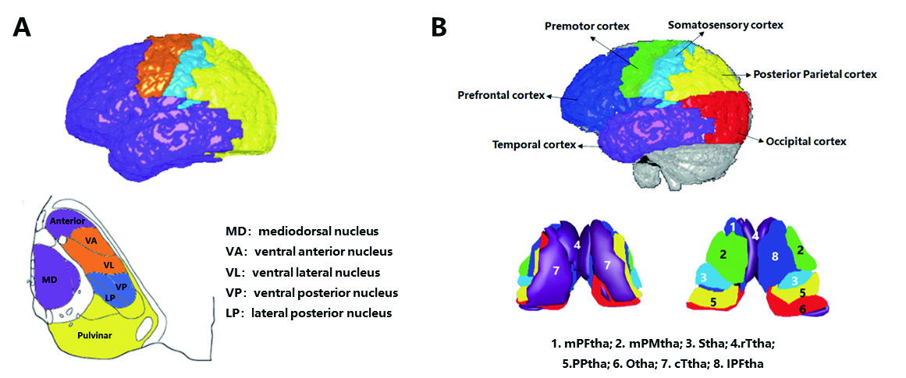
Figure S1. Thalamic subregions based on both the pattern of thalamocortical connectivity and the locations of major nuclei in histological atlas ²². Panel (A): An axial section based on a histological atlas of the human thalamus. Nuclei have been color-coded corresponding to the cortical zone that shows strongest connectivity, on the basis of previous research on non-human primates. Panel (B) showed the human Brainnetome Atlas with 16 thalamic subregions color-coded according to the cortical zone that show the strongest connectivity. The mPFtha is thought to include the ventral anterior , the mediodorsal nucleus and parts of the anterior complex that project to the prefrontal cortices; The mPMtha is thought to include the ventral lateral nucleus and ventral anterior nucleus that project to the premotor cortices; The Stha is thought to include the lateral posterior nucleus and ventral posterior nucleus , which project to the somatosensory cortices; The rTtha is thought to include parts of the anterior complex that projects to the limbic areas in the medial temporal lobe, and parts of mediodorsal nucleus which receives the inputs from the temporal lobe; The PPtha is thought to include the anterior parts of the pulvinar that projects to the posterior parietal cortices; The Otha is thought to include the lateral geniculate nucleus, parts of the inferior pulvinar and some intralaminar nuclei projecting to the occipital cortices; The cTtha is thought to include the ventral lateral and ventral posterior nucleus which connect to the premotor and somatosensory cortices, and parts of the lateral and inferior pulvinar that project to the temporal lobe; The lPFtha is thought to include mediodorsal nucleus and parts of the anterior complex that project to prefrontal cortices. mPFtha, medial pre-frontal thalamus (L: ROI01, R: ROI02); mPMtha, medial pre-motor thalamus (L: ROI03, R: ROI04); Stha, sensory thalamus (L: ROI05, R: ROI06); rTtha, rostral temporal thalamus (L: ROI07, R: ROI08); PPtha, posterior parietal thalamus (L: ROI09, R: ROI10); Otha, occipital thalamus (L: ROI11, R: ROI12); cTtha, caudal temporal thalamus (L: ROI13, R: ROI14); lPFtha, lateral pre-frontal thalamus (L: ROI15, R: ROI16).

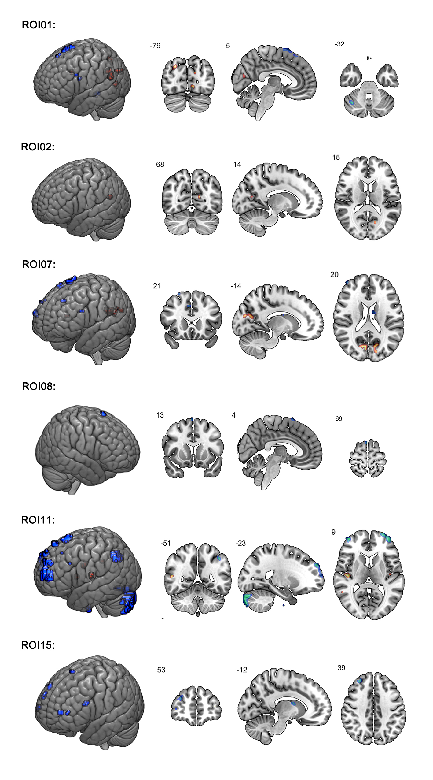
Figure S2. Regions with increased and decreased FC in thalamocortical circuit for individual ROIs overlapping between 0-back task and resting conditions in the discovery patients
There were six ROIs showing overlapping regions with abnormal FC between 0-back and rest conditions. ROI01, ROI07 and ROI11 showed regions with increased FC overlapped in the bilateral temporal cortex and occipital cortex, and regions with decreased FC overlapped in the bilateral prefrontal lobes, anterior cingulate cortex and cerebellum. ROI02 showed a region with increased FC overlapping in the left precuneus, ROI08 showed a region with decreased FC overlapping in the right middle prefrontal cortex, and ROI15 showed a region with decreased FC overlapping in the bilateral middle prefrontal cortex. Abbreviation. FC, functional connectivity.

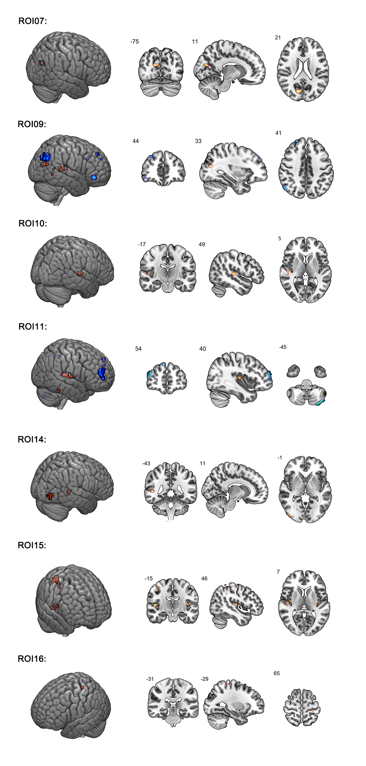
Figure S3. Regions with increased and decreased FC in thalamocortical circuit for individual ROIs overlapping between 2-back task and resting conditions in the discovery patients
There were seven ROIs showing overlapping regions with abnormal FC between 2-back and rest conditions. ROI09 and ROI11 showed regions with increased FC overlapping in the right temporal cortex and occipital cortex, and regions with decreased FC overlapping in the right prefrontal lobes and left cerebellum. ROI07, ROI10, ROI14 and ROI16 showed a region with increased FC overlapping in the right cuneus, temporal cortex, occipital cortex and the left postcentral cortex, respectively. ROI15 showed regions with increased FC overlapping in the bilateral temporal cortex and postcentral cortex. Abbreviation. FC, functional connectivity.

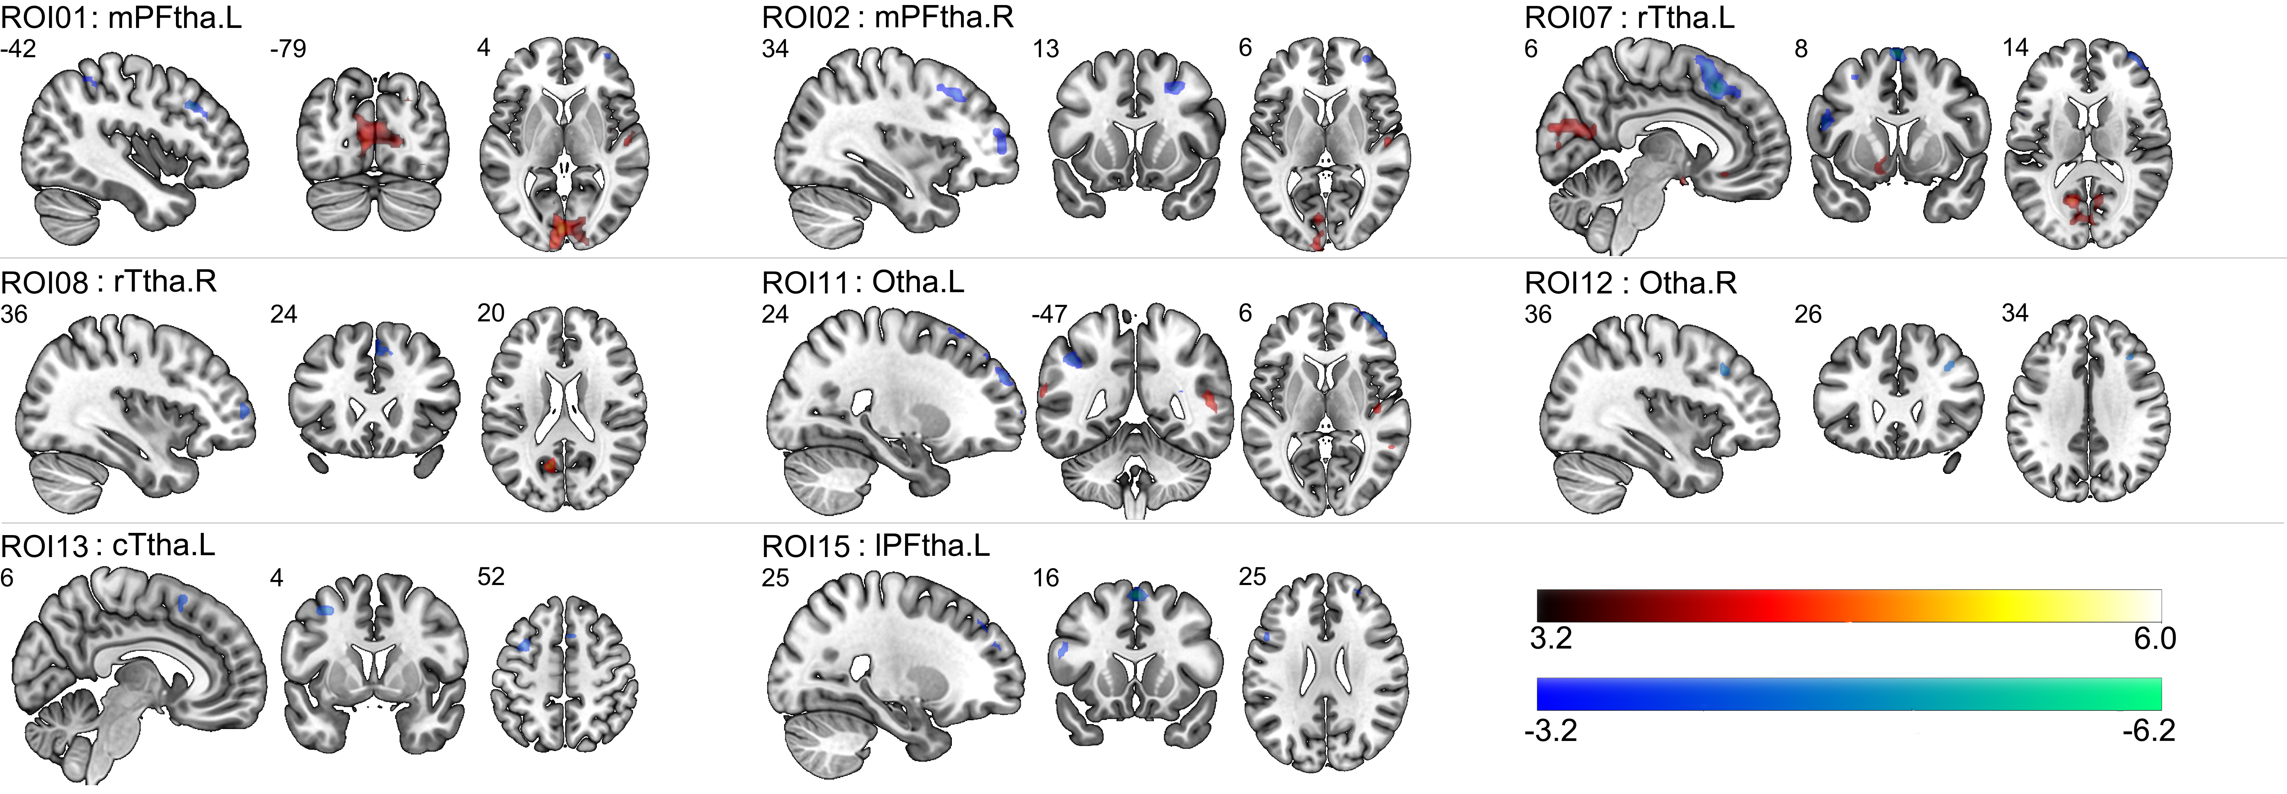
Figure S4. Abnormal thalamocortical connectivity of patients during 0-back task in the discovery sample
The brain regions showed increased (red) and decreased (blue) functional connectivity in patients compared to healthy subjects in 0-back task-state fMRI of discovery sample (P_{FDR} < .05). Decreased prefrontal-thalamic functional connectivity was observed in ROI12 (Otha.R), ROI13 (cTha.L), ROI15 (lPFtha.L), and both increased and decreased functional connectivity was observed in ROI01/02 (mPFtha.L/R), ROI07/08 (rTtha.L/R), ROI11 (Otha.L). Abbreviations. mPFtha, medial pre-frontal thalamus; rTtha, rostral temporal thalamus; Otha, occipital thalamus; cTha, caudal temporal thalamus; lPFtha, lateral pre-frontal thalamus.

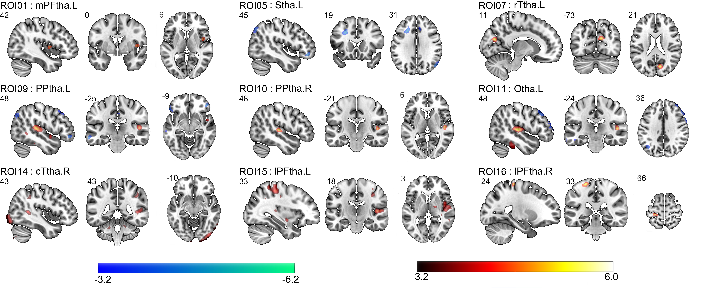
Figure S5. Abnormal thalamocortical connectivity of patients during 2-back task in the discovery sample
The brain regions showed increased (red) and decreased (blue) functional connectivity in patients compared to healthy subjects in the discovery sample for the 2-back task condition (P_{FDR} < .05). Increased sensorimotor-thalamic functional connectivity was observed in ROI01 (mPFtha.L), ROI07 (rTtha.L), ROI10 (PPtha. R), ROI14 (cTtha.R), ROI15/16 (lPFtha.L/R), while decreased prefrontal-thalamic functional connectivity was observed in the thalamic regions labeled ROI05 (Stha.L), and both increased and decreased functional connectivity was observed in ROI09 (PPtha.L), ROI11 (Otha.L). Abbreviations. mPFtha, medial pre-frontal thalamus; Stha, sensory thalamus; rTtha, rostral temporal thalamus; PPtha, posterior parietal thalamus; Otha, occipital thalamus; cTtha, caudal temporal thalamus; lPFtha, lateral pre-frontal thalamus.

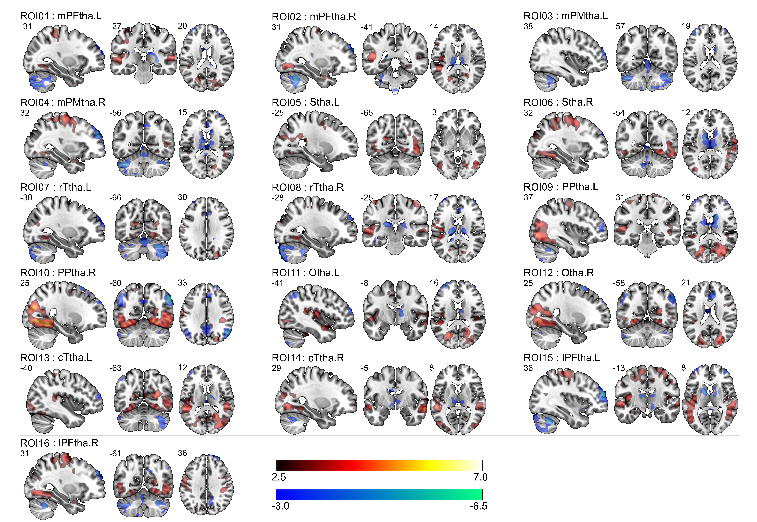
Figure S6. The figure depicts the brain regions with increased (red) and decreased (blue) functional connectivity in patients compared to healthy subjects in resting-state fMRI of discovery sample (P_{FDR} < 0.05). Increased sensorimotor-thalamic functional connectivity was observed in ROI05 (Stha.L), while decreased prefrontal-thalamic functional connectivity was observed in the thalamic regions labeled ROI03 (mPMtha.L), and both increased and decreased functional connectivity was observed in ROI01/02 (mPFtha.L/R), ROI04 (mPMtha.R), ROI06 (Stha.R), ROI07/08 (rTtha.L/R), ROI09/10 (PPtha.L/R), ROI11/12 (Otha.L/R), ROI13/14 (cTtha.L/R), ROI15/16 (lPFtha.L/R). Abbreviations. mPFtha, medial pre-frontal thalamus; mPMtha, medial pre-motor thalamus Stha, sensory thalamus; rTtha, rostral temporal thalamus; PPtha, posterior parietal thalamus; Otha, occipital thalamus; cTtha, caudal temporal thalamus; lPFtha, lateral pre-frontal thalamus.
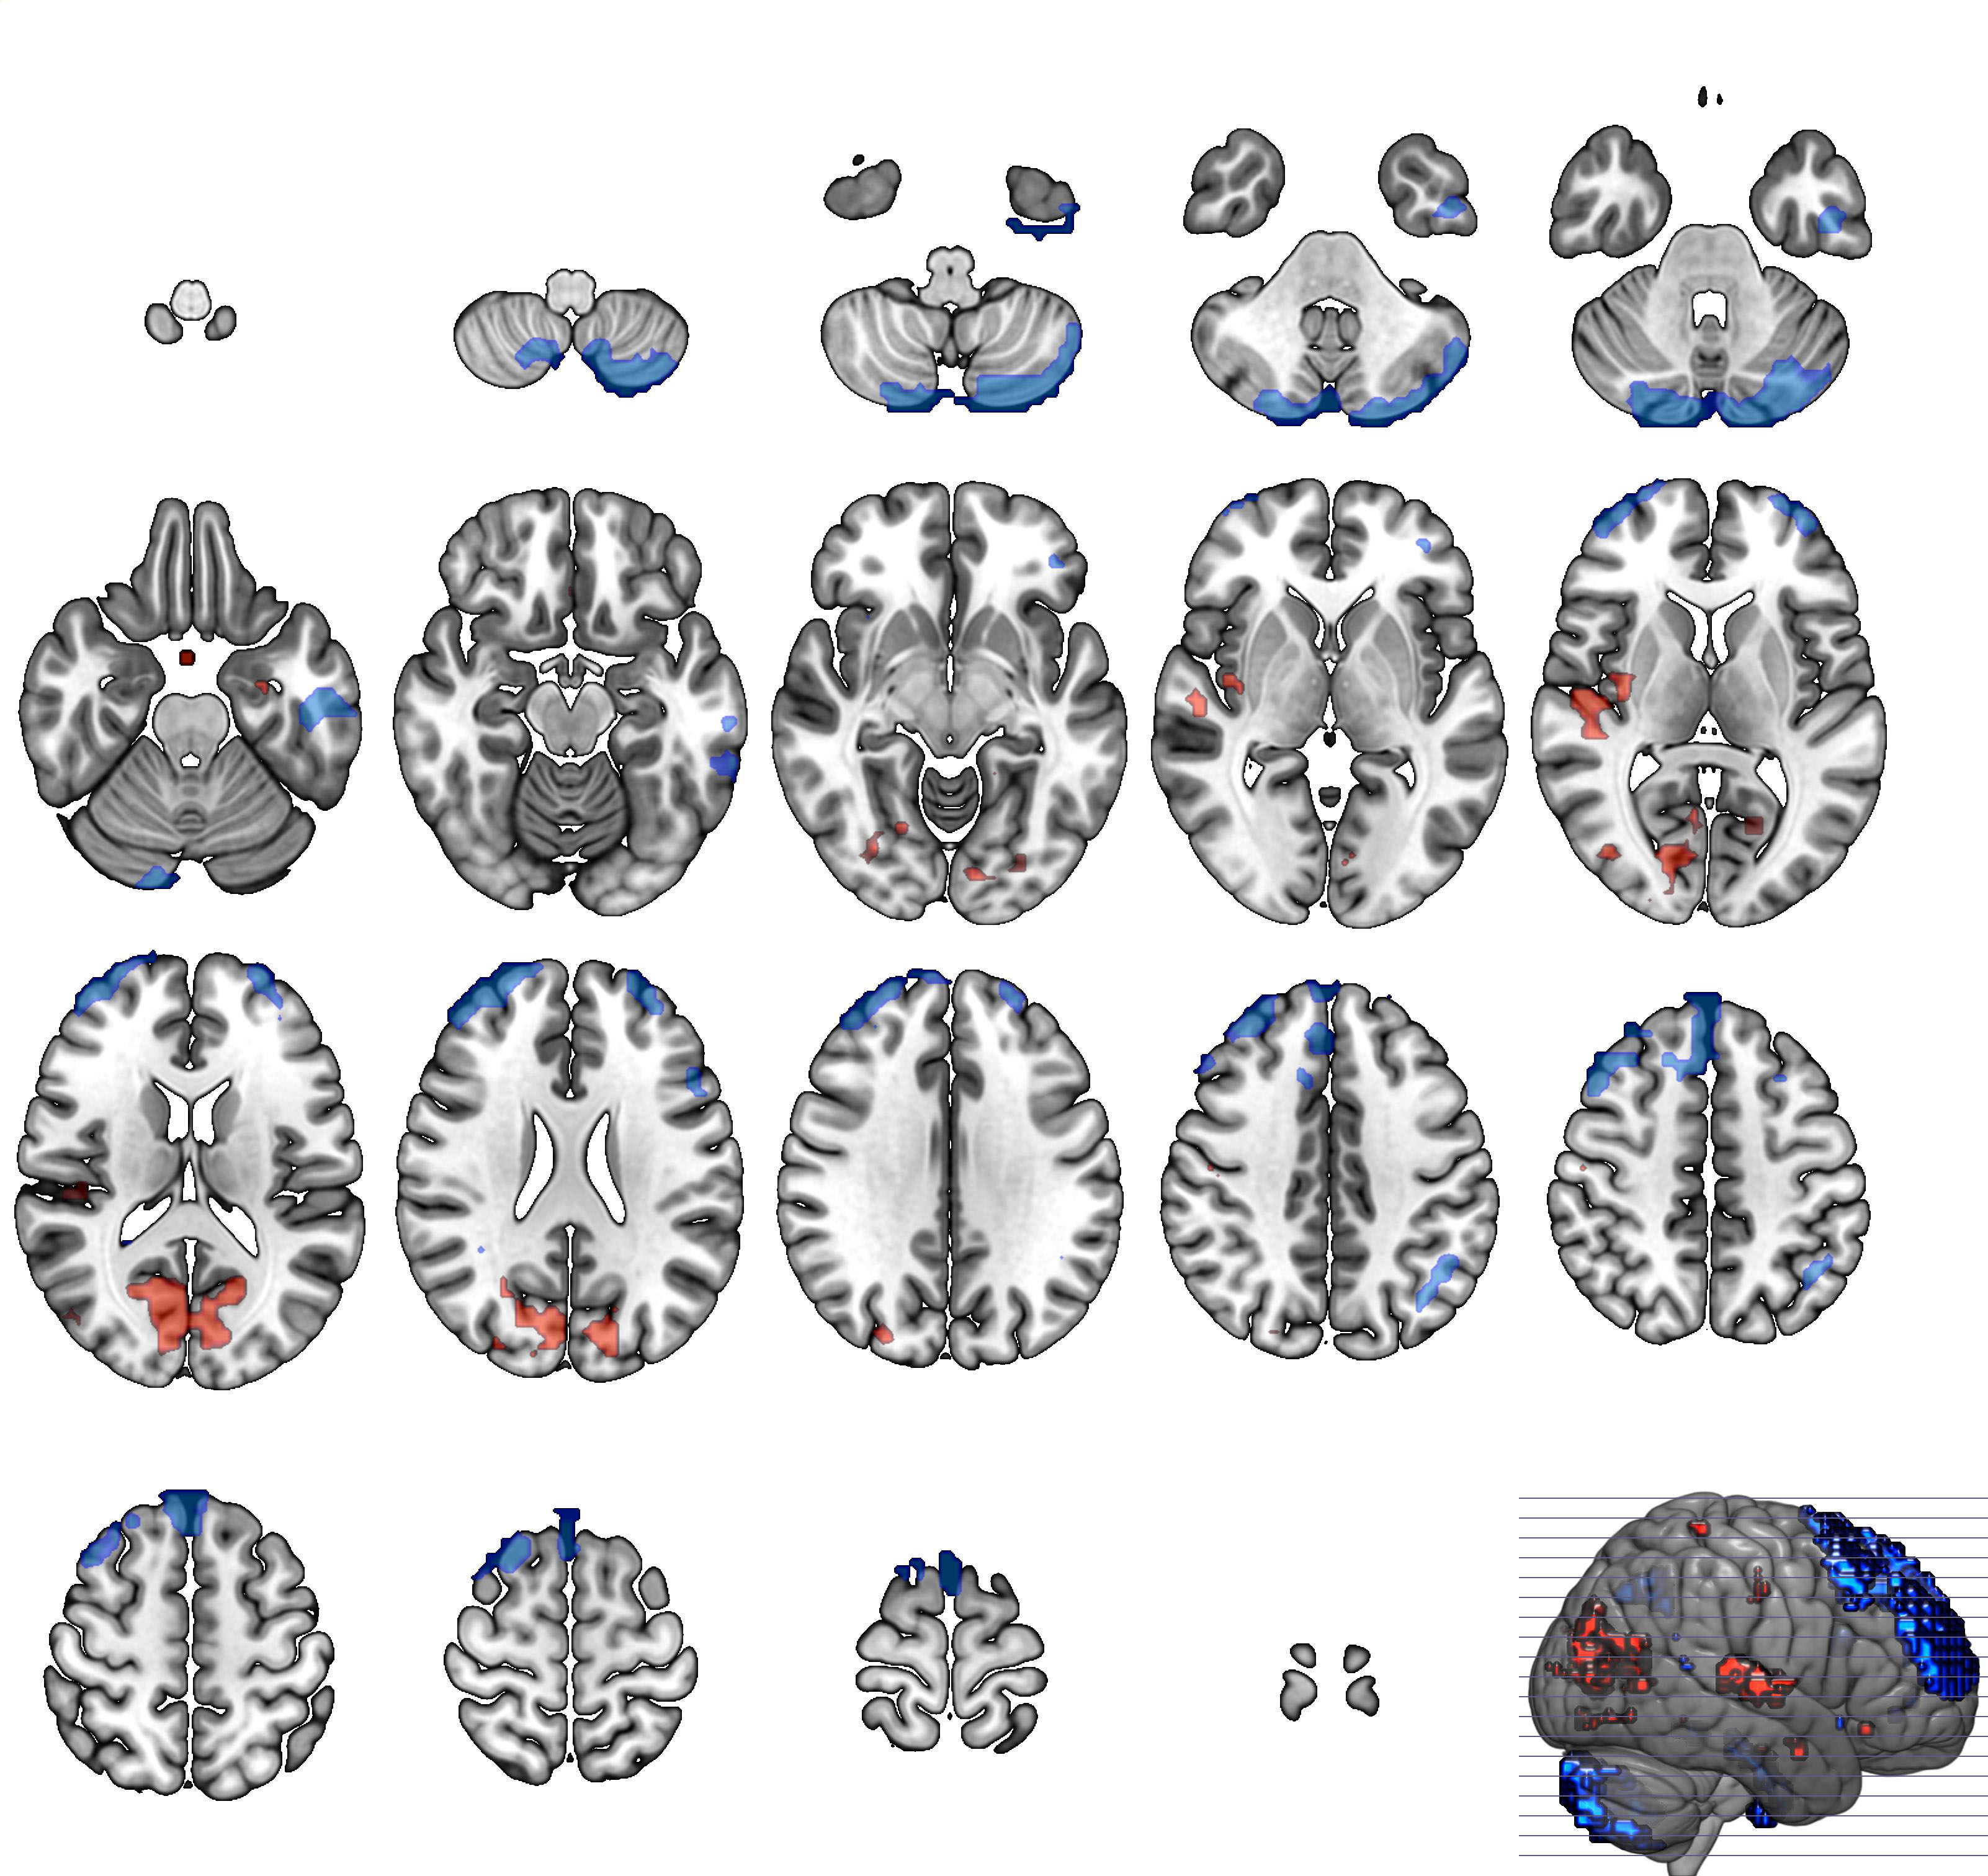
Figure S7. Regions with increased and decreased functional connectivity in thalamo-cortical circuit overlapping between 0-back task and resting states in the discovery dataset.
The regions with increased thalamic functional connectivity (red) during 0-back and rest conditions overlapped in the sensorimotor regions and those with decreased thalamic functional connectivity (blue) during the two conditions overlapped in the prefrontal, parietal, striatum and cerebellar regions.
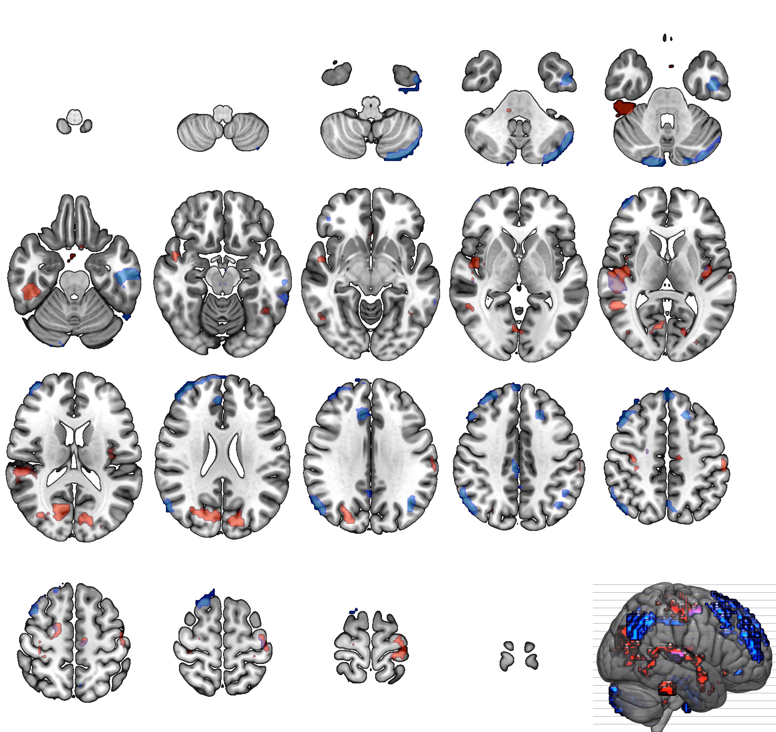
Figure S8. Regions with increased and decreased functional connectivity in thalamo-cortical circuit overlapping between 2-back task and resting states in the discovery dataset. The regions with increased thalamic functional connectivity (red) during 2-back and rest conditions overlapped in the sensorimotor regions and those with decreased thalamic functional connectivity (blue) during the two conditions overlapped in the prefrontal, parietal and cerebellar regions.

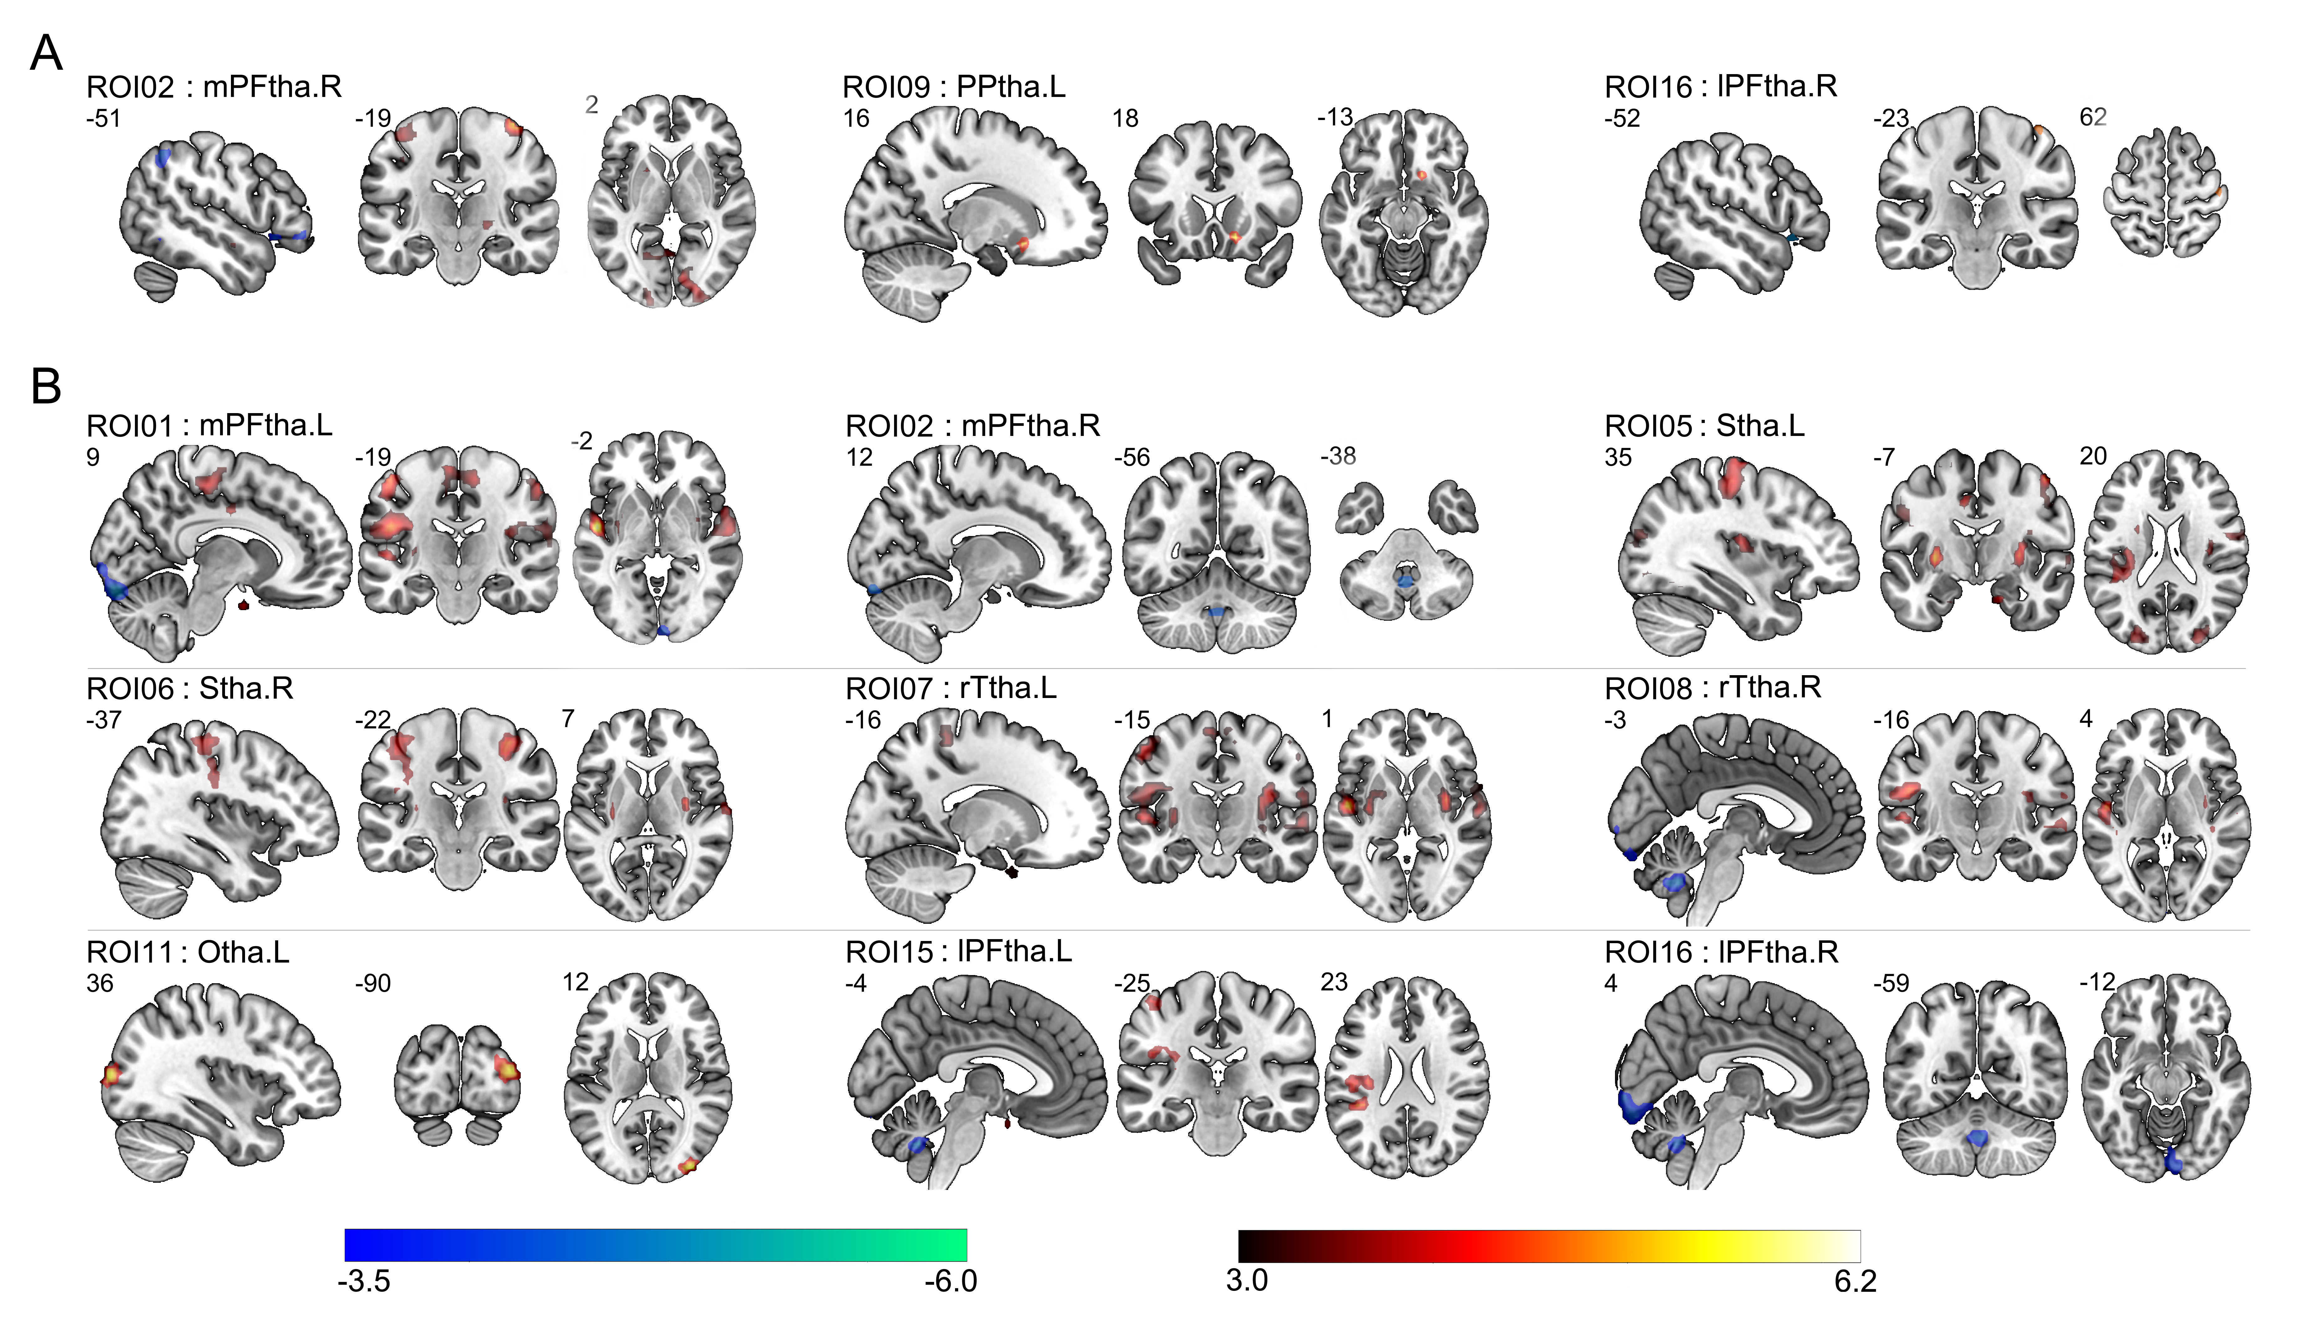
Figure S9. Abnormal thalamocortical connectivity of patients during 2-back task and resting-state in the replication sample
The figure depicts the brain regions with increased (red) and decreased (blue) functional connectivity in patients compared to healthy subjects in the replication sample. Panel A shows increased sensorimotor-thalamic functional connectivity in ROI09 (PPtha.L), while both increased and decreased functional connectivity in ROI02 (mPFtha.R) and ROI16 (lPFtha.R) for the 2-back task condition. Panel B shows increased sensorimotor-thalamic functional connectivity in ROI05/06 (Stha.L/R), ROI07 (rTtha.L), ROI11 (Otha.L), decreased prefrontal-thalamic functional connectivity in ROI02 (mPFtha.R) and ROI16 (lPFtha.R), and both increased and decreased functional connectivity in ROI01 (mPFtha.L), ROI08 (rTtha.R), ROI15 (lPFtha.L) for the resting condition. Abbreviations. mPFtha, medial pre-frontal thalamus; Stha, sensory thalamus; rTtha, rostral temporal thalamus; Otha, occipital thalamus; lPFtha, lateral pre-frontal thalamus.
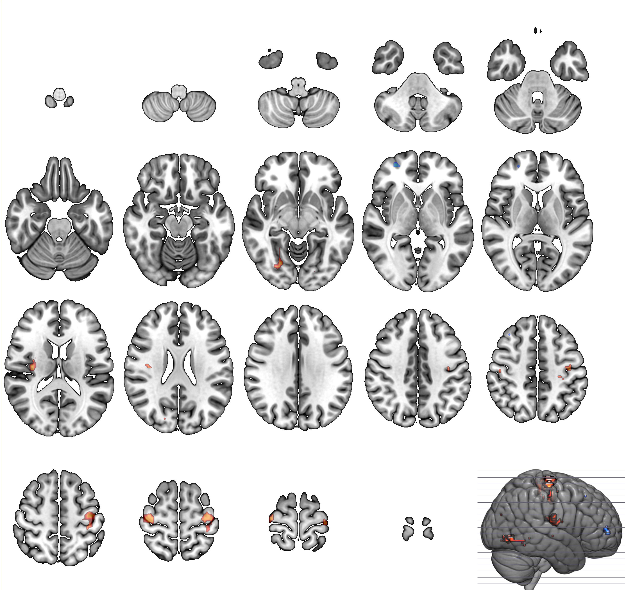
Figure S10. Regions with increased and decreased functional connectivity in thalamocortical circuit overlapping between 2-back task and resting states in the replication dataset. The regions with increased thalamic functional connectivity (red) during 2-back and rest conditions overlapped in the sensorimotor regions and those with decreased thalamic functional connectivity (blue) during the two conditions overlapped in the prefrontal regions.

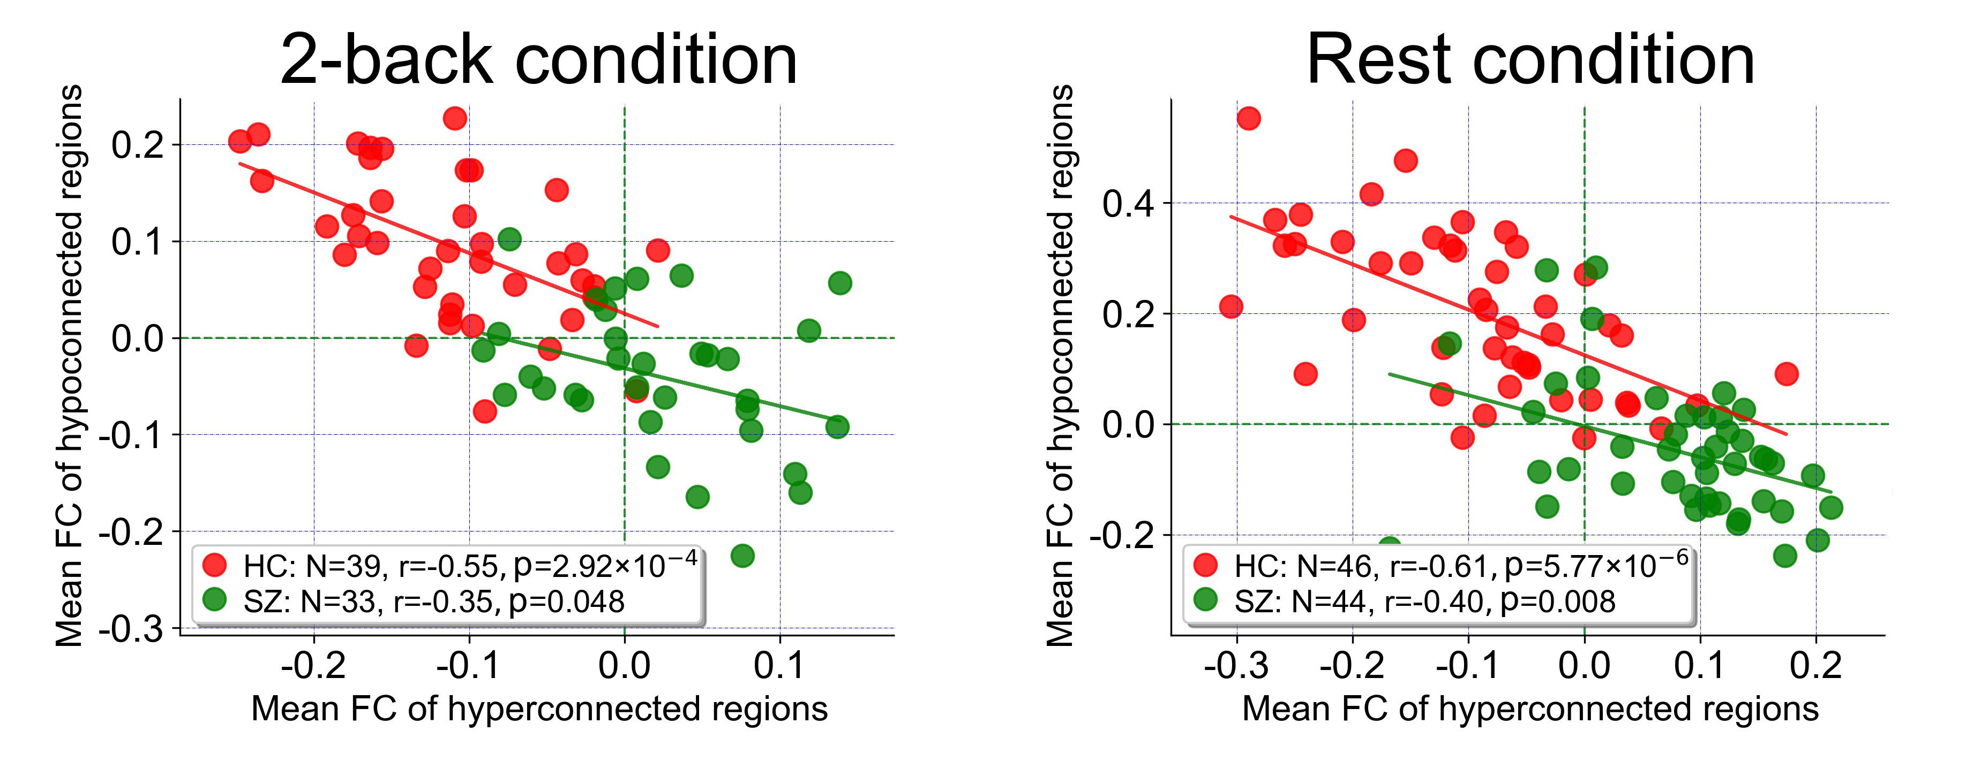
Figure S11. Correlations between mean hyperconnectivity and hypoconnectivity in the replication sample
In the replication sample, a significant negative linear relationship was evident across all schizophrenia patients (red data points) and healthy subjects (green data points) during 2-back and resting conditions. Vertical/horizontal green lines mark the zero points. Abbreviation. FC, functional connectivity.

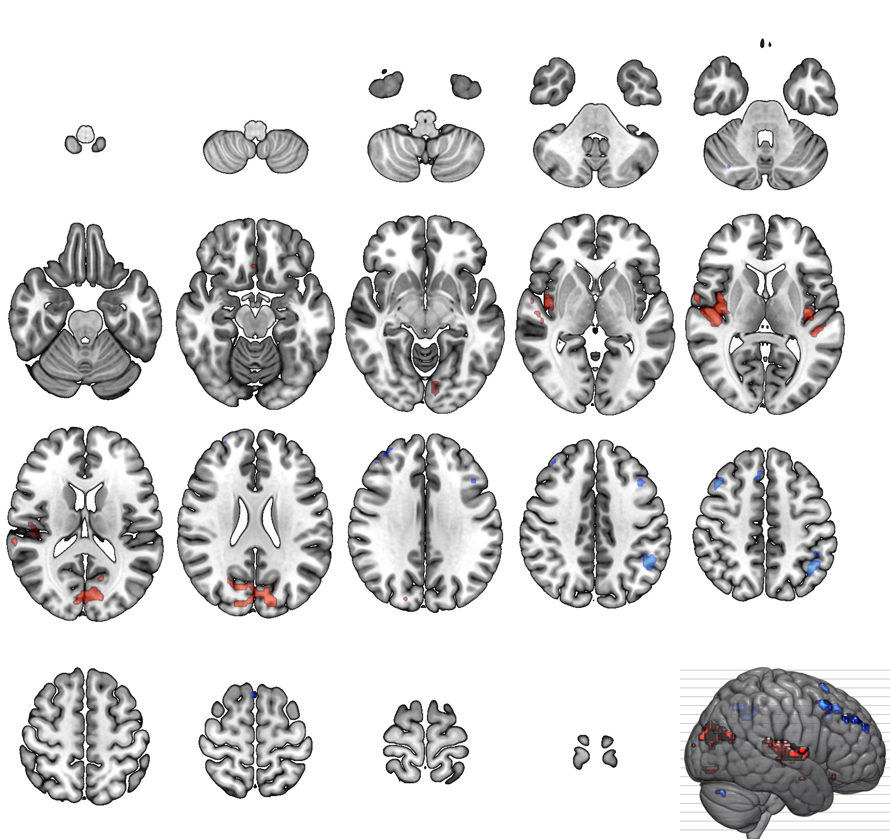
Figure S12. Regions with increased and decreased functional connectivity in thalamo-cortical circuit overlapping between 0-back task and resting states in the patients with head displacement less than 2mm/2°of discovery dataset. The regions with increased thalamic functional connectivity (red) during 0-back and rest conditions overlapped in the sensorimotor regions and those with decreased thalamic functional connectivity (blue) during the two conditions overlapped in the prefrontal, parietal, striatum and cerebellar regions.
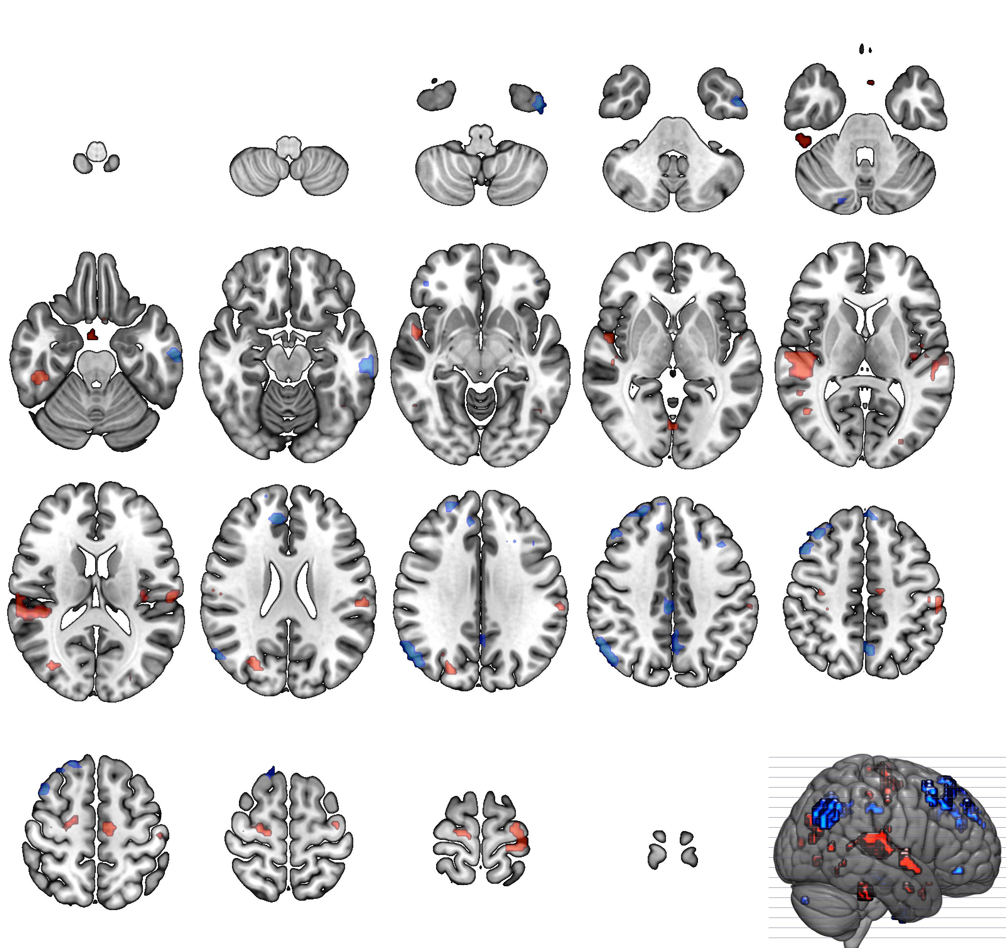
Figure S13. Regions with increased and decreased functional connectivity in thalamo-cortical circuit overlapping between 2-back task and resting states in the patients with head displacement less than 2mm/2°of discovery dataset. The regions with increased thalamic functional connectivity (red) during 0-back and rest conditions overlapped in the sensorimotor regions and those with decreased thalamic functional connectivity (blue) during the two conditions overlapped in the prefrontal, parietal, striatum and cerebellar regions.

References
1. First MB, Gibbon M, Spitzer RL, Williams JBW, Benjamin LS. Structured clinical interview for DSM-IV axis II personality disorders, (SCID-II). Washington, DC: American Psychiatric Association 1996.
2. Andreasen NC, Pressler M, Nopoulos P, Miller D, Ho BC. Antipsychotic dose equivalents and dose-years: a standardized method for comparing exposure to different drugs. Biol Psychiatry 2010;67:255-262.
3. Zhou L, Pu W, Wang J, et al. Inefficient DMN Suppression in Schizophrenia Patients with Impaired Cognitive Function but not Patients with Preserved Cognitive Function. Sci Rep 2016;6:21657.
4. Wu G, Wang Y, Mwansisya TE, et al. Effective connectivity of the posterior cingulate and medial prefrontal cortices relates to working memory impairment in schizophrenic and bipolar patients. Schizophr Res 2014;158:85-90.
5. Pu W, Li L, Zhang H, et al. Morphological and functional abnormalities of salience network in the early-stage of paranoid schizophrenia. Schizophr Res 2012;141:15-21.
6. Yan C, Zang Y. DPARSF: a MATLAB toolbox for “pipeline” data analysis of resting-state fMRI. Front Syst Neurosci 2010;4:13.
7. Dipasquale O, Sethi A, Lagana MM, et al. Comparing resting state fMRI de-noising approaches using multi- and single-echo acquisitions. PloS one 2017;12:e0173289.
8. Jenkinson M, Bannister P, Brady M, Smith S. Improved Optimization for the Robust and Accurate Linear Registration and Motion Correction of Brain Images. Neuroimage 2002;17:825-841.
9. Power JD, Plitt M, Laumann TO, Martin A. Sources and implications of whole-brain fMRI signals in humans. Neuroimage 2017;146:609-625.
10. Murphy K, Fox MD. Towards a consensus regarding global signal regression for resting state functional connectivity MRI. Neuroimage 2017;154:169-173.
11. Anticevic A, Haut K, Murray JD, et al. Association of Thalamic Dysconnectivity and Conversion to Psychosis in Youth and Young Adults at Elevated Clinical Risk. JAMA Psychiatr 2015;72:882.
12. Cole MW, Bassett DS, Power JD, Braver TS, Petersen SE. Intrinsic and task-evoked network architectures of the human brain. Neuron 2014;83:238-251.
13. Elliott ML, Knodt AR, Cooke M, et al. General functional connectivity: Shared features of resting-state and task fMRI drive reliable and heritable individual differences in functional brain networks. Neuroimage 2019;189:516-532.
14. Woodward ND, Karbasforoushan H, Heckers S. Thalamocortical dysconnectivity in schizophrenia. Am J Psychiatry 2012;169:1092-1099.
15. Jones EG. The Thalamus, 2nd ed. Cambridge University Press, Cambridge, United Kingdom 2007.
16. Yuan R, Di X, Taylor PA, Gohel S, Tsai YH, Biswal BB. Functional topography of the thalamocortical system in human. Brain structure & function 2016;221:1971-1984.
17. Sim K, Cullen T, Ongur D, Heckers S. Testing models of thalamic dysfunction in schizophrenia using neuroimaging. J Nneural Transm 2006;113:907-928.
18. Andrews J, Wang L, Csernansky J, Gado M, Barch D. Abnormalities of thalamic activation and cognition in schizophrenia. Am J Psychiatry 2006;163:463-469.
19. Woodward N, Heckers S. Mapping Thalamocortical Functional Connectivity in Chronic and Early Stages of Psychotic Disorders. Biol Psychiatry 2016;79:1016-1025.
20. Zhang M, Palaniyappan L, Deng M, et al. Abnormal Thalamocortical Circuit in Adolescents With Early-Onset Schizophrenia. J Am Acad Child Adolesc Psychiatry 2021;60:479-489.
21. Fan L, Li H, Zhuo J, et al. The Human Brainnetome Atlas: A New Brain Atlas Based on Connectional Architecture. Cereb Cortex 2016;26:3508-3526.
22. Xi C, Liu ZN, Yang J, et al. Schizophrenia patients and their healthy siblings share decreased prefronto-thalamic connectivity but not increased sensorimotor-thalamic connectivity. Schizophr Res 2020;222:354-361.

