Supplement
S1: Quality Assessment Tool for Quantitative Studies (Adapted version)
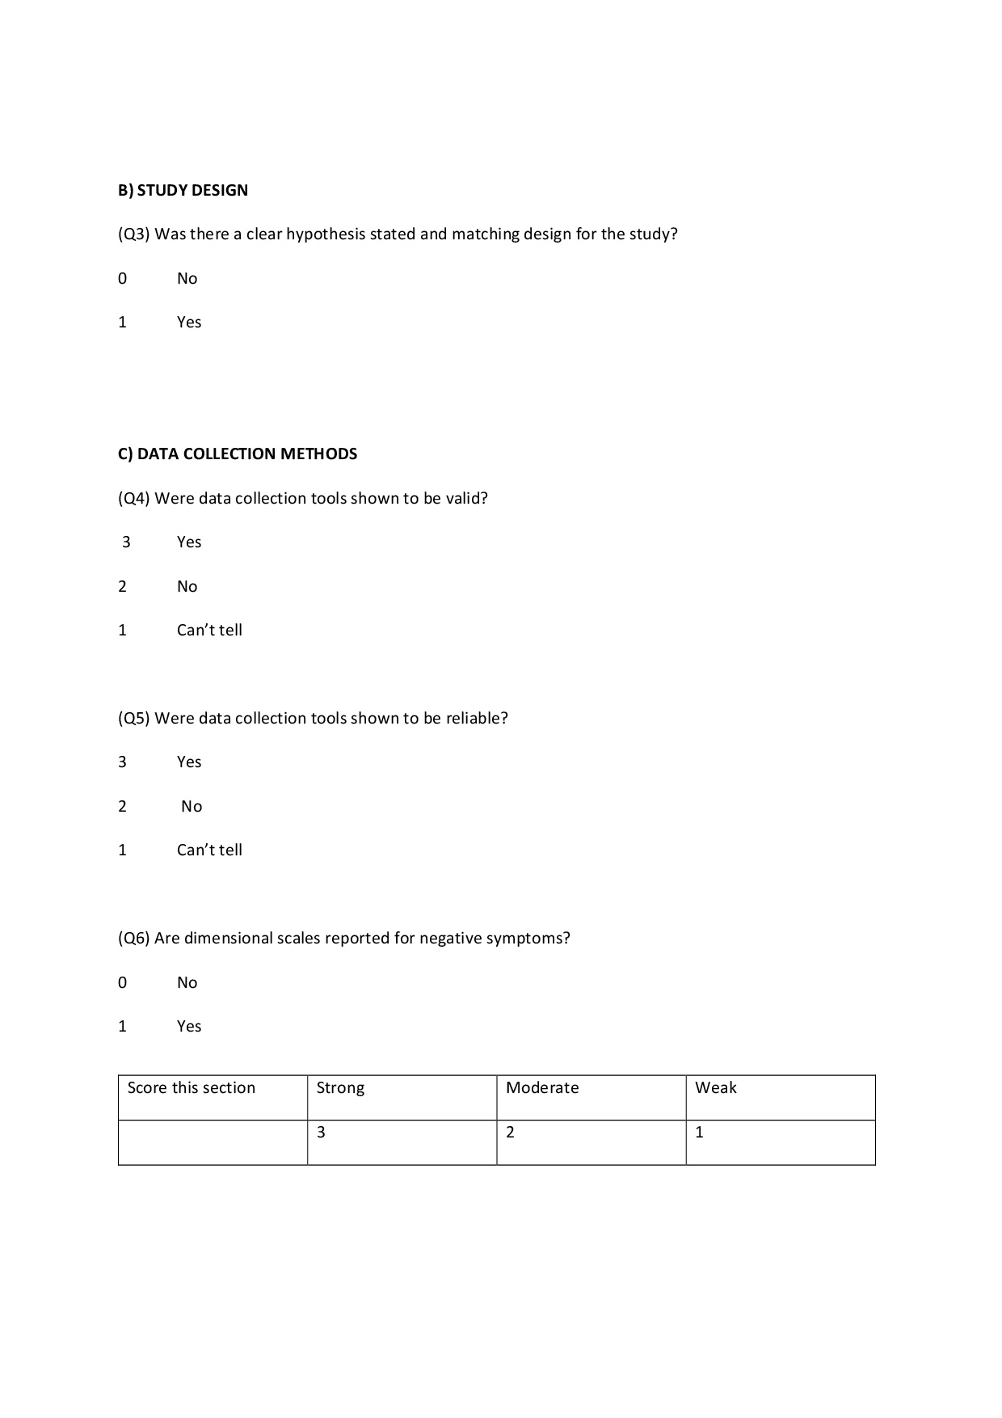
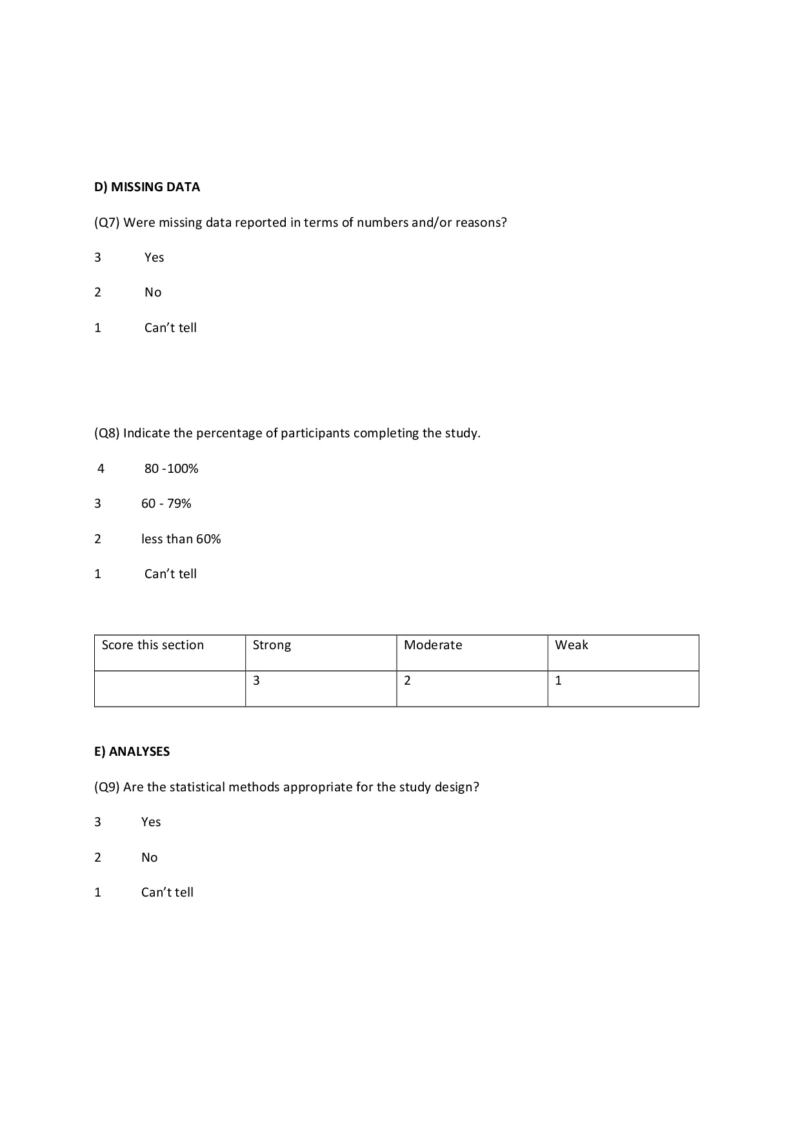
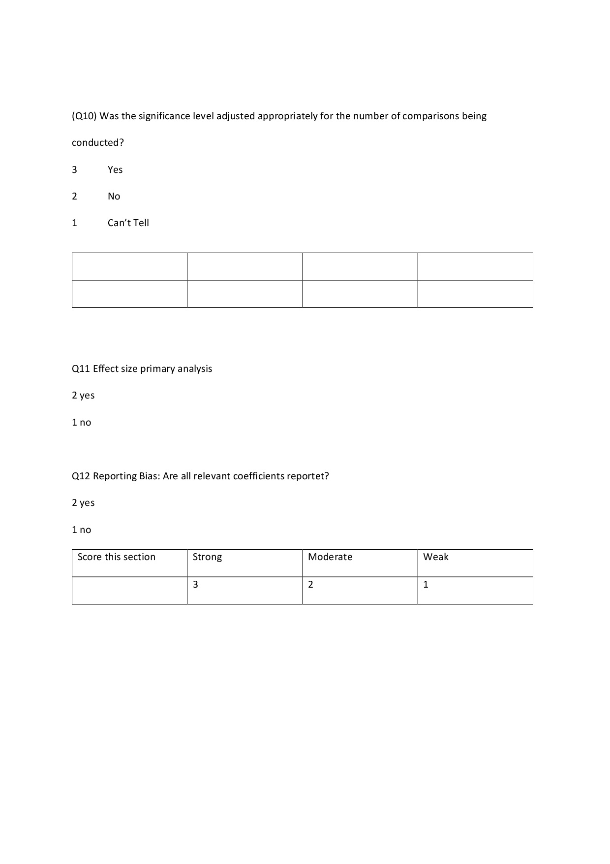
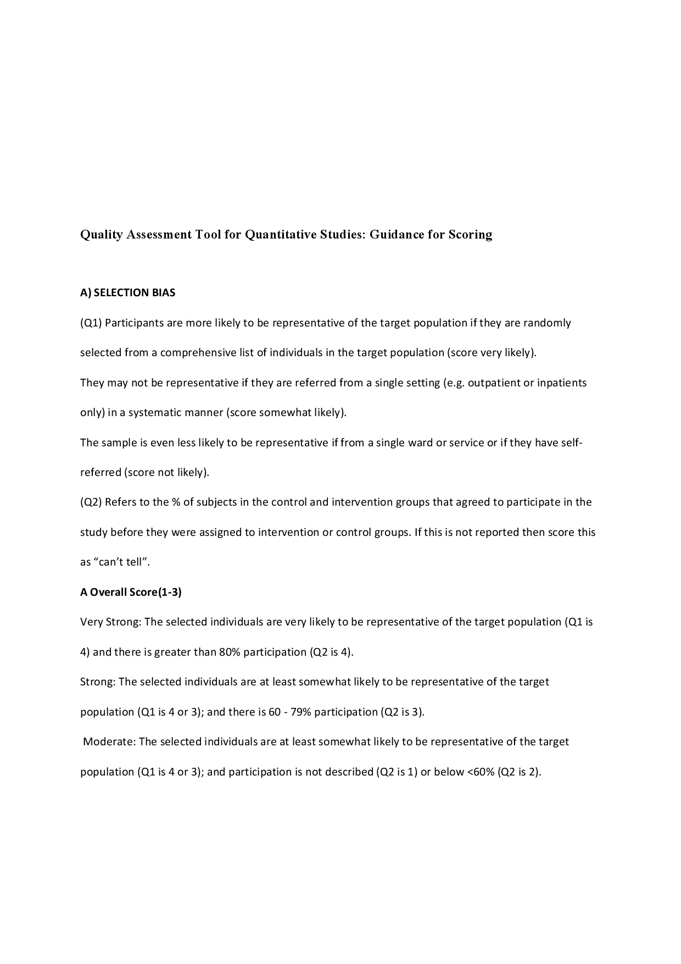
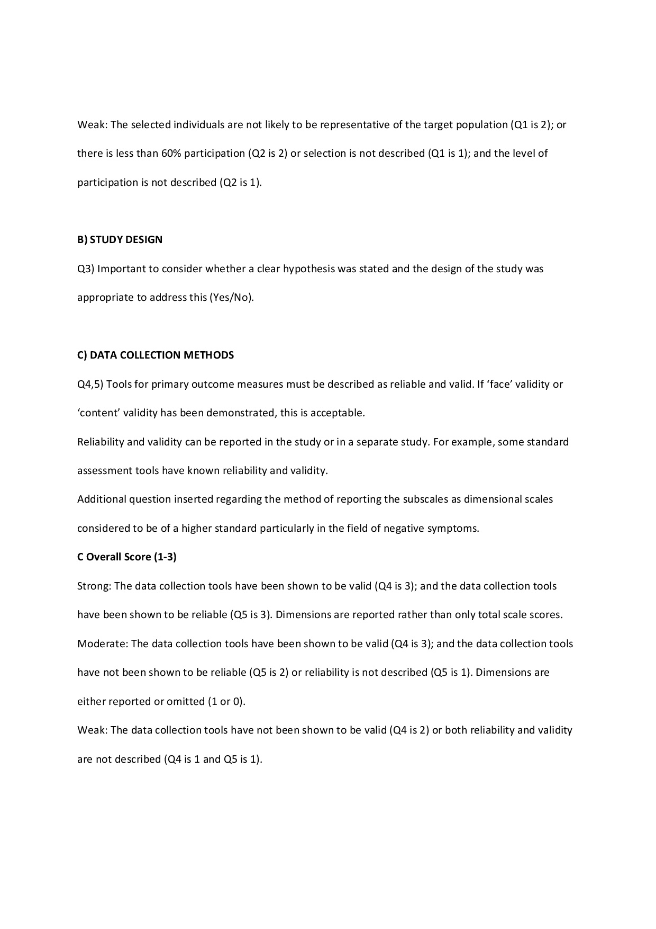
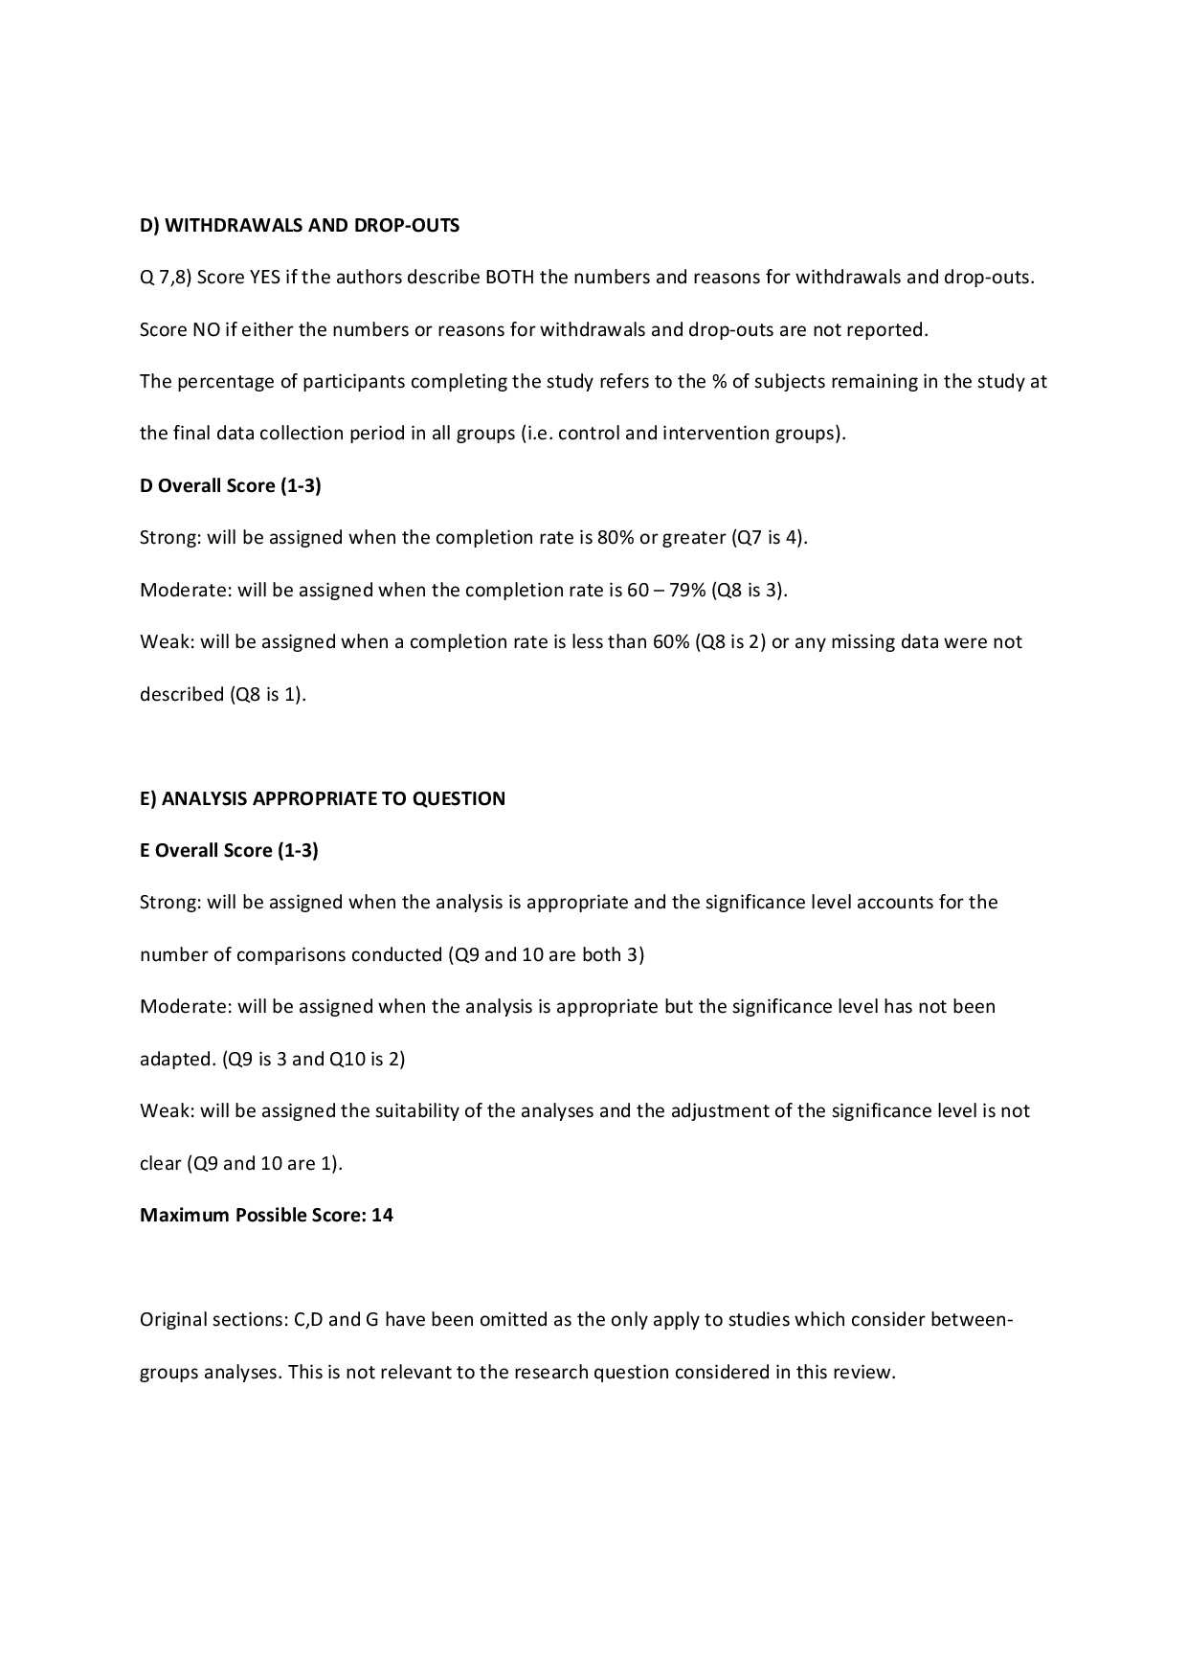
S3: Table of study characteristics and measurement information

Study | Fisher’s z transformed effect size ($V_{z}$) |  | Data points synthesized in main ES |  | Coefficient type reported in studies; significance statistics (α) |  | n [% female] | Mean age (SD) | Diagnosis (%) | Years of education  M (SD) | CPZ equivalents in mg/day M (SD) | Positive symptoms  M (SD) [Scale] | Depressive symptoms M (SD) [Scale] | Negative symptoms  M (SD)  [Scale] | Memory test | Study quality
Addington & Addington (1999) | -0.26 (0.01) |  | 2 |  | 𝑟; .05, two-tailed |  | 80 [32.5] | 36.0 (9.5) | SZ: 100 | 12.0 (1.7) | 510.0 (nr) | 13.6 (5.7) [PANSS] | nr | 16.75 (6.25)${[PANSS]}^{c}$ | WMS-R, ROCFT | 14
Addington et al. (1991) | -0.13 (0.03) |  | 5 |  | 𝑟; .05, two-${tailed}^{a}$ |  | 38 [34.2] | 30.9 (8.7) | SZ: 100 | 11.5 (nr) | nr | nr | nr | nr  $${[SANS]}^{e}$$ | WMS, ROCFT | 10
Bagney et al. (2015) | -0.16 (0.01) |  | 2 |  | 𝑟; .05, two-${tailed}^{a}$ |  | 80 [33.8] | 41.6 (8.0) | SZ: 100 | 11.1 (3.7) | 576.1 (541.6) | 9.4 (3.8) [PANSS] | 7.5 (2.6) [PANSS] | 16.9 (6.6)  $${[PANSS]}^{d}$$ | HVLT-R, BVMT-R | 12
Balogh et al. (2015) | -0.61 (0.03) |  | 2 |  | ρ; .05, two-${tailed}^{a}$ |  | 42 [42.9] | 39.0 (10.0) | SZ: 100 | 13.7 (nr) | nr | 21.8 (4.8) [PANSS] | nr | 23.5 (5.6)  $${[PANSS]}^{c}$$ | CANTAB | 10
Basso et al. (1998) | -0.42 (0.02) |  | 2 |  | 𝑟; .01, two-${tailed}^{a}$ |  | 62 [27.4] | 32.3 (7.3) | SZ: 100 | 13.7 (2.2) | 626.6 (746) | 2.1 (1.7) [SAPS] | nr | 2.05 (1.43)  $${[SANS]}^{f}$$ | WMS-R | 15
Bell & Mishara (2006) | -0.08 (0.01) |  | 7 |  | 𝑟; .001, two-${tailed}^{a}$ |  | 267 [12.7] | 43.1 (8.7) | SZ: nr  SZA: nr | 12.9 (2.0) | 601.3 (503.9) | 17.7 (5.7) [PANSS] | nr | 18.3 (5.8)  $${[PANSS]}^{d}$$  $${SANS}^{e,h}$$ | HVLT, WMS-R | 14
Berenbaum et al. (2008) | -0.10 (0.02) |  | 1 |  | ρ; .05, two-${tailed}^{a}$ |  | 47 [36.2] | 40.3 (9.1) | SZ: 83.0  SZA: 17.0 | 12.0 (8.2) | 576.7 (585.8) | nr | nr | 1,5 (1,8)  $${[SANS]}^{g}$$ | WMS-R, Face Recognition Task | 11
Berman et al. (1997) | 0.17  (0.04) |  | 2 |  | 𝑟; .05, two-tailed |  | 30 [3.3] | 50.6 (11.1) | SZ: 100 | 12.3 (1.7) | 684.0 (279.8) | 20.9 (5.9) [PANSS] | nr | 21.8 (4.6)  $${[PANSS]}^{c}$$ | WMS-R | 13
Bilder et al. (2007) | -0.23 (0.01) |  | 4 |  | 𝑟; .05, two-tailed |  | 94 [41.5] | 25.7 (6.3) | SZ: 74.5  SZA: 25.5 | 13.1 (2.3) | 712.0 (730.0) | nr | nr | nr  $${[SANS]}^{f}$$ | WMS-R, CVLT, ROCFT | 12
Bismarck et al. (2018) | -0.21 (0.03) |  | 2 |  | 𝑟; .0024, two-${tailed}^{a}$ |  | 36 [47.2] | 36.7 (12.5) | SZ: 100 | 12.0 (2.1) | nr | 5.3 (4.7) [SAPS] | nr | 6.42 (4.1)  $${[SANS]}^{e}$$ | HVLT-R, BVMT-R | 11
Bodapati et al. (2019) | -0.26 (0.03) |  | 4 |  | 𝑟; .05,  two-tailed |  | 38 [47.4] | 39.5 (12.9) | SZ: 100 | nr | nr | 15.9 (3.8) [PANSS] | 14.7 (2.8)  [PANSS] | 38.0 (9.23)  [CAS] | HVLT-R, BVMT-R | 11
Boeker et al. (2006) | -0.43 (0.05) |  | 1 |  | 𝑟; .05, two-tailed |  | 22 [50.0] | 29.7 (4.5) | SZ: 100 | 11.2 (1.3) | 924.1 (218.6) | nr | nr | nr  $${[SANS]}^{g}$$ | WMS-R | 10
Bozikas et al. (2004) | -0.30 (0.02) |  | 7 |  | 𝑟; .01,  one-tailed |  | 53 [29.3] | 37.5 (10.6) | SZ: 100 | 10.4 (3.3) | nr | 16.4 (6.0) [PANSS] | 4.7 (2.0) [PANSS] | 16.83  (6.0)  $${[PANSS]}^{d}$$ | CVLT, ROCFT | 11
Brazo et al. (2002) | -0.51 (0.04) |  | 3 |  | $r^{b}$; .05, two-tailed |  | 26 [20.0] | 36.1 (10.5) | SZ: 100 | nr | 414.8 (401.3) | nr | nr | nr  SDS | CVLT | 10
Bryson et al. (2001) | -0.12 (0.01) |  | 5 |  | $r^{b};$ .05, two-${tailed}^{a}$ |  | 90 [7.8] | 41.3 (8.4) | SZ: 100 | 12.3 (1.6) | 740.3 (nr) | 17.9 (5.9) [PANSS] | nr | 18.15 (4.64)  $${[PANSS]}^{d} \\ {SDS}^{h}$$ | HVLT, WMS-R | 11
Buchanan et al. (1994) a | -0.20 (0.03) |  | 3 |  | $r^{b}$; .05, two-${tailed}^{a}$ |  | 39 [17.9] | 33.7 (6.2) | SZ: 100 | 12.1 (2.2) | nr | 6.7 (3.2) [BPRS] | nr | nr  [SDS] | WMS-R | 10
Buchanan et al. (1994) b | -0.46 (0.03) |  | 1 |  | 𝑟; .05, two-${tailed}^{a}$ |  | 33 [15.1] | 33.9 (6.5) | SZ: 100 | nr | nr | 11.4 (5.2) [BPRS] | nr | 44.45 (17.1)  $${[SANS]}^{g}$$ | WMS-R | 9
Cammisuli et al. (2016) | 0.65  (0.04) |  | 2 |  | ρ; .01, two-${tailed}^{a}$ |  | 30 [26.7] | 42.9 (10.8) | SZ: 100 | 10.6 (2.8) | nr | nr | nr | 20.5 (9.7)  $${[PANSS]}^{c}$$ | WMS-IV | 8
Cascella et al. (2008) | -0.12 (0.01) |  | 4 |  | $r^{b}$; .05, two-${tailed}^{a}$ |  | 105 [31.4] | 38.3 (11.3) | SZ: 100 | 11.9 (2.3) | nr | 4.7 (3.7) [SAPS] | nr | 8.7 (3.43)  $${[SANS]}^{g}$$  $${SDS}^{h}$$ | HVLT-R, BVMT-R | 10
Chan et al. (2015) | -0.15 (0.01) |  | 4 |  | $r^{b}$; ${.05}^{a}$ two-${tailed}^{a}$ |  | 145 [52.4] | 21.8 (3.8) | SZ: 100 | 11.9 (2.2) | nr | 11.3 (5.1) [PANSS] | nr | 11.94 (3.85)  $${[PANSS]}^{g}$$  $${SDS}^{h}$$ | WMS-R | 8
Chang et al. (2013) | -0.37 (0.01) |  | 2 |  | 𝑟; .05, two-tailed |  | 84 [57.1] | 31.5 (9.5) | SZ: 79.8  SZA: 5.9  SZf: 14.3 | 10.5 (2.9) | 179.4 (405.5) | 19.9 (5.4) [PANSS] | nr | 10.75 (9.64) [HEN] | WMS-R | 10
Chang et al. (2014) | -0.24 (0.01) |  | 8 |  | 𝑟; .0083, two-${tailed}^{a}$ |  | 93 [54.8] | 31.2 (9.6) | SZ: 80.6  SZA: 5.4  SZf: 14.0 | 10.5 (2.9) | nr | nr | nr | nr  [HEN] | WMS-R | 14
Chang et al. (2016) | -0.10 (0.003) |  | 2 |  | 𝑟; .05, two-${tailed}^{a}$ |  | 321 [55.8] | 38.3 (8.4) | SZ: 43.6  SZA: 0.9  SZf: 18.1  Other: 37.4 | 10.8 (3.8) | nr | 9.1 (3.6) [PANSS] | nr | 6.22 (9.26)  $${[SANS]}^{f}$$ | WMS-R | 13
Chen et al. (1996) | -0.14 (0.01) |  | 3 |  | 𝑟; .05, two-${tailed}^{a}$ |  | 175 [40.2] | 40.5 (12.2) | SZ: 100 | nr | 940.0 (1007.0) | nr | nr | nr  [HEN] | WMS-R | 10
Chen et al. (2014) | -0.14 (0.04) |  | 8 |  | ρ; .05 two-${tailed}^{a}$ |  | 157 [49.7] | 28.8 (7.5) | SZ: 100 | 13.8 (2.7) | nr | 15.5 (4.9) [PANSS] | nr | 15.78 (5.38)  $${[PANSS]}^{c}$$ | ISLT, CPAL | 10
Chkonia & Tsverava (2007) | -0.45 (0.06) |  | 6 |  | 𝑟; .05, two-${tailed}^{a}$ |  | 20 [50.0] | 34.2 (9.2) | SZ: 100 | 13.6 (2.6) | nr | nr | nr | nr  $${[SANS]}^{g}$$ | CVLT | 10
Cohen et al. (2007) | -0.19 (0.02) |  | 5 |  | $r^{b};$ .05, two-${tailed}^{a}$ |  | 45 [13.3] | 39.6 (6.2) | SZ: 100 | 12.1 (2.2) | nr | 9.8 (4.9) [BPRS] | nr | 7.47 (2.45) [BPRS]  $${SDS}^{h}$$ | WMS-R | 12
Dorofeikova et al. (2018) | -0.31 (0.01) |  | 1 |  | 𝑟; .05, two-${tailed}^{a}$ |  | 125 [41.6] | 35.8 (9.9) | SZ: 100 | nr | nr | nr | 2.9 (5.2) [MADRS] | nr  $${[PANSS]}^{c}$$ | ROCFT | 7
Eckman et al. (2000) | -0.07 (0.02) |  | 1 |  | 𝑟; .001, two-${tailed}^{a}$ |  | 51 [37.7] | 40.9 (9.5) | SZ: 100 | 11.1 (2.4) | 660.0 (378.3) | nr | nr | nr  $${[SANS]}^{f}$$ | WMS-R | 11
Ehmann et al. (2004) | -0.02 (0.05) |  | 4 |  | 𝑟; .01, two-${tailed}^{a}$ |  | 37 [13.5] | 30.0 (8.8) | SZ: 75.7  SZA: 24.3 | 11.2 (2.0) | nr | 20.4 (6.2) [PANSS] | nr | 22.73 (7.27)  $${[PANSS]}^{d}$$ | WMS-R | 10
Faerden et al. (2009) | -0.16 (0.02) |  | 2 |  | 𝑟; .03, two-tailed |  | 71 [52.1] | 27.4 (8.1) | SZ: 50.7  SZA: 21.1  Other: 28.2 | 12.5 (2.7) | nr | 14.4 (5.1) [PANSS] | 6.4 (4.5) [CDSS] | 27.2 (7.1)  [AES-C] | CVLT-II, ROCFT | 12
Fonseca et al. (2017) | 0.02  (0.01) |  | 2 |  | 𝑟; .05,  two-tailed |  | 99 [52.1] | 37.6 (10.3) | SZ: 100 | 10.7 (3.7) | nr | 13.2 (4.7) [PANSS] | nr | 17.58 (6.92)  $${[PANSS]}^{c}$$ | HVLT-R, BVMT-R | 14
Foussias et al. (2015) | -0.31 (0.02) |  | 1 |  | 𝑟; .05, two-${tailed}^{a}$ |  | 69 [30.4] | 38.0 (10.3) | SZ: 76.8  SZA: 23.2 | nr | 458.2 (258.2) | 11.8 (11.8) [SAPS] | 2.5 (3.0) [CDSS] | 24.4 (17.3)  $${[SANS]}^{g}$$ | BACS | 12
Frydecka et al. (2016) | -0.35 (0.01) |  | 3 |  | 𝑟; .05, two-${tailed}^{a}$ |  | 85 [58.8] | 36.5 (10.8) | SZ: 100 | 13.4 (2.8) | 488.5 (306.5) | 21.4 (7.3)  [PANSS] | 1.6 (1) [PANSS] | 24.41 (18.9)  $${[PANSS]}^{c}$$ | AVLT | 12
Galderisi et al. (2002) | -0.06 (0.01) |  | 2 |  | $r^{b};$ .05, two-${tailed}^{a}$ |  | 112 [25.0] | 34.8 (7.5) | SZ: 100 | 11.4 (3.2) | 541.4 (385.7) | 3.9 (2.8) [SAPS] | 6.2 (2.5) [BPRS] | 11.61 (3.15)  $${[SANS]}^{f}$$  $${SDS}^{h}$$ | AVLT, PMIT | 12
Galderisi et al. (2013) | -0.05 (0.01) |  | 2 |  | $r^{b};$ .05, two-${tailed}^{a}$ |  | 160 [42.2] | 25.8 (5.6) | SZ: 54.5  SZA: 8.6  SZf: 36.9 | 12.7 (2.8) | nr | nr | 5.8 (5.2) [CDSS] | nr  $${[PANSS]}^{g}$$ | AVLT | 8
González-Blanch et al. (2008) | -0.02 (0.01) |  | 2 |  | ρ; .01, two-tailed |  | 131 [35.1] | 26.8 (7.3) | SZ: 59.7  SZA: 3.1  SZf: 26.4  Other: 10.9 | 10.3 (3.2) | nr | 3.0 (3.3) [SAPS] | nr | 5.1 (5.0)  $${[SANS]}^{g}$$ | AVLT, ROCFT | 12
Good et al. (2004) | -0.20 (0.01) |  | 4 |  | ρ; .002, two-${tailed}^{a}$ |  | 153 [23.3] | 26.4 (6.9) | SZ: 55.1  SZA: 8.4  SZf: 36.5 | nr | none | 21.3 (5.4) [PANSS] | nr | 23.1 (6.9)  $${[PANSS]}^{c}$$ | AVLT, WMS-R | 12
Guillem et al. (2001) | 0.02  (0.04) |  | 4 |  | ρ; .05, two-${tailed}^{a}$ |  | 27 [40.7] | 38.1 (nr) | SZ: 100 | nr | nr | nr | nr | nr  $${[SANS]}^{g}$$ | WMS-R | 11
Gur et al. (2015) a | -0.38 (0.004) |  | 3 |  | $r^{a};$ ${.05}^{a}$, two-${tailed}^{a}$ |  | 328 [21.0] | 34.9 (11.0) | SZ: 100 | 13.6 (2.2) | nr | 2.4 (3.9) [SAPS] | nr | 4.09 (5.68)  $${[SANS]}^{e}$$ | PCNB | 12
Gur et al. (2015) b | -0.10 (0.001) |  | 3 |  | $r^{a};$ ${.05}^{a}$, two-${tailed}^{a}$ |  | 1195 [18.3] | 46.2 (11.3) | SZ: 100 | 12.7 (2.1) | nr | 6.9 (4)  [SAPS] | nr | 11.03 (5.66)  $${[SANS]}^{e}$$ | PCNB | 12
Hammer et al. (1995) | -0.22 (0.02) |  | 2 |  | 𝑟; .05,  two-tailed |  | 65 [12.3] | 28.3 (4.8) | SZ: 100 | nr | nr | nr | nr | nr  $${[SANS]}^{e}$$ | AVLT, BVRT | 9
Harrison & Fowler (2004) | -0.45 (0.03) |  | 1 |  | 𝑟; .05; two-tailed |  | 36 [16.7] | 36.5 (11.1) | SZ: 100 | nr | nr | 12.6 (5.6) [PANSS] | 4.7 (4.3) [CDSS] | 13.74 (7.05)  $${[PANSS]}^{c}$$ | AMT | 13
Hartmann-Riemer et al. (2015) | -0.39 (0.02) |  | 2 |  | 𝑟; .05, two-${tailed}^{a}$ |  | 47 [27.7] | 31.3 (7.7) | SZ: 87.2  SZA: 12.8 | 11.3 (2.7) | 566.3 (428.9) | 7.2 (2.9) [PANSS] | 1.9 (2.3) [CDSS] | 25.64 (7.94)  BNSS | AVLT | 13
Harvey et al. (1996) | -0.45 (0.01) |  | 12 |  | 𝑟; .003, two-tailed |  | 174 [44.8] | 75.3 (6.8) | SZ: 100 | 9.3 (2.6) | nr | 19.3 (6.7) [PANSS] | nr | 27.09 (8.17)  $${[PANSS]}^{c}$$ | CERAD | 11
Hedge et al. (2013) | -0.35 (0.02) |  | 3 |  | 𝑟; .05, two-${tailed}^{a}$ |  | 49 [30.6] | 29.2 (6.9) | SZ: 100 | 11.9 (3.6) | nr | 20.5 (7.9) [PANSS] | nr | 26.3 (5.46)  $${[PANSS]}^{g}$$ | AVLT, ROCFT | 11
Heydebrand et al. (2004) | -0.30 (0.004) |  | 1 |  | 𝑟; .05, two-${tailed}^{a}$ |  | 254 [24.1] | 25.0 (6.8) | SZ: 53.4  SZA: 9.4  SZf: 37.1 | nr | nr | nr | nr | nr  $${[PANSS]}^{c}$$ | AVLT, WMS-R | 14
Hintze & Borkowska (2015) | -0.16 (0.03) |  | 2 |  | 𝑟; .05, two-${tailed}^{a}$ |  | 33 [39.4] | 17.4 (1.2) | SZ: 100 | 9.7 (0.9) | nr | 13.5 (4.4) [PANSS] | nr | 24.5 (8.3)  $${[PANSS]}^{c}$$ | AVLT | 11
Horan & Blanchard (2003) | -0.15 (0.02) |  | 4 |  | $r^{b}$; .05, two-tailed |  | 45 [17.8] | 34.2 (8.8) | SZ: 100 | 12.0 (2.6) | 645.6 (519.4) | 10.1 (4.3) [BPRS] | nr | 6.31 (1.88)  [BPRS] | WMS-R | 11
Hornig et al. (2014) | -0.42 (0.06) |  | 4 |  | ρ; .05, two-${tailed}^{a}$ |  | 20 [60.0] | 29.2 (6.9) | SZ: 100 | 12.3 (1.3) | 10.0 (nr) | nr | nr | nr  $${[SANS]}^{e}$$ | WMS-R | 8
Hovington et al. (2013) | -0.34 (0.01) |  | 4 |  | ρ; .05, two-tailed |  | 136 [28.7] | 22.6 (4.0) | SZ: 62.5  SZA: 27.2  Other: 10.3 | nr | 155.4 (158.4) | 32.5 (13.8) [SAPS] | 5.2 (5.2) [CDSS] | 31.74 (16.44)  $${[SANS]}^{f}$$ | WMS-R | 11
Jhung et al. (2016) | -0.22 (0.05) |  | 6 |  | 𝑟; .05, two-${tailed}^{a}$ |  | 23 [60.0] | 21.9 (4.7) | SZ: 100 | 13.6 (2.5) | 598.4 (352.8) | 5.4 (2.9) [SAPS] | 14.0 (12.0)  [BDI] | 32.7 (7.34)  [CAS-R] | CVLT | 12
Kanchanatawan et al. (2018) | -0.48 (0.01) |  | 6 |  | $r^{b}$; .05, two-tailed |  | 80 [46.2] | 41.1 (11.1) | SZ: 100 | 12.3 (4.2) | nr | nr | nr | nr  SDS | CERAD | 11
Keefe et al. (2006) | -0.24 (0.01) |  | 1 |  | 𝑟; .05, two-${tailed}^{a}$ |  | 1332 [24.8] | 40.4 (10.9) | SZ: 100 | 12.1 (2.2) | nr | nr | nr | nr  $${[PANSS]}^{c}$$ | HVLT-R | 13
Khalil et al. (2020) | -0.21 (0.01) |  | 2 |  | 𝜏; .05, two-tailed |  | 109 [70.6] | 32.2 (9.0) | SZ: 100 | nr | 624.3 (501.7) | 32.7 (6.8) [PANSS] | nr | 24.9 (6.82)  $${[PANSS]}^{c}$$ | WMS-R | 11
Klinberg et al. (2006) | -0.17 (0.01) |  | 1 |  | 𝑟; .05, two-tailed |  | 151 [51.7] | 33.6 (10.3) | SZ: 88.7  SZA: 11.3 | nr | 610.0 (364.0) | 2.1 (0.7) [PANSS] | nr | 16.1 (7.1)  $${[PANSS]}^{c}$$ | AVLT, RCFT | 12
Konstantakopoulos et al. (2011) | -0.07 (0.03) |  | 2 |  | 𝑟; .05, two-${tailed}^{a}$ |  | 36 [38.9] | 42.2 (8.8) | SZ: 100 | 10.9 (2.9) | 486.0 (237.0) | 10.5 (3.3) [PANSS] | 5.4 (3.7) [CDSS] | 36.9 (10.1)  [AES-C] | AVLT, ROCFT | 11
Krishnadas et al. (2007) | 0.08  (0.05) |  | 8 |  | ρ; .01, two-${tailed}^{a}$ |  | 25 [36.0] | 40.2 (8.2) | SZ: 100 | 9.1 (1.5) | nr | nr | 1.4 (1.0) [HRSD] | 2.68 (0.69)  $${[SANS]}^{g}$$ | PGIMS, ROCFT | 10
Lee et al. (2019) | -0.31 (0.01) |  | 1 |  | 𝑟; .05, two-${tailed}^{a}$ |  | 160 [36.9] | 31.2 (13.1) | SZ: 100 | 11.6 (3.9) | 338.8 (223.2) | 8.7 (3.3) [PANSS] | nr | 9.0 (3.1)  $${[PANSS]}^{c}$$ | WMS-R | 10
Li et al. (2019) | -0.20 (0.01) |  | 2 |  | ρ; .05, two-${tailed}^{a}$ |  | 360 [43.6] | 36.4 (8.7) | SZ: 43.6  SZA: 1  SZf: 16.7  Other: 38.6 | 10.8 (3.9) | 168.2 (141.8) | nr | nr | nr  $${[PANSS]}^{g}$$ | WMS-R | 10
Lin et al. (2013) | -0.33 (0.003) |  | 2 |  | $r^{a};$ ${.01}^{a}$, two-${tailed}^{a}$ |  | 302 [38.7] | 38.2 (9.5) | SZ: 100 | 10.9 (2.4) | 495.7 (299.6) | 19.9 (4.5) [PANSS] | 5.9 (4.2)  [HRSD] | 50.42 (15.97)  $${[SANS]}^{e}$$ | WMS-III | 13
Lindsberg et al. (2009) | -0.22 (0.01) |  | 6 |  | $r^{a}$; .05, two-tailed |  | 92 [34.8] | 26.7 (7.0) | SZ: 21.7  SZA: 4.3  Other: 73.9 | 13.1 (2.8) | nr | nr | nr | nr  $${[PANSS]}^{d}$$ | WMS-R | 9
Lipkovich et al. (2009) | -0.07 (0.003) |  | 1 |  | 𝑟; .05, two-${tailed}^{a}$ |  | 395 [71.1] | 39.1 (8.2) | SZ: 100 | nr | nr | 3.2 (0.7) [PANSS] | nr | 2.83 (0.81)  $${[PANSS]}^{c}$$ | AVLT | 9
Liu et al. (2019) | -0.28 (0.01) |  | 2 |  | 𝑟; .05, two-${tailed}^{a}$ |  | 78 [0.0] | 25.3 (3.5) | SZ: 100 | 11.3 (3.1) | nr | 17.7 (6.1) [PANSS] | nr | 19.18 (7.9)  $${[PANSS]}^{c}$$ | HVLT-R, BVMT-R | 12
Manglam & Das (2013) | -0.12 (0.01) |  | 3 |  | τ; .05,  two-tailed |  | 78 [3.8] | 30.3 (6.8) | SZ: 100 | nr | none | 23.1 (9.5) [SAPS] | 2.7 (3.6) [CDSS] | 30.24 (13.36)  $${[SANS]}^{e}$$ | AVLT | 12
McCraedie et al. (1997) a | -0.41 (0.06) |  | 3 |  | 𝑟; .03, two-${tailed}^{a}$ |  | 19 [36.8] | 62.0 (nr) | SZ: 100 | nr | none | 20.0 (7.0) [PANSS] | nr | 13.0 (nr)  $${[PANSS]}^{c}$$ | WMS | 12
McCraedie et al. (1997) b | -0.24 (0.05) |  | 3 |  | 𝑟; .03, two-${tailed}^{a}$ |  | 25 [48.0] | 62.0 (nr) | SZ: 100 | nr | nr | 15.0 (6.0) [PANSS] | nr | 13.0 (nr)  $${[PANSS]}^{c}$$ | WMS | 12
McDaniel et al. (2000) | -0.19 (0.03) |  | 2 |  | 𝑟; .05, two-${tailed}^{a}$ |  | 35 [29.7] | 44.5 (8.7) | SZ:100 | nr | nr | Nr | nr | 8.24 (3.93)  $${[SANS]}^{g}$$ | WMS-R | 11
Mingrone et al. (2013) | -0.32 (0.004) |  | 1 |  | 𝑟; .05, two-${tailed}^{a}$ |  | 276 [42.0] | 40.1 (10.8) | SZ: 100 | 10.9 (3.5) | nr | 14.9 (7.1) [PANSS] | nr | 19.99 (8.41)  $${[PANSS]}^{c}$$ | CVLT | 11
Minzenberg et al. (2003) | -0.05 (0.02) |  | 1 |  | 𝑟; .05, two-${tailed}^{a}$ |  | 57 [26.3] | 40.2 (10.7) | SZ: 100 | 13.2 (2.3) | 320.0 (nr) | 3.3 (1.1) [PANSS] | 3.1 (1.0) [PANSS] | 2.9 (0.9)  $${[PANSS]}^{d}$$ | CVLT | 14
Moritz et al. (2001) | -0.45 (0.05) |  | 6 |  | 𝑟; .05,  two-tailed |  | 25 [36.0] | 30.8 (10.0) | SZ: 100 | 11.1 (1.8) | nr | nr | nr | nr  PANADSS | AVLT | 12
Morrison-Stewart et al. (1992) | -0.44 (0.04) |  | 1 |  | 𝑟; .05, two-tailed |  | 30 [16.7] | 32.1 (8.5) | SZ: 100 | 32.1 (8.5) | 506.0 (401.0) | 25.6 (13.3) [SAPS] | nr | 24.3 (17.39)  $${[SANS]}^{e}$$ | WMS | 10
Mu et al. (2020) | -0.47 (0.004) |  | 2 |  | β; .05, two-tailed |  | 251 [33.5] | 47.15 (8.58) | SZ: 100 | nr | nr | nr | nr | 17.48 (5.4)  $${[PANSS]}^{c}$$ | HVLT-R, BVMT-R | 11
Newcomer et al. (1991) | -0.37 (0.07) |  | 2 |  | ρ; .05,  one-tailed |  | 21 [0.0] | 41.5 (9.5) | SZ: 100 | nr | none | 2.8 (1.1) [BPRS] | 2.1 (0.7) [BPRS] | 2.21 (0.79)  [BPRS] | AVLT, BVRT | 10
Norman et al. (1997) | -0.13 (0.01) |  | 4 |  | 𝑟; .05,  one-tailed |  | 87 [34.5] | 33.3 (nr) | SZ: 100 | nr | 316.6 (nr) | 18.5 (14.0) [SAPS] | nr | 29.8 (17.1)  $${[SANS]}^{g}$$ | AVLT, BVRT, ROCFT, WMS-R | 15
O’Leary et al. (2000) | -0.22 (0.01) |  | 8 |  | ρ; .05,  one-tailed |  | 110 [18.2] | 31.2 (9.6) | SZ: 100 | 13.1 (2.0) | nr | 3.1 (0.3) [SAPS] | nr | 3.0 (1.15)  $${[SANS]}^{f}$$ | AVLT, BVRT, ROCFT, WMS-R | 13
Pandina et al. (2020) | -0.06 (0.003) |  | 1 |  | $r^{a}$; .05, two-${tailed}^{a}$ |  | 300 [32.3] | 15.4 (1.5) | SZ: 100 | nr | nr | 22.9 (6.3) [PANSS] | nr | 21.5 (6.07)  $${[PANSS]}^{d}$$ | ROCFT | 10
Pegoraro et al. (2013) | -0.21 (0.01) |  | 1 |  | $r^{b}$; .05, two-${tailed}^{a}$ |  | 73 [28.8] | 33.1 (8.8) | SZ: 100 | 9.7 (3.5) | nr | 4.6 (3.6) [SAPS] | 1.5 (2.6) [CDSS] | 9.77 (4.36)  $${[SANS]}^{e}$$  $${SDS}^{h}$$ | ROCFT | 11
Perlick et al. (2008) | -0.19 (0.003) |  | 1 |  | 𝑟; .05, two-${tailed}^{a}$ |  | 309 [3.6] | 46.5 (8.7) | SZ: nr  SZA: nr | 12.4 (1.6) | nr | 21.5 (5.2) [PANSS] | nr | 22.5 (5.6)  $${[PANSS]}^{c}$$ | RBANS | 10
Puig et al. (2008) | -0.38 (0.04) |  | 1 |  | 𝑟; .05,  two-tailed |  | 29 [44.8] | 35.2 (9.2) | SZ: 100 | nr | nr | 11.1 (3.6) [PANSS] | nr | 19.2 (8.2)  $${[PANSS]}^{c}$$ | WMS-III | 11
Putman & Harvey (2000) a | -0.43 (0.02) |  | 3 |  | $r^{b}$; .05, two-${tailed}^{a}$ |  | 59 [44.1] | 44.0 (10.8) | SZ: 100 | 11.9 (1.8) | nr | 22.6 (6.0) [PANSS] | nr | 23.39 (6.08)  $${[PANSS]}^{c}$$  $${SDS}^{h}$$ | CERAD | 10
Putman & Harvey (2000) b | -0.42 (0.01) |  | 3 |  | $r^{b}$; .05, two-${tailed}^{a}$ |  | 174 [51.9] | 75.3 (6.8) | SZ: 100 | 9.3 (2.6) | nr | 19.3 (6.6) [PANSS] | nr | 27.14 (6.54)  $${[PANSS]}^{c}$$  $${SDS}^{h}$$ | CERAD | 10
Quinlan et al. (2014) | -0.15 (0.01) |  | 1 |  | 𝑟; .05, two-${tailed}^{a}$ |  | 179 [36.9] | 46.4 (11.0) | SZ: 70.9  SZA: 29.1 | 12.3 (1.9) | nr | 19.0 (6.5) [PANSS] | nr | 3.8 (2.3)  $${[SANS]}^{g}$$ | HVLT | 12
Raffard et al. (2018) | -0.26 (0.01) |  | 1 |  | β; .05, two-${tailed}^{a}$ |  | 82 [22.0] | 36.7 (9.9) | SZ: 100 | 4.6 (1.0) | 600.0 (nr) | 13.5 (nr) [PANSS] | 2.5 (nr) [CDSS] | -18.59 (6.98)  [LARS] | CVLT | 10
Rémillard et al. (2008) | -0.33 (0.04) |  | 3 |  | 𝑟; .05, two-${tailed}^{a}$ |  | 28 [21.4] | 42.4 (9.7) | SZ: 100 | 12.0 (2.9) | nr | 14.3 (4.6) [PANSS] | nr | 23.2 (5.46)  $${[PANSS]}^{g}$$ | CVLT | 10
Réthelyi et al. (2012) | -0.33 (0.004) |  | 1 |  | $r^{b}$; .05, two-tailed |  | 266 [54.1] | 37.5 (11.7) | SZ: 100 | 12.6 (2.9) | 455.0 (349.4) | 17.7 (5.0) [PANSS] | nr | 13.82 (2.38)  [SDS] | AVLT | 9
Rhinewine et al. (2005) | -0.16 (0.02) |  | 1 |  | 𝑟; .01, two-tailed |  | 54 [37.0] | 16.0 (2.2) | SZ: 100 | nr | 269.9 (240.9) | 9.5 (4.2) [BPRS] | nr | 38.0 (17.6)  $${[SANS]}^{f}$$ | CVLT | 12
Rocca et al. (2005) | -1.01 (0.01) |  | 1 |  | 𝑟; .005, two-tailed |  | 78 [41.0] | 36.1 (8.9) | SZ: 100 | nr | nr | 11.9 (5.3) [PANSS] | 4.0 (3.0) [CDSS] | 17.1 (9.52)  $${[PANSS]}^{c}$$ | WMS-III | 9
Rund et al. (2004) | -0.09 (0.01) |  | 2 |  | ρ; .01, two-tailed |  | 207 [42.0] | 28.1 (9.6) | SZ: 27.1  SZA: 12.6  SZf: 24.2  Other: 36.2 | 12.0 (2.4) | nr | 20.4 (5.6) [PANSS] | nr | 15.3 (6.9)  $${[PANSS]}^{c}$$ | CVLT | 13
Sergi et al. (2007) | -0.16 (0.01) |  | 4 |  | 𝑟; .05,  two-tailed |  | 100 [9.0] | 49.0 (7.1) | SZ: nr  SZA: nr | 12.6 (2.1) | nr | 2.7 (1.5) [BPRS] | nr | 2.2 (1.0) [BPRS]  $${SANS}^{f,h}$$ | CVLT | 10
Smith et al. (2009) | -0.28 (0.01) |  | 1 |  | 𝑟; .05, two-${tailed}^{a}$ |  | 72 [56.9] | 39.1 (12.1) | SZ: 100 | nr | nr | nr | nr | nr  $${[SANS]}^{f}$$ | WMS-III | 11
Srinivasan et al. (2005) | -0.27 (0.01) |  | 3 |  | 𝑟; .05, two-${tailed}^{a}$ |  | 100 [40.0] | 33.6 (8.2) | SZ: 100 | 14.3 (3.1) | nr | 10.2 (3.9) [PANSS] | nr | 9.6 (3.2)  $${[PANSS]}^{c}$$ | WMS-R | 8
Strauss et al. (2012) | -0.15 (0.01) |  | 2 |  | 𝑟; .05, two-${tailed}^{a}$ |  | 100 [26.0] | 42.2 (11.1) | SZ: 88.0  SZA: 12.0 | 12.7 (2.1) | nr | nr | nr | 24.1 (17.0)  BNSS | HVLT-R, BVMT-R | 13
Tanaka et al. (2012) | -0.42 (0.02) |  | 1 |  | ρ; .05, two-${tailed}^{a}$ |  | 61 [45.9] | 40.1 (12.2) | SZ: 100 | nr | 642.3 (501.7) | 13.4 (4.8) [PANSS] | 3.2 (3.1) [CDSS] | 18.0 (6.6)  $${[PANSS]}^{c}$$ | BACS | 12
Tong et al. (2018) | -0.32 (0.02) |  | 2 |  | 𝑟; .05,  two-tailed |  | 60 [100] | 24.6 (8.3) | SZ: 61.7  SZA: 33.3  Other: 5.0 | nr | nr | 10.2 (3.6) [PANSS] | 4.1 (4.3) [CDSS] | 11.93 (4.74)  $${[PANSS]}^{c}$$ | HKLLT | 10
Tregellas et al. (2014) | -0.49 (0.04) |  | 1 |  | 𝑟; .01, two-${tailed}^{a}$ |  | 28 [28.6] | 48.0 (12.0) | SZ: 100 | nr | nr | nr | nr | 4.2 (3.1)  $${[SANS]}^{g}$$ | HVLT-R | 9
van der Werf et al. (2012) | -0.06 (0.001) |  | 4 |  | 𝑟; .05, two-${tailed}^{a}$ |  | 1053 [25.4] | 29.3 (11.9) | SZ: 68.4  SZA: 11.8  SZf: 5.5  Other: 14.3 | nr | 140.0 (175.0) | 14.2 (6.8) [PANSS] | nr | 14.9 (6.6)  $${[PANSS]}^{d}$$ | WLT | 12
Villalta-Gil et al. (2006) | -0.32 (0.01) |  | 1 |  | 𝑟; .05, two-${tailed}^{a}$ |  | 94 [18.1] | 41.6 (12.8) | SZ: 100 | nr | nr | 10.0 (3.3) [PANSS] | nr | 19.97 (6.26)  $${[PANSS]}^{g}$$ | CVLT | 17
Wang et al. (2008) | -0.06 (0.01) |  | 2 |  | $r^{b}$; .05, two-${tailed}^{a}$ |  | 123 [30.8] | 42.7 (9.8) | SZ: 100 | 10.8 (2.8) | 511.3 (255.8) | 15.8 (13.8) [SAPS] | 6.8 (2.1) [BPRS] | 40.17 (20.05)  [SANS]  $${SDS}^{h}$$ | WMS-R | 11
Wittorf et al. (2004) | -0.71 (0.08) |  | 1 |  | τ;.05, two-tailed |  | 15 [66.7] | 31.9 (10.9) | SZ: 93.3  SZA: 6.7 | nr | 472.0 (229.0) | 2.0 (0.6) [PANSS] | nr | 1.9 (1.0)  $${[PANSS]}^{g}$$ | AVLT, RCFT | 8
Woodward et al. (2004) | -0.24 (0.02) |  | 10 |  | 𝑟; .05,  one-tailed |  | 68 [29.4] | 35.8 (9.6) | SZ: 94.1  SZA: 5.9 | 12.3 (2.3) | 731.3 (572.0) | nr | nr | nr  [SSPI] | AVLT, BVMT-R | 9
Yazihan & Yetkin (2020) | -0.61 (0.08) |  | 2 |  | 𝑟; .05, two-${tailed}^{a}$ |  | 15 [0.0] | 22.7 (2.4) | SZ: 100 | 11.2 (2.7) | none | 20.7 (4.2) [PANSS] | nr | 25.75 (5.31)  $${[PANSS]}^{c}$$ | AVLT, SDLT | 11
Zakzanis (1998) | 0.36  (0.04) |  | 1 |  | $r^{b}$; .05, two-${tailed}^{a}$ |  | 27 [14.8] | 42.5 (7.5) | SZ: 100 | nr | 420.5 (336.7) | 12.8 (nr) [BPRS] | nr | 18.89 (nr)  [BPRS] | CVLT | 10
Note: 𝑟 = Pearson’s r; ρ = Spearman’s rho; τ = Kendall’s tau; α = alpha level for all correlation analyses; CSS = Cross-sectional study; PS = Prospective study; RS = Retrospective study; nr = not reported; SZ = Schizophrenia; SZA = Schizoaffective disorder; SZf = Schizophreniform disorder; CPZ = Chlorpromazine; BDI = Beck Depression Inventory; BPRS = Brief Psychiatric Rating Scale; CDSS = Calgary Depression Scale for Schizophrenia; MADRS = Montgomery–Åsberg Depression Rating Scale; HRSD = Hamilton Rating Scale for Depression; PANSS = Positive and Negative Syndrome Scale; SAPS = Scale for the Assessment of Positive Symptoms; SANS = Scale for the Assessment of Negative Symptoms; CAS = Chapman Anhedonia scale, CAS = Chapman Anhedonia Scale; SPPI = Standardized Polyvalent Psychiatric Interview; SDS = Schedule for the Deficit Syndrome; BNSS = Brief Negative Symptom Scale; LARS = Lille Apathy Rating Scale; PANADSS = Positive and Negative and Disorganized Symptoms Scale; AES-C = Apathy Evaluation Scale - Clinician version; HEN = High Royds Evaluation of Negativity Scale; SSPI = Signs and Symptoms of Psychotic Illness; WMS-R = Wechsler Memory Scale - Revised, WMS = Wechsler Memory Scale; RCFT = Rey Complex Figure Test; ROCFT = Rey–Osterrieth Complex Figure Test; HVLT = Hopkins Verbal Learning Test; HVLT-R = Hopkins Verbal Learning Test – Revised; BVMT-R = Brief Visuospatial Memory Test – Revised; BACS = Brief Assessment of Cognition in Schizophrenia; CANTAB = Cambridge Neuropsychological Test Automated Battery; AVLT = Auditory Verbal Learning Test; PMIT = Picture Memory and Interference Test; PCNB = Computerized Neurocognitive Battery; AMT = Autobiographical Memory Test; CERAD = Consortium to Establish a Registry for Alzheimer's Disease; PGIMS = Post Graduate Institute Memory Scale; BVRT = Benton Visual Retention Test; RBANS = Repeatable Battery for the Assessment of Neuropsychological Status; HKLLT = Hong Kong List Learning Test; WLT = Groningen Word Learning Task; SDLT = Serial Digit Learning Test; ISLT = International Shopping List Task; CPAL = Continuous Paired Association Learning Task.
$0^{a}$ Information assumed rather than explicitly stated in the article.
$0^{b}$ Correlation coefficient was transformed from d to r.
$0^{c}$ PANSS based on three-factor model: positive symptoms, negative symptoms, and general psychopathology.
$0^{d}$ PANSS based on 5-factor-model (different five-factor models were applied across studies).
$0^{e}$ SANS based on 5-factor model: affective flattening or blunting, alogia, avolition-apathy, anhedonia-asociality, and attention.
$0^{f}$ SANS based on 4-factor model: affective flattening or blunting, alogia, avolition-apathy, anhedonia-asociality.
$0^{g}$ Factor structure deviates from commonly used factor-models or is not specified by study authors.
$0^{h}$ Scale used for correlation analysis (if deviating from reported severity of negative symptoms).
S3: Funnel plot for meta-analysis on negative symptoms in general

S4: Funnel plot for meta-analysis on amotivation

S5: Funnel plot for meta-analysis on reduced expressivity

