Schizophrenia polygenic risk and experiences of childhood adversity: a systematic review and meta-analysis
  - Supplementary materials
Supplementary Table 1. Newcastle-Ottawa Quality Assessment for cohort studies
Supplementary Table 1 displays the Newcastle Ottawa Scale for assessing the quality of the cohort studies included in this systematic review. Studies are awarded a star if they meet the outlined criteria and given an overall score to assess the quality. A score of less than 5 is thought to indicate a high risk of bias.
Quality assessment criteria | Acceptable (*) | Docherty et al (2018) | Krapohl et al (2017) | Lehto et al (2020) | Leppert et al (2020) | Pergola et al (2019) | Pries et al (2020) | Riglin et al (2019) | Sallis et al (2020) | Schoeler et al (2019) | Zwicker et al (2020) | Ratanatharathorn et al (2021) |  | Bolhuis et al (2021) |  | Peel et al (2021)
Selection
Representativeness of the exposed cohort? | Truly or somewhat representative of average child/adult in the community | - | * | * | * | * | * | * | * | * | - | - |  | * |  | *
Selection of the non-exposed cohort? | Drawn from same community as exposed cohort | * | * | * | * | * | * | * | * | * | * | * |  | * |  | *
Ascertainment of exposure? | Secure records or structured interview | - | - | - | - | - | - | * | - | * | * | - |  | * |  | -
Demonstration that outcome of interest was not present at start of study? | Yes | * | * | * | - | * | * | * | * | * | * | * |  | * |  | *
Comparability
Study controls for sex? | Yes | * | - | * | * | - | * | * | - | * | * | - |  | * |  | *
Study controls/adjusts for any additional factor? | Controlled for any baseline variables associated with outcome or other sensitivity analyses | - | * | * | * | * | * | * | * | * | * | * |  | * |  | *
Outcome
Assessment of outcome? | Independent blind assessment or record linkage | - | - | - | - | - | - | - | - | - | * | - |  | - |  | -
Was follow-up long enough for outcome to occur? | Childhood adversity assessed as adults or data collected at a minimum of two timepoints across childhood (0-18) | * | * | * | * | * | - | * | * | * | * | * |  | - |  | *
Adequacy of follow-up of cohorts? | Adjusted for missing data or followed up at least once/completed as adult. | * | * | * | * | * | - | * | * | * | * | * |  | * |  | *
Overall quality score (Maximum=9) |  | 5 | 6 | 7 | 6 | 6 | 5 | 8 | 6 | 8 | 8 | 5 |  | 7 |  | 7
Supplementary Table 2. Newcastle-Ottawa Quality Assessment for case-control studies

Supplementary Table 2 displays the Newcastle Ottawa Scale for assessing the quality of the case-control studies included in this systematic review. Studies are awarded a star if they meet the outlined criteria and given an overall score to assess the quality. A score of less than 5 is thought to indicate a high risk of bias.
Quality assessment criteria | Acceptable (*) | Guloksuz et al (2019) | Trotta et al (2016) | Lemvigh et al (2021) | Aas et al (2021)
Selection
Is the case definition adequate? | Independently validated (research diagnosis/diagnosis from records) | * | * | * | *
Representativeness of cases | Consecutive or obvious representative series of cases | * | * | * | *
Selection of controls | Community controls | * | * | * | *
Definition of controls | No history of disease | * | * | * | *
Comparability
Study controls for sex? | Yes | * | * | * | *
Study controls/adjusts for any additional factor? | Controlled for any baseline variables associated with outcome or other sensitivity analyses | * | * | - | *
Exposure
Ascertainment of exposure? | Secure record (e.g., surgical records) or structured interview where blind to case/control status | - | - | - | -
Same method of ascertainment for cases and controls? | Yes | * | * | * | *
Non-response rate | Same rate for both groups | - | - | - | *
Overall quality score (Maximum=9) |  | 7 | 7 | 6 | 8

Supplementary Table 3. Meta-analysis results

Supplementary Table 3 displays the output of the multi-level meta-analysis.

 | Estimate | Standard error | Z value | P value | Lower 95% CI | Upper 95% CI
Population studies | 0.0197 | 0.0063 | 3.1179 | 0.0018 | 0.0073 | 0.0321
Clinical studies | 0.0121 | 0.0273 | 0.4424 | 0.6582 | -0.0415 | 0.0656
Overall model | 0.0191 | 0.0059 | 3.2450 | 0.0012 | 0.0076 | 0.0307

Supplementary Table 4. Meta-analysis results per sub-group

Supplementary Table 4 displays the output of the multi-level meta-analysis per childhood adversity sub-group: physical abuse, sexual abuse, bullying/victimization and general adversity.

 | Estimate | Standard error | Z value | P value | Lower 95% CI | Upper 95% CI
Physical abuse | 0.0629 | 0.0496 | 1.2666 | 0.2053 | -0.0344 | 0.1601
Sexual abuse | -0.0098 | 0.0196 | -0.5010 | 0.6163 | -0.0482 | 0.0286
Bullying/victimization | 0.0170 | 0.0190 | 0.8974 | 0.3695 | -0.0201 | 0.0542
General adversity | 0.0242 | 0.0062 | 3.9182 | <.0001 | 0.0121 | 0.0363

Supplementary Figure 1. Multi-level heterogeneity
Supplementary Figure 1A displays the multi-level heterogeneity between cohorts (I²_{Level3}) and within cohorts (I²_{Level2}). Figure 1B displays the same results after removing the Guloskuz et al study from the analysis to demonstrate the within-cohort(I²_{Level2}) heterogeneity was driven by this study.
A B
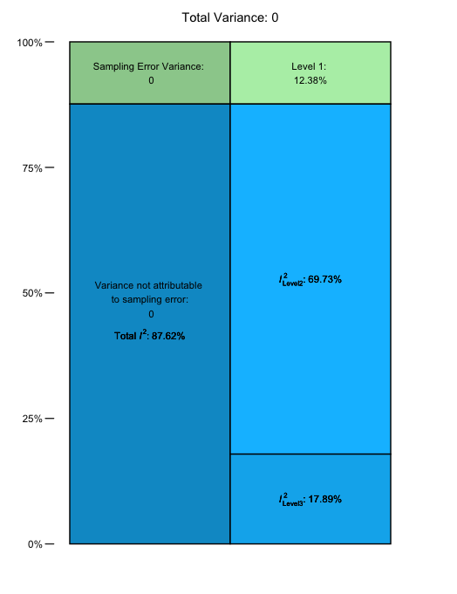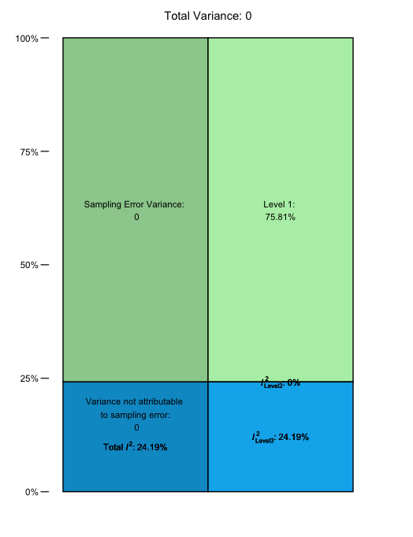

Supplementary Figure 2. Funnel plot of studies
Supplementary figure 2A and 2B show funnel plots of all included studies in the meta-analysis (A=without study labels, B=with study labels).
A B
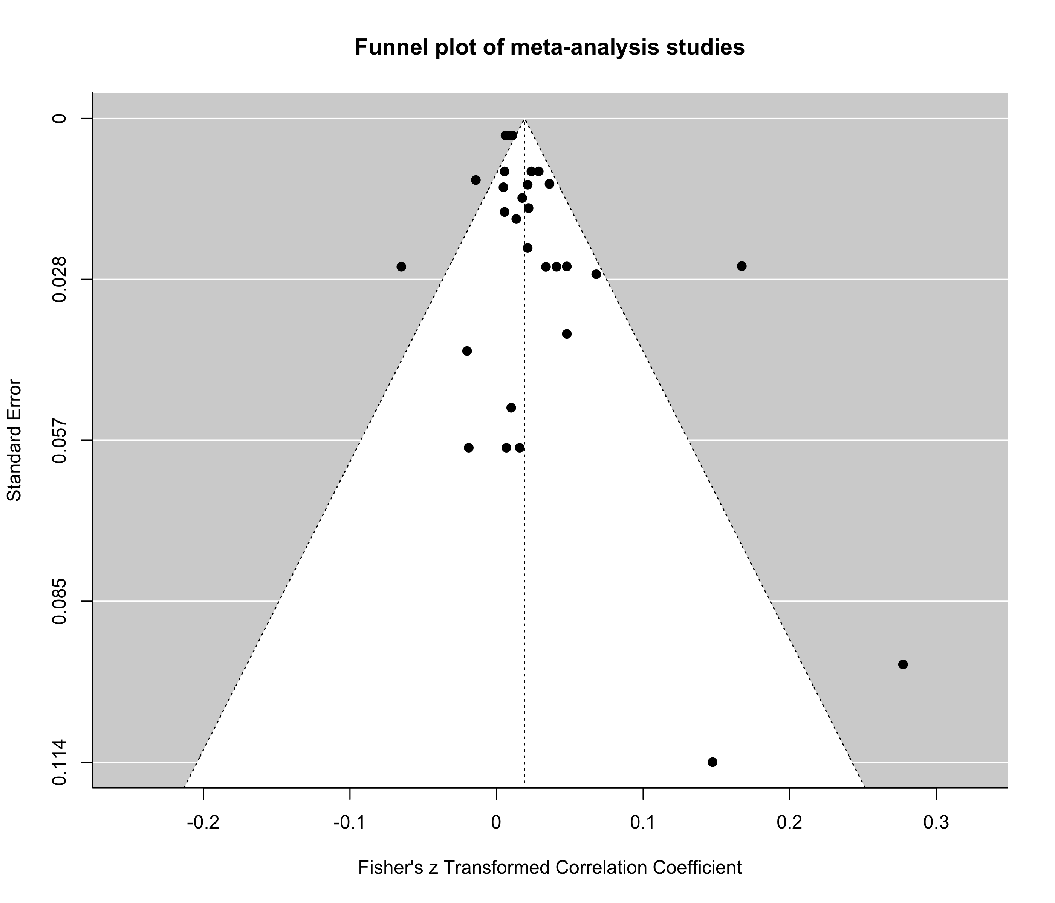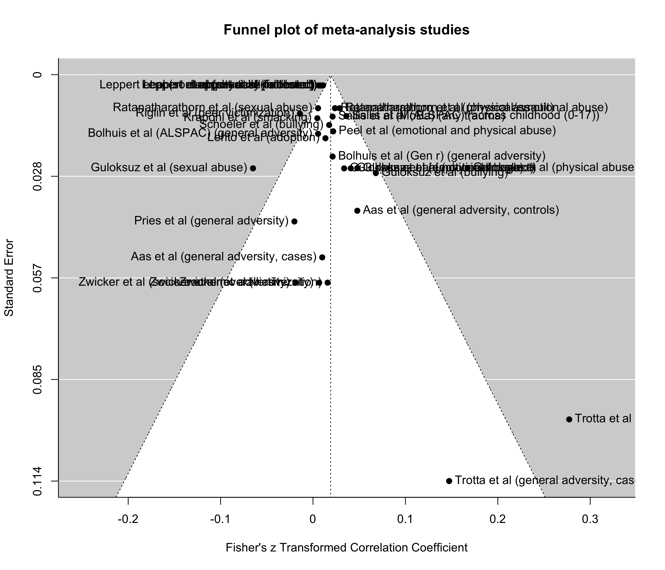

Supplementary Table 3. PRISMA Abstract 2020 Checklist
Section and Topic | Item # | Checklist item | Reported (Yes/No)
TITLE
Title | 1 | Identify the report as a systematic review. | Yes
BACKGROUND
Objectives | 2 | Provide an explicit statement of the main objective(s) or question(s) the review addresses. | Yes
METHODS
Eligibility criteria | 3 | Specify the inclusion and exclusion criteria for the review. | Yes
Information sources | 4 | Specify the information sources (e.g. databases, registers) used to identify studies and the date when each was last searched. | Yes
Risk of bias | 5 | Specify the methods used to assess risk of bias in the included studies. | Yes
Synthesis of results | 6 | Specify the methods used to present and synthesise results. | Yes
RESULTS
Included studies | 7 | Give the total number of included studies and participants and summarise relevant characteristics of studies. | Yes
Synthesis of results | 8 | Present results for main outcomes, preferably indicating the number of included studies and participants for each. If meta-analysis was done, report the summary estimate and confidence/credible interval. If comparing groups, indicate the direction of the effect (i.e. which group is favoured). | Yes
DISCUSSION
Limitations of evidence | 9 | Provide a brief summary of the limitations of the evidence included in the review (e.g. study risk of bias, inconsistency and imprecision). | Yes
Interpretation | 10 | Provide a general interpretation of the results and important implications. | Yes
OTHER
Funding | 11 | Specify the primary source of funding for the review. | Yes
Registration | 12 | Provide the register name and registration number. | Yes

Supplementary Table 4. PRISMA 2020 Checklist
Section and Topic | Item # | Checklist item | Location where item is reported
TITLE
Title | 1 | Identify the report as a systematic review. | 1
ABSTRACT
Abstract | 2 | See the PRISMA 2020 for Abstracts checklist. | 2
INTRODUCTION
Rationale | 3 | Describe the rationale for the review in the context of existing knowledge. | 3
Objectives | 4 | Provide an explicit statement of the objective(s) or question(s) the review addresses. | 5
METHODS
Eligibility criteria | 5 | Specify the inclusion and exclusion criteria for the review and how studies were grouped for the syntheses. | 6
Information sources | 6 | Specify all databases, registers, websites, organisations, reference lists and other sources searched or consulted to identify studies. Specify the date when each source was last searched or consulted. | 6
Search strategy | 7 | Present the full search strategies for all databases, registers and websites, including any filters and limits used. | 6
Selection process | 8 | Specify the methods used to decide whether a study met the inclusion criteria of the review, including how many reviewers screened each record and each report retrieved, whether they worked independently, and if applicable, details of automation tools used in the process. | 7
Data collection process | 9 | Specify the methods used to collect data from reports, including how many reviewers collected data from each report, whether they worked independently, any processes for obtaining or confirming data from study investigators, and if applicable, details of automation tools used in the process. | 7
Data items | 10a | List and define all outcomes for which data were sought. Specify whether all results that were compatible with each outcome domain in each study were sought (e.g. for all measures, time points, analyses), and if not, the methods used to decide which results to collect. | 7
 | 10b | List and define all other variables for which data were sought (e.g. participant and intervention characteristics, funding sources). Describe any assumptions made about any missing or unclear information. | 7
Study risk of bias assessment | 11 | Specify the methods used to assess risk of bias in the included studies, including details of the tool(s) used, how many reviewers assessed each study and whether they worked independently, and if applicable, details of automation tools used in the process. | 7
Effect measures | 12 | Specify for each outcome the effect measure(s) (e.g. risk ratio, mean difference) used in the synthesis or presentation of results. | See Table 2/3
Synthesis methods | 13a | Describe the processes used to decide which studies were eligible for each synthesis (e.g. tabulating the study intervention characteristics and comparing against the planned groups for each synthesis (item #5)). | See Table 2/3
 | 13b | Describe any methods required to prepare the data for presentation or synthesis, such as handling of missing summary statistics, or data conversions. | 6/7/8
 | 13c | Describe any methods used to tabulate or visually display results of individual studies and syntheses. | 8
 | 13d | Describe any methods used to synthesize results and provide a rationale for the choice(s). If meta-analysis was performed, describe the model(s), method(s) to identify the presence and extent of statistical heterogeneity, and software package(s) used. | 7/8
 | 13e | Describe any methods used to explore possible causes of heterogeneity among study results (e.g. subgroup analysis, meta-regression). | 8
 | 13f | Describe any sensitivity analyses conducted to assess robustness of the synthesized results. | 8
Reporting bias assessment | 14 | Describe any methods used to assess risk of bias due to missing results in a synthesis (arising from reporting biases). | 8
Certainty assessment | 15 | Describe any methods used to assess certainty (or confidence) in the body of evidence for an outcome. | 8
RESULTS
Study selection | 16a | Describe the results of the search and selection process, from the number of records identified in the search to the number of studies included in the review, ideally using a flow diagram. | 8  See also Figure 2
 | 16b | Cite studies that might appear to meet the inclusion criteria, but which were excluded, and explain why they were excluded. | 8
Study characteristics | 17 | Cite each included study and present its characteristics. | See Table 2/3
Risk of bias in studies | 18 | Present assessments of risk of bias for each included study. | See sup materials Table1/2
Results of individual studies | 19 | For all outcomes, present, for each study: (a) summary statistics for each group (where appropriate) and (b) an effect estimate and its precision (e.g. confidence/credible interval), ideally using structured tables or plots. | See Table 2/3
Results of syntheses | 20a | For each synthesis, briefly summarise the characteristics and risk of bias among contributing studies. | 8-17
 | 20b | Present results of all statistical syntheses conducted. If meta-analysis was done, present for each the summary estimate and its precision (e.g. confidence/credible interval) and measures of statistical heterogeneity. If comparing groups, describe the direction of the effect. | See Figure 1 and supp materials
 | 20c | Present results of all investigations of possible causes of heterogeneity among study results. | 15  See also supp Figure 1
 | 20d | Present results of all sensitivity analyses conducted to assess the robustness of the synthesized results. | 15
Reporting biases | 21 | Present assessments of risk of bias due to missing results (arising from reporting biases) for each synthesis assessed. | N/A
Certainty of evidence | 22 | Present assessments of certainty (or confidence) in the body of evidence for each outcome assessed. | See Figure 1 and supp materials
DISCUSSION
Discussion | 23a | Provide a general interpretation of the results in the context of other evidence. | 17
 | 23b | Discuss any limitations of the evidence included in the review. | 19-21
 | 23c | Discuss any limitations of the review processes used. | 19
 | 23d | Discuss implications of the results for practice, policy, and future research. | 22
OTHER INFORMATION
Registration and protocol | 24a | Provide registration information for the review, including register name and registration number, or state that the review was not registered. | 2, 6
 | 24b | Indicate where the review protocol can be accessed, or state that a protocol was not prepared. | 2, 6
 | 24c | Describe and explain any amendments to information provided at registration or in the protocol. | 2, 6
Support | 25 | Describe sources of financial or non-financial support for the review, and the role of the funders or sponsors in the review. | 23
Competing interests | 26 | Declare any competing interests of review authors. | 23
Availability of data, code and other materials | 27 | Report which of the following are publicly available and where they can be found: template data collection forms; data extracted from included studies; data used for all analyses; analytic code; any other materials used in the review. | N/A

