Sleep symptomatology is associated with greater subjective cognitive concerns: Findings from the community-based Healthy Brain Project

Jessica Nicolazzo*¹, Katharine Xu*², Alexandra Lavale¹, Rachel Buckley^{2,3,4}, Nawaf Yassi^{5,6}, Garun S. Hamilton^{7,8,9}, Paul Maruff^{10,11}, Andree-Ann Baril¹², Yen Ying Lim^{ł 1}, & Matthew P. Pase^{ł 1,13}
*Joint first author; ^{ł}Joint senior author

¹The Turner Institute for Brain and Mental Health, Monash University, Clayton, Victoria, Australia
² Melbourne School of Psychological Sciences, University of Melbourne, Parkville, Victoria, Australia
³ Department of Neurology, Massachusetts General Hospital and Harvard Medical School, Boston, Massachusetts, USA
⁴ Center for Alzheimer Research and Treatment, Department of Neurology, Brigham and Women’s Hospital, Boston, Massachusetts, USA
⁵ Department of Medicine and Neurology, Melbourne Brain Centre at The Royal Melbourne Hospital, University of Melbourne, Parkville, Victoria, Australia
⁶ Population Health and Immunity Division, The Walter and Eliza Hall Institute of Medical Research, Parkville, Victoria, Australia
⁷ Monash Lung and Sleep, Monash Health, Melbourne, Victoria, Australia
⁸ School of Clinical Sciences, Monash University, Melbourne, Victoria, Australia
⁹ Monash Partners Epworth, Melbourne, Victoria, Australia
¹⁰ Cogstate Ltd., Melbourne, Victoria, Australia
¹¹ The Florey Institutes of Neurosciences and Mental Health, Melbourne, Victoria, Australia
¹² Department of Neurology, Boston University School of Medicine, Boston, MA, USA
¹³ Harvard T.H. Chan School of Public Health, MA, USA

Correspondence to:
A/Prof Matthew Pase
18 Innovation Walk, Monash University, Clayton, Australia, 3800
matthewpase@gmail.com | + 61 401 267 924
Contents
Supplemental Methods. Copy of the Modified Cognitive Function Instrument
Supplemental Table 1. Inter-correlations between scores on the Pittsburgh Sleep Quality Index (PSQI), Epworth Sleepiness Scale (ESS), and Insomnia Severity Index (ISI)
Supplementary Table 2. Omnibus variable level tests for interactions between sleep symptomatology (low, moderate, high) and APOE Ɛ4 carrier (yes/no), sex (male/female), depressive symptoms ((HADS depression scores > 7 vs. the remainder of the sample), and subjective cognitive concerns (top quartile [most concerns] of the CFI vs. the remainder of the sample)
Supplemental Figure 1. Frequency distributions of the Pittsburgh Sleep Quality Index (A), Epworth Sleepiness Scale (B), and Insomnia Severity Index (C)

Supplemental Methods. Copy of the Modified Cognitive Function Instrument
This survey is related to how you think your mental function has been over the PAST YEAR. Please do not refer to your long-term traits in relation to mental function but think in terms of whether there has been a CHANGE in the past year.
All of the following items have the following responses: “Yes, and I find it concerning”, “Yes, but I do not find it concerning”, “No”, “Not applicable to me”.
1. Thinking back over the past year, have you noticed any decline in your memory or thinking?
2. Thinking back over the past year, have you noticed any decline in your ability to recall important information (i.e., conversations you've had with your family or friends)?
3. Thinking back over the past year, have you noticed any decline in your ability to recall short-term information (i.e., shopping lists)?
4. Thinking back over the past year, have you noticed a decline in your ability to remember the names of acquaintances?
5. Thinking back over the past year, have you noticed a decline in your ability to remember appointments, dates/times of family events and/or meeting times?
6. Thinking back over the past year, have you noticed a decline in your ability to organise your finances (i.e., pay bills, keep track of investments, etc)?
7. Thinking back over the past year, have you tended to become more disoriented or become lost more often in unfamiliar suburbs?
8. Thinking back over the past year, have you been misplacing things more often?
9. Thinking back over the past year, have you been requiring more written reminders than you needed a year ago?
10. Thinking back over the past year, are you becoming more absent-minded and distracted (i.e., entering a room and forgetting your purpose)?
11. Thinking back over the past year, are you increasingly relying on others to complete tasks that you used to do before (i.e., finances)?
12. Thinking back over the past year, are you finding it more difficult to think of the right word to use in a conversation?
13. Thinking back over the past year, have family or friends commented that they have noticed a change in your memory or thinking abilities?
14. Thinking back over the past year, have you visited a doctor in relation to a concern about your memory or thinking?
15. Do you think you have troubles with your memory or thinking?
Supplementary Table 1. Inter-correlations between scores on the Pittsburgh Sleep Quality Index (PSQI), Epworth Sleepiness Scale (ESS), and Insomnia Severity Index (ISI)
 | PSQI | ESS | ISI
PSQI | - | 0.06 | 0.60
ESS | 0.06 | - | 0.09
ISI | 0.60 | 0.09 | -
All correlation coefficients are significant at p<0.05

Supplementary Table 2. Omnibus variable level tests for interactions between sleep symptomatology (low, moderate, high) and APOE Ɛ4 carrier (yes/no), sex (male/female), depressive symptoms (HADS depression scores > 7 vs. the remainder of the sample), and subjective cognitive concerns (top quartile [most concerns] of the CFI vs. the remainder of the sample)
Interaction term | Outcome | N | F (df) | p
Depression x Sleep Symptomatology
 | DET | 1293 | 0.39 (2, 1279) | 0.68
 | IDN | 1292 | 0.49 (2, 1278) | 0.61
 | OCL | 1293 | 1.55 (2, 1279) | 0.21
 | OBK | 1293 | 1.49 (2, 1279) | 0.23
 | CFI | 1200 | 1.66 (2, 1186) | 0.19
Sex x Sleep Symptomology
 | DET | 1293 | 0.49 (2, 1279) | 0.61
 | IDN | 1292 | 0.88 (2, 1278) | 0.41
 | OCL | 1293 | 0.02 (2, 1279) | 0.98
 | OBK | 1293 | 1.64 (2, 1279) | 0.19
 | CFI | 1200 | 0.15 (2, 1186) | 0.86
APOE x Sleep Symptomatology
 | DET | 689 | 0.29 (2, 674) | 0.75
 | IDN | 689 | 0.34 (2, 674) | 0.71
 | OCL | 689 | 0.35 (2, 674) | 0.71
 | OBK | 689 | 1.77 (2, 674) | 0.17
 | CFI | 657 | 1.62 (2, 642) | 0.20
Subjective Cognitive Concerns x Sleep Symptomatology
 | DET | 1200 | 3.12 (2, 1185) | 0.045
 | IDN | 1199 | 0.21 (2, 1184) | 0.21
 | OCL | 1200 | 2.84 (2, 1185) | 0.06
 | OBK | 1200 | 1.74 (2, 1185) | 0.18
CFI = cognitive function instrument (subjective cognitive concerns), DET = Detection, IDN = Identification, OCL = One Card Learning, OBK = One-Back. DET and IDN are measures of speed; OCL and OBK are measures of accuracy. DET and IDN scores were reverse coded such that higher responses indicate better performance. All analyses were adjusted for the effects of age, sex, years of education, levels of depression and anxiety symptoms (using the HADS), BMI, smoking status, and self-reported history of diabetes and hypertension. Continuous HADS depression scores were not entered in the model evaluating the moderating effects of the binary depression variable (binary depression scores were used instead).

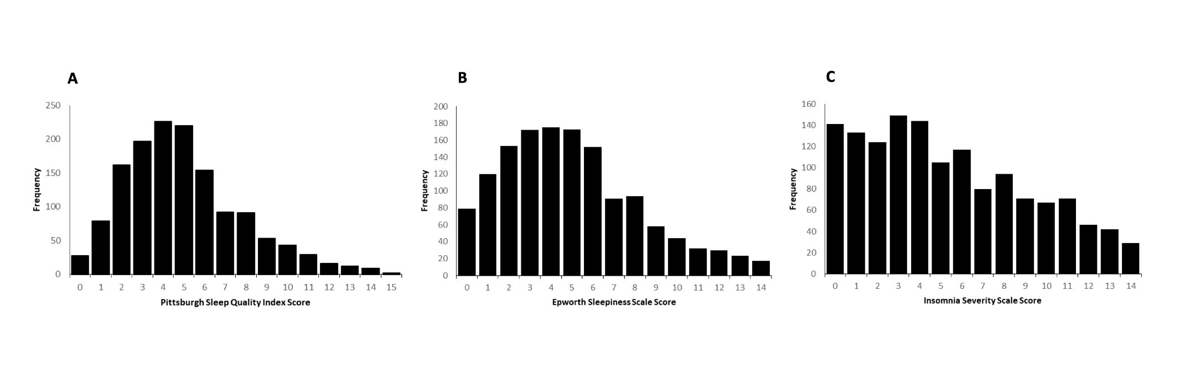
Supplementary Figure 1. Frequency distributions of the Pittsburgh Sleep Quality Index (A), Epworth Sleepiness Scale (B), and Insomnia Severity Index (C)

