Supplementary Material

let-7c-5p regulates CyclinD1 in fluoride-mediated osteoblast proliferation and activation
Keke Luo¹, Yu Qin², Ting Ouyang¹, Xilan Wang¹, Aihua Zhang¹, Peng Luo^{1#}, Xueli Pan^{1#}
¹School of Public Health, The Key Laboratory of Environmental Pollution Monitoring and Disease Control, Ministry of Education, Guizhou Medical University, Guiyang, 550025, China
² Guizhou Orthopedics Hospital, Guiyang, 550007, China
# To whom correspondence should be addressed at School of Public Health, Guizhou Medical University, Guiyang 550025, China. E-mail: xuelipan@gmc.edu.cn and luopeng@gmc.edu.cn.

Supplemental Table 1 Primers of mRNA used in qRT-PCR.
Gene | Primer sequences
CyclinD1 F | 5′-GGGCCACTTGCATGTTCGT-3′
CyclinD1 R  Wnt9a F  Wnt9a R | 5′-CAGGTTCCACTTGAGCTTGTTCAC-3′  5′-GCATCTGAAGCACAAGTATGAG-3′  5′-CAGAAGCTAGGCGAGTCATC-3′
GAPDH F | 5′-GCACCGTCAAGGCTGAGAAC -3′
GAPDH R | 5′- TGGTGAAGACGCCAGTGGA -3′

Supplemental Table 2 Primers used in ChIP-qRT-PCR.
Gene | Primer sequences
ChIP 1 F | 5′-ACCTCCACCTCACCCCCTAA-3′
ChIP 1 R  ChIP 2 F  ChIP 2 R  GAPDH F  GAPDH R | 5′-GCAACTTCAACAAAACTCCCCT-3′  5′-CGTCCATGCGGAAGATCGT-3′  5′-GGGGGGTGAGTAGCAAAGAAA-3′  5′-GCCATGTAGACCCCTTGAAGAG-3′  5′-ACTGGTTGAGCACAGGGTACTTTAT-3′

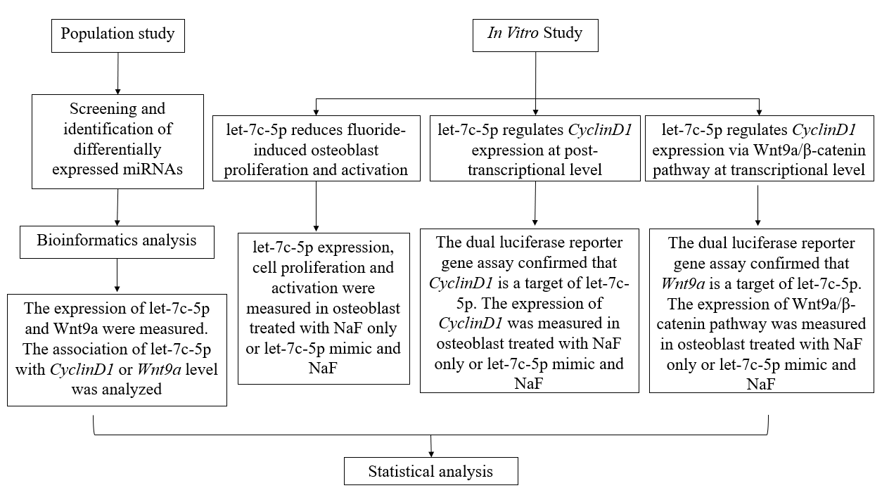
Supplementary figure 1. The flowchart of experimental design.

