**Table S1. Spectra sample sizes in each weekly dataset.** Symptomatic leaf sample numbers were low in weeks prior to week 6 and were not included in analyses. In all analyses, sample sizes (oak wilt vs. not oak wilt) were randomly sampled to balance sample sizes.



**Table S2. Pairwise differences in instantaneous photosynthesis and stomatal conductance declines (difference from control) by treatment and leaf symptom status.** Values are the mean difference (units are photosynthesis = µmolCO2 m-2 s-1 and stomatal conductance = molH2O m-2 s-1) between columns and rows, followed by lower and upper limits of a 95% CI and significance of pairwise difference (* *P* < 0.05, ** *P* < 0.01, *** *P* < 0.001) from a post-hoc Tukey test (α = 0.05).



**Table S3. Oak wilt specific spectral regions.** Wavelengths and indices at which oak wilt inoculated individuals have significantly different reflectance values, including commonly used indices or reflectance values (at top, from Pontius et al. ( 2005)). Reflectance percent values are mean difference between oak wilt and all other treatments. The minimum difference (min. diff %) in reflectance between the mean value of the oak wilt reflectance and the most similar treatment at that wavelength. * = oak wilt reflectance values are significantly different from all other treatment reflectance values (*P* < 0.001). wk = interactive effect of treatment and experimental timing was significant (*P* <0.001). Species oak wilt reflectance values are mean difference between oak wilt and all other treatments (*ellip* OW % or *macro* OW %) and are only shown if species is a significant predictor of reflectance. Annotations included when available (Blackburn, 1998; Carter, 1993; Cotrozzi et al., 2017; Curran, 1989; Elvidge, 1990; Govender, Dye, Weiersbye, Witkowski, & Ahmed, 2009; Kumar, 2007; Lehmann, Große-Stoltenberg, Römer, & Oldeland, 2015; Penuelas et al., 1997; Pontius et al., 2005; Serbin, Dillaway, Kruger, & Townsend, 2012; Tucker, 1980).



**Table S4. PLS-DA oak wilt classification summary, all experimental times aggregated.**



**Table S5. PLS-DA oak wilt classification summary, time explicit and comparisons oak wilt or “not oak wilt”.**



**Table S6. PLS-DA species classification summary, all experimental times aggregated.**



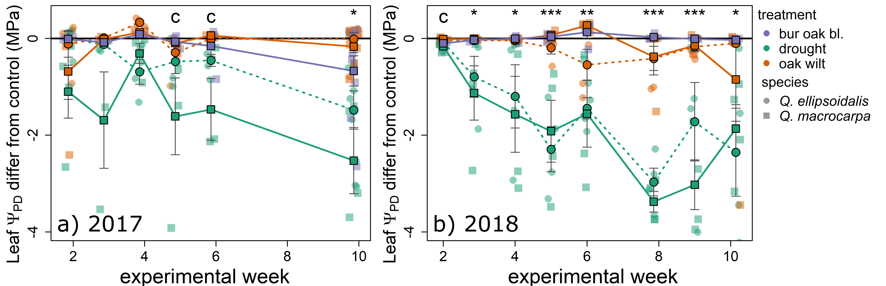

**Figure S1. Pre-dawn water potentials**. Difference between mean control treatments of each species and treatments. **a)** 2017 experimental data, **b)** 2018 experimental data. Error bars show one standard error around the mean differences. Asterisks denote significant pairwise differences between drought and all other treatments (* P < 0.05, ** P < 0.01, *** P < 0.001), significant differences from control, when all other pairwise differences are not significant, are denoted by “c”.

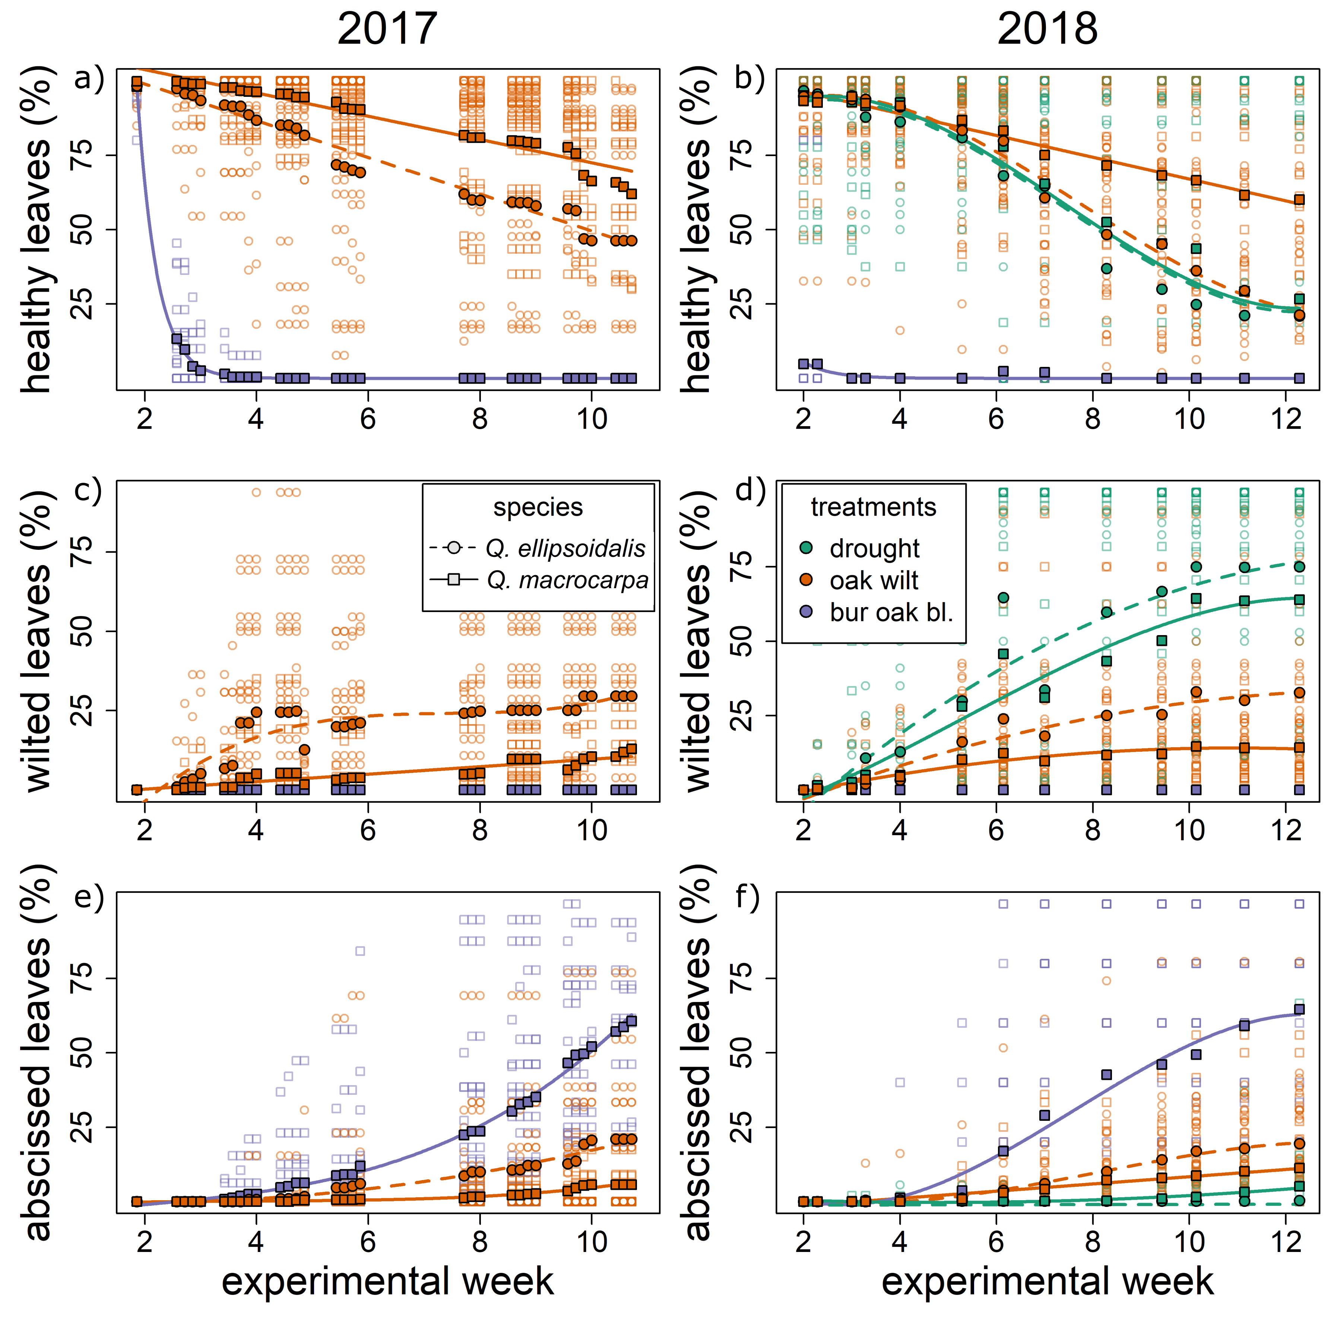

**Figure S2. Symptom appearance by week of experiment**, 2017 and 2018 experiments. 2017 does not include data for drought symptoms. **a,b)** Percent of healthy leaves remaining. **c,d)** Percent of leaves showing signs of wilting (browning, curling, and/or desiccation). **e,f)** Percent of leaves lost during the experiment. Bur oak blight percentages are calculated from the total of inoculated leaves, not total canopy.

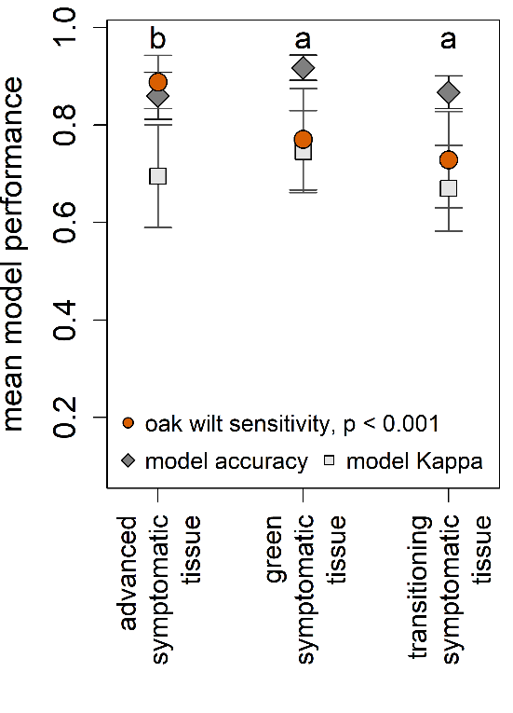

**Figure S3. PLS-DA Model performance by symptomatic leaf status.** Letters denote significant differences in oak wilt sensitivity between models, error bars are one standard deviation in model summary statistics from 100 model fitting iterations.

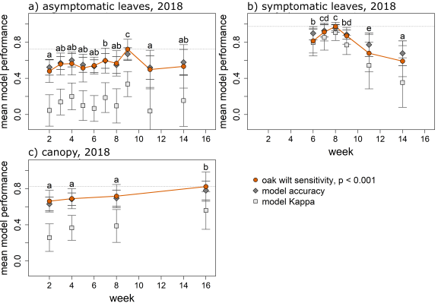

**Figure S4. PLS-DA model accuracy, Kappa, and sensitivity to oak wilt by week of experiment.** Model performance statistics from PLS-DA classifications of data into oak wilt or not oak wilt (all other treatments grouped) in spectral reflectance weekly datasets of **a)** asymptomatic leaves **b)** symptomatic leaves, and c**)** seedling canopies. Letters denote significant comparisons (post hoc Tukey test, P < 0.001) between oak wilt sensitivities of each week’s models and error bars are one SD (100 iterations of model fitting).

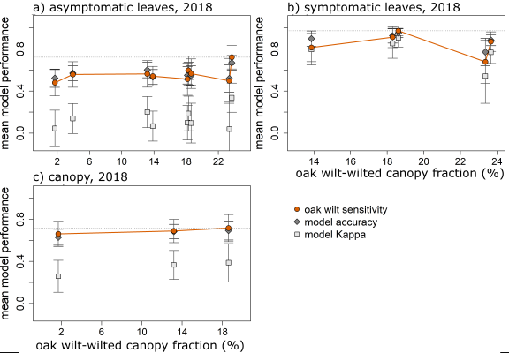

**Figure S5. PLS-DA model accuracy, Kappa, and sensitivity to oak wilt by oak wilt-treatments wilted canopy fractions.** Model performance statistics from PLS-DA classifications of data into oak wilt or not oak wilt (all other treatments grouped) in spectral reflectance weekly datasets plotted against mean canopy fraction of wilted leaves among oak wilt-inoculated plants. **a)** asymptomatic leaves **b)** symptomatic leaves, and c**)** seedling canopies. Letters denote significant comparisons (post hoc Tukey test, P < 0.001) between oak wilt sensitivities of each week’s models and error bars are one SD (100 iterations of model fitting).

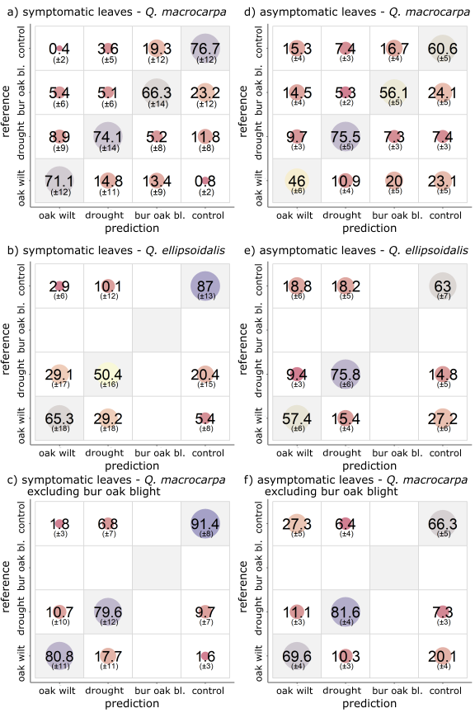

**Figure S6. Confusion matrices of PLS-DA classification to treatment in leaf level, symptom status data sets subset to species.** Average percentage of treatment individuals classified in PLS-DA models (100 iterations for each dataset) of subsets of: symptomatic leaves **a)** *Q. macrocarpa*, **b)** *Q. ellipsoidalis*, **c)** *Q. macrocarpa* when bur oak blight individuals are excluded from the analysis; and asymptomatic leaves **d)** *Q. macrocarpa*, **e)** *Q. ellipsoidalis*, and **f)** *Q. macrocarpa* when bur oak blight individuals are excluded from the analysis. Vertical axis is applied treatments and horizontal axis is predicted classification.

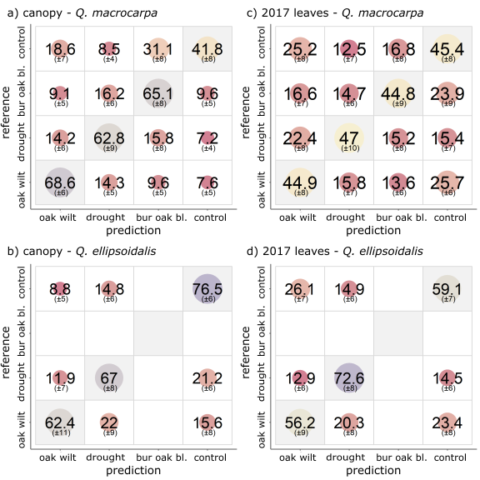

**Figure S7. Confusion matrices of PLS-DA classification to treatment whole plant and leaf aggregated data sets.** Average percentage of treatment individuals classified in PLS-DA models (100 iterations for each dataset) of subsets of: canopy reflectance **a)** *Q. macrocarpa*, **b)** *Q. ellipsoidalis*; and leaf reflectance (2017) **c)** *Q. macrocarpa*, d**)** *Q. ellipsoidalis*. Vertical axis is applied treatments and horizontal axis is predicted classification.

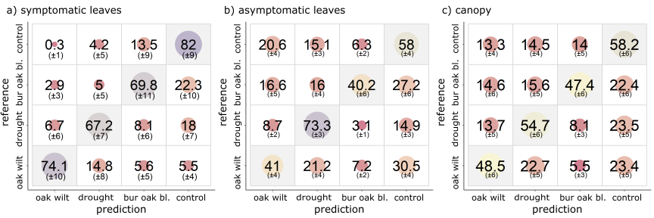

**Figure S8. Oak wilt diagnostic wavelengths only as predictors perform classifications as well in symptomatic leaves, but not in asymptomatic leaves or canopy reflectance datasets.** Using 30 wavelengths found to be significantly different in oak wilt reflectance spectra from other treatments, the average percentage of treatment individuals classified in PLS-DA models (100 iterations for each dataset) in **a)** symptomatic leaves, **b)** asymptomatic leaves, and **c)** canopy reflectances. Vertical axis is applied treatments and horizontal axis is predicted classification.

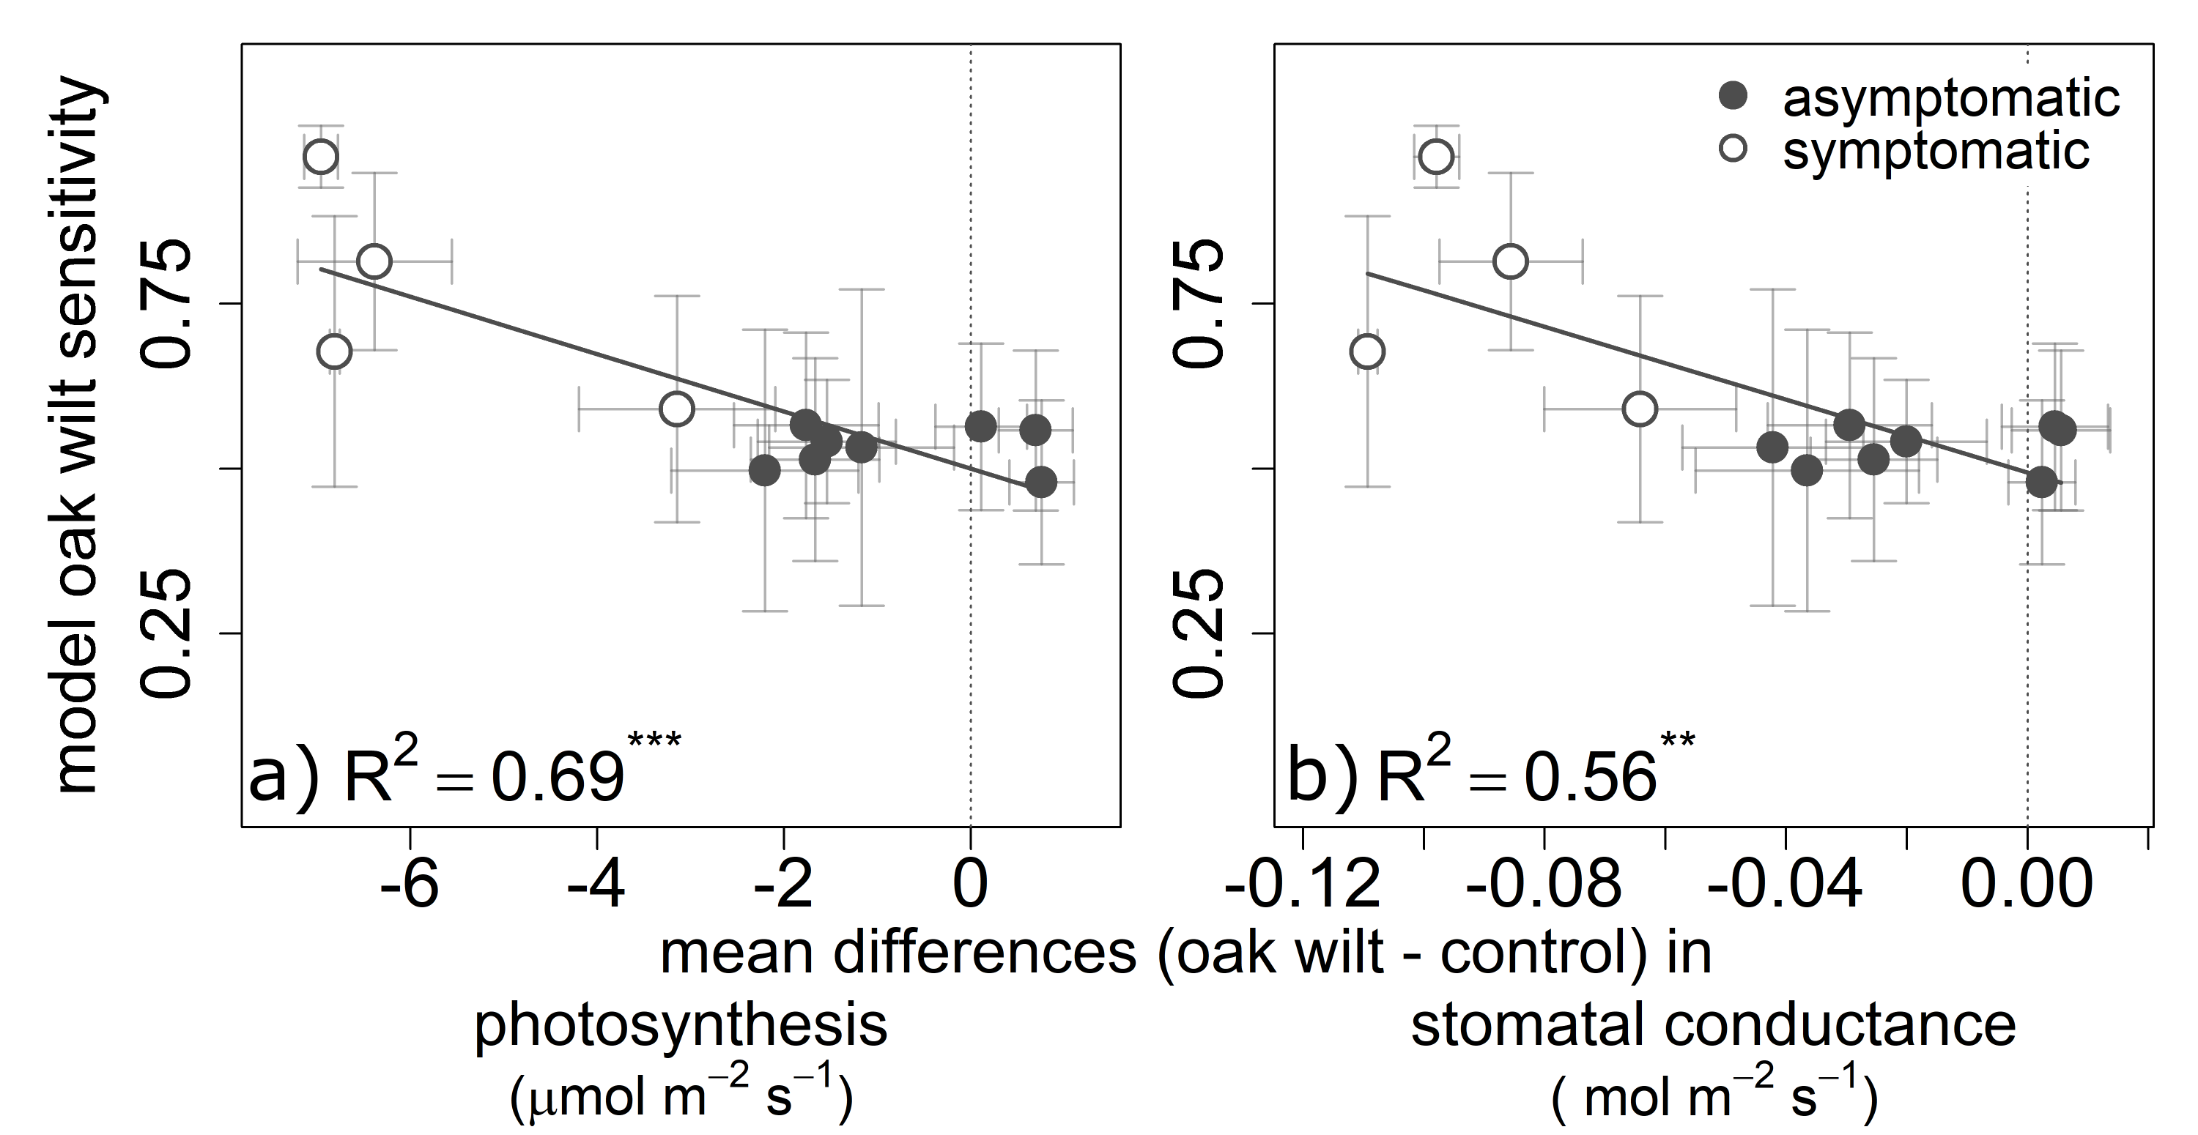

**Figure S9. PLS-DA model oak wilt sensitivity increases as photosynthesis and stomatal conductance decline in oak wilt-inoculated plants.** Mean PLS-DA oak wilt sensitivity by differences between oak wilt-inoculated individual leaf gas exchange rates and controls. Error bars are standard error of oak wilt sensitivity and standard error of the mean in gas exchange. *** = *P* < 0.001, ** = *P* < 0.01. **a)** instantaneous photosynthetic assimilation rate declines (R2 = 0.69, *P* < 0.001, F1,10 = 22) and **b)** instantaneous stomatal conductance rate declines (R2 = 0.56, *P* = 0.005, F1,10 = 12.9).

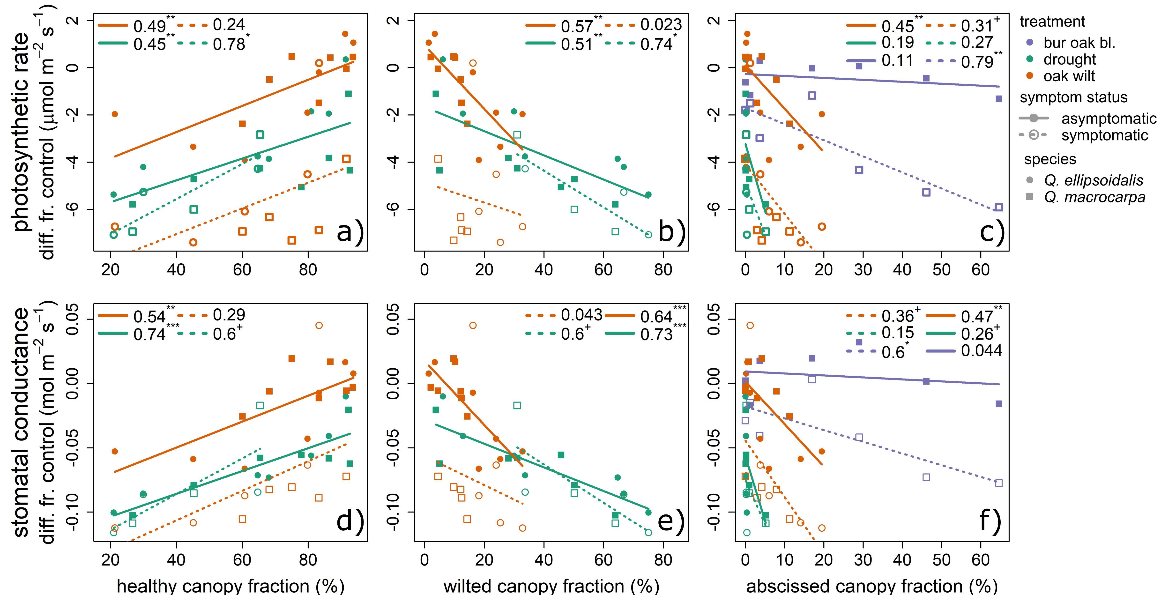

**Figure S10. Gas exchange rate declines correlated with symptom progression in canopies.** Mean weekly treatment differences from control by mean symptom prevalence in canopy and leaf symptom type. Species are shown by squares (*Q.* ellipsoidalis) and circles (*Q. macrocarpa)*. Values are R2 followed by significance (+ = *P* < 0.1, * = *P* < 0.05, ** = *P* < 0.01, *** = *P* < 0.001). Instantaneous photosynthetic rate difference from control (**a,b,c**) or mean stomatal conductance difference from control (**d,e,f**) by mean canopy fraction of healthy, wilted, and abscissed leaves.

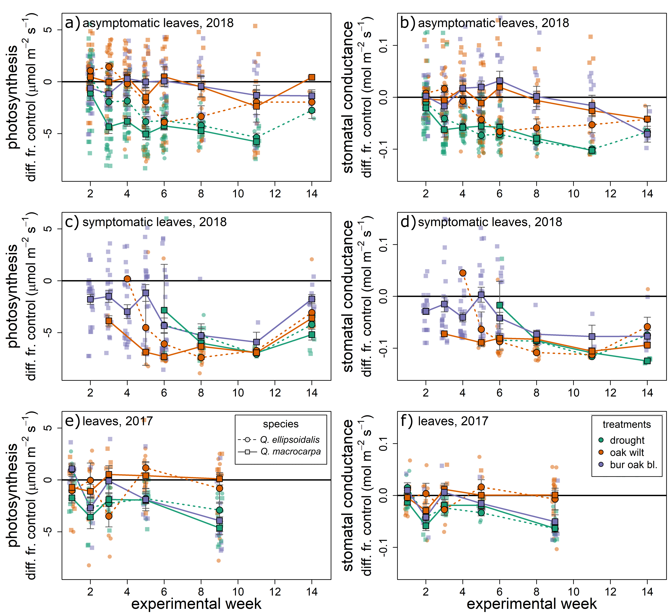

**Figure S11. Differences from mean control gas exchange rates by experimental week, species, and treatment**. Difference between mean control treatments of each species and week, instantaneous photosynthetic and stomatal conductance rates. **a & b)** Measurements on asymptomatic leaves in 2018 seedling experiment, **c & d)** Measurements of symptomatic leaves in 2018 seedling experiment, **e & f)** Measurements of leaves, without symptom status considered in 2017 seedling experiment. Error bars show one standard error around the mean differences.

Blackburn, G. A. (1998). Spectral indices for estimating photosynthetic pigment concentrations: A test using senescent tree leaves. *International Journal of Remote Sensing*, *19*(4), 657–675. https://doi.org/10.1080/014311698215919

Carter, G. A. (1993). Responses of Leaf Spectral Reflectance To Plant Stress. *American Journal of Botany*, *80*(3), 239–243. https://doi.org/10.1002/j.1537-2197.1993.tb13796.x

Carter, G. A., & Miller, R. L. (1994). Early detection of plant stress by digital imaging within narrow stress-sensitive wavebands. *Remote Sensing of Environment*, *50*(3), 295–302. https://doi.org/10.1016/0034-4257(94)90079-5

Cotrozzi, L., Couture, J. J., Cavender-Bares, J., Kingdon, C. C., Fallon, B., Pilz, G., … Townsend, P. A. (2017). Using foliar spectral properties to assess the effects of drought on plant water potential. *Tree Physiology*, (October), 1–10. https://doi.org/10.1093/treephys/tpx106

Curran, P. J. (1989). Remote sensing of foliar chemistry. *Remote Sensing of Environment*, *30*, 271–278. Retrieved from https://www.scopus.com/inward/record.uri?eid=2-s2.0-85009802387&doi=10.3303%2FCET1652182&partnerID=40&md5=8d95c8e3ded7e5a8966281de61079cd3

Elvidge, C. D. (1990). Visible and near infrared reflectance characteristics of dry plant materials. *International Journal of Remote Sensing1*, *11*(10), 1775–1795.

Gamon, J. A., Field, C. B., Bilger, W., Björkman, O., Fredeen, A. L., & Peñuelas, J. (1990). Remote sensing of the xanthophyll cycle and chlorophyll fluorescence in sunflower leaves and canopies. *Oecologia*, *85*(1), 1–7. https://doi.org/10.1007/BF00317336

Gamon, J. A., Serrano, L., & Surfus, J. S. (1997). The photochemical reflectance index: An optical indicator of photosynthetic radiation use efficiency across species, functional types, and nutrient levels. *Oecologia*, *112*(4), 492–501. https://doi.org/10.1007/s004420050337

Govender, M., Dye, P. J., Weiersbye, I. M., Witkowski, E. T. F., & Ahmed, F. (2009). Review of commonly used remote sensing and ground-based technologies to measure plant water stress. *Water SA*, *35*(5), 741–752. https://doi.org/10.4314/wsa.v35i5.49201

Kumar, L. (2007). High-spectral resolution data for determining leaf water content in Eucalyptus species: Leaf level experiments. *Geocarto International*, *22*(1), 3–16. https://doi.org/10.1080/10106040701204396

Lehmann, J. R. K., Große-Stoltenberg, A., Römer, M., & Oldeland, J. (2015). Field spectroscopy in the VNIR-SWIR region to discriminate between mediterranean native plants and exotic-invasive shrubs based on leaf tannin content. *Remote Sensing*, *7*(2), 1225–1241. https://doi.org/10.3390/rs70201225

Mohammed, G. H., Binder, W. D., & Gillies, S. L. (1995). Chlorophyll fluorescence: A review of its practical forestry applications and instrumentation. *Scandinavian Journal of Forest Research*, *10*(1–4), 383–410. https://doi.org/10.1080/02827589509382904

Osborne, B. G., & Fearn, T. (1986). *Near-infrared spectroscopy in food analysis*. New York: John Wiley and Sons Inc.

Penuelas, J., Pinol, J., Ogaya, R., & Filella, I. (1997). Estimation of plant water concentration by the reflectance Water Index WI (R900/R970). *International Journal of Remote Sensing*, *18*(13), 2869–2875. https://doi.org/10.1080/014311697217396

Pontius, J., Hallett, R., & Martin, M. (2005). Using AVIRIS to assess hemlock abundance and early decline in the Catskills, New York. *Remote Sensing of Environment*, *97*(2), 163–173. https://doi.org/10.1016/j.rse.2005.04.011

Serbin, S. P., Dillaway, D. N., Kruger, E. L., & Townsend, P. A. (2012). Leaf optical properties reflect variation in photosynthetic metabolism and its sensitivity to temperature. *Journal of Experimental Botany*, *63*(1), 489–502. https://doi.org/10.1093/jxb/err294

Tucker, C. J. (1980). Remote sensing of leaf water content in the near infrared. *Remote Sensing of Environment*, *10*(1), 23–32. https://doi.org/10.1016/0034-4257(80)90096-6

Williams, P., & Norris, K. (1987). *Near-infrared technology in the agricultural and food industries*. St. Paul, MN: American Association of Cereal Chemists.